ANOVA for a RCBD trial: SPYLUN2012_MZ-Estacao Agraria do Umbeluzi

reinhardsimon using HIDAP

March 31, 2016, 15:34h

Table of Contents

# This is an automatedly created report.  
  
# See more details in section on materials.

Alternate formats:

PDF DOCX

# Abstract

This trial has the identifier SPYLUN2012_MZ-Estacao Agraria do Umbeluzi. It was conducted under the supervision of x y as a Advanced Trial as part of a Yield Breeding Program in Estacao Agraria do Umbeluzi, Mozambique, Z in 2016. A total of 59 clones (including reference clones) were evaluated for 34 traits.

# Materials and Methods

## Location characterization

### Installation

### Geographic and climate characterization

### Weather during planting season

### Soil

### Field management

### Observations on special events

## Materials

## Trait descriptions (from ontology)

## Model specification and data description

There is data from 59 treatments, evaluated using a randomize complete block design with 1, 2 blocks. The statistical model is

$$y_{ij}=μ+τ_{i}+β_{j}+ϵ_{ij}$$

where

* $y_{ij}$ is the observed response with treatment $i$ and block $j$.
* $μ$ is the mean response over all treatments and blocks.
* $τ_{i}$ is the effect for treatment $i$.
* $β_{j}$ is the effect for block $j$.
* $ϵ_{ij}$ is the error term.

In this model we assume that the errors are independent and have a normal distribution with common variance, that is, $ϵ_{ij}∼N(0,σ_{ϵ}^{2})$.

The following traits are analyzed: **Beta carotene content measuring mg per 100g, Content of iron on dry weight basis measuring mg per 100g, Content of zinc on dry weight basis measuring mg per 100g, Dry weight of storage root samples measuring g of sample, Fibers in cooked samples 1 estimating 1-9, Fresh weight of storage root samples measuring g of sample, Fructose content measuring percent, Glucose content measuring percent, Harvest index computing percent, Number of commercial storage roots counting number per plot, Number of non-commercial storage roots counting number per plot, Overall taste of cooked sample 1 estimating 1-9, Plants established counting number per plot, Plants harvested counting number per plot, Plants planted counting number per plot, Plants with storage roots counting number per plot, Protein content measuring percent, Storage root damages estimatimg 1-9, Storage root dry matter content computing percent, Storage root form estimating 1-9, Storage root size estimating 1-9, Storage root starch content measuring percent, Storage root sweetness 1 estimating 1-9, Storage root texture 1 estimating 1-9, Sucrose content measuring percent, Survival index computing percent, Sweet potato weevil symptoms 1 estimating 1-9, Total carotenoids measuring mg per 100g, Vine vigor 1 estimating 1-9, Virus symptoms 1 estimating 1-9, Virus symptoms 2 estimating 1-9, Weight of commercial storage roots measuring kg per plot, Weight of non-commercial storage roots measuring kg per plot, Weight of vines measuring kg per plot**.

The following germplasm was analyzed: MUSG11030-9, MUSG11049-5, MUSG11016-16, MUSG11001-2, MUSG11049-7, MUSG11046-18, MUSG11003-10, MUSG11016-2, MUSG11022-10, MUSG11026-11, Resisto, MUSG11010-11, MUSG11049-16, MUSG11048-15, MUSG11023-11, MUSG11022-11, MUSG11016-19, MUSG11021-16, MUSG11016-12, MUSG11004-9, MUSG11012-14, MUSG11016-21, Jonathan, MUSG11046-7, MUSG11036-3, MUSG11006-8, MUSG11033-6, MUSG11010-7, MUSG11044-15, MUSG11040-15, MUSG11050-3, MUSG11011-3, MUSG11016-14, MUSG11022-1, MUSG11002-9, MUSG11044-16, MUSG11046-3, MUSG11008-12, MUSG11040-16, MUSG11001-11, MUSG11042-7, MUSG11016-18, MUSG11046-14, MUSG11019-5, Chingova, MUSG11006-15, MUSG11010-19, MUSG11049-3, MUSG11019-15, MUSG11016-22, MUSG11004-5, MUSG11048-16, MUSG11040-13, MUSG11049-2, MUSG11007-15, MUSG11019-17, MUSG11007-1, MUSG11003-2, MUSG11016-10.

## Computational tools

This report was created using x86_64-apple-darwin13.4.0, x86_64, darwin13.4.0, x86_64, darwin13.4.0, , 3, 2.3, 2015, 12, 10, 69752, R, R version 3.2.3 (2015-12-10), Wooden Christmas-Tree on a x86_64-apple-darwin13.4.0 (64-bit) running OS X 10.11.3 (El Capitan) in . The following base packages were loaded: **stats, graphics, grDevices, utils, datasets, methods, base** and the following additional packages: **brapi, shinyURL, rmdformats, knitr, qtlcharts, d3heatmap, rhandsontable, dplyr, shinydashboard, ggplot2, leaflet, miniUI, shiny**.

# Results

## Raw data

## Trait summaries

## Trait analyses

The following traits were not analyzed since they had too many missing values (>= 10%): Sucrose content measuring percent. For the remaining traits missing values were imputed using all available information.

Valid traits: **Beta carotene content measuring mg per 100g, Content of iron on dry weight basis measuring mg per 100g, Content of zinc on dry weight basis measuring mg per 100g, Dry weight of storage root samples measuring g of sample, Fibers in cooked samples 1 estimating 1-9, Fresh weight of storage root samples measuring g of sample, Fructose content measuring percent, Glucose content measuring percent, Harvest index computing percent, Number of commercial storage roots counting number per plot, Number of non-commercial storage roots counting number per plot, Overall taste of cooked sample 1 estimating 1-9, Plants established counting number per plot, Plants harvested counting number per plot, Plants planted counting number per plot, Plants with storage roots counting number per plot, Protein content measuring percent, Storage root damages estimatimg 1-9, Storage root dry matter content computing percent, Storage root form estimating 1-9, Storage root size estimating 1-9, Storage root starch content measuring percent, Storage root sweetness 1 estimating 1-9, Storage root texture 1 estimating 1-9, Survival index computing percent, Sweet potato weevil symptoms 1 estimating 1-9, Total carotenoids measuring mg per 100g, Vine vigor 1 estimating 1-9, Virus symptoms 1 estimating 1-9, Virus symptoms 2 estimating 1-9, Weight of commercial storage roots measuring kg per plot, Weight of non-commercial storage roots measuring kg per plot, Weight of vines measuring kg per plot**.

### Analysis of **Beta carotene content measuring mg per 100g**

You have fitted a linear model for a RCBD. The ANOVA table for your model is:

|  |  |  |  |  |  |
| --- | --- | --- | --- | --- | --- |
|  | Df | Sum Sq | Mean Sq | F value | Pr(>F) |
| **germplasmName** | 58 | 58683 | 1011.78 | 4.84375 | 5.65092e-09 |
| **REP** | 1 | 12.7735 | 12.7735 | 0.0611515 | 0.805558 |
| **Residuals** | 58 | 12115.2 | 208.883 | NA | NA |

The p-value for treatments is 0.00000000565092 which is significant at the 5% level.

The means of your treatments are:

|  |  |
| --- | --- |
| germplasmName | Beta carotene content measuring mg per 100g |
| Chingova | 29.6 |
| Jonathan | 26.9 |
| MUSG11001-11 | 25.5 |
| MUSG11001-2 | 25 |
| MUSG11002-9 | 25 |
| MUSG11003-10 | 14.7 |
| MUSG11003-2 | 22.1 |
| MUSG11004-5 | 63.5 |
| MUSG11004-9 | 18.2 |
| MUSG11006-15 | 21.1 |
| MUSG11006-8 | 35.9 |
| MUSG11007-1 | 14 |
| MUSG11007-15 | 42.1 |
| MUSG11008-12 | 92.3 |
| MUSG11010-11 | 30.7 |
| MUSG11010-19 | 31.5 |
| MUSG11010-7 | 27.7 |
| MUSG11011-3 | 20.9 |
| MUSG11012-14 | 15.7 |
| MUSG11016-10 | 25.3 |
| MUSG11016-12 | 27.4 |
| MUSG11016-14 | 95 |
| MUSG11016-16 | 26.8 |
| MUSG11016-18 | 10.8 |
| MUSG11016-19 | 44.4 |
| MUSG11016-2 | 23 |
| MUSG11016-21 | 34.4 |
| MUSG11016-22 | 80.7 |
| MUSG11019-15 | 30.2 |
| MUSG11019-17 | 35.4 |
| MUSG11019-5 | 33 |
| MUSG11021-16 | 33.4 |
| MUSG11022-1 | 16.6 |
| MUSG11022-10 | 29.7 |
| MUSG11022-11 | 24.6 |
| MUSG11023-11 | 3.58 |
| MUSG11026-11 | 15.7 |
| MUSG11030-9 | 7.01 |
| MUSG11033-6 | 18.4 |
| MUSG11036-3 | 11 |
| MUSG11040-13 | 11 |
| MUSG11040-15 | 19.9 |
| MUSG11040-16 | 28.2 |
| MUSG11042-7 | 25.2 |
| MUSG11044-15 | 35.1 |
| MUSG11044-16 | 42.2 |
| MUSG11046-14 | 40.3 |
| MUSG11046-18 | 7.74 |
| MUSG11046-3 | 42.2 |
| MUSG11046-7 | 13.8 |
| MUSG11048-15 | 36.7 |
| MUSG11048-16 | 54.8 |
| MUSG11049-16 | 25.6 |
| MUSG11049-2 | 68.2 |
| MUSG11049-3 | 39.6 |
| MUSG11049-5 | 99.6 |
| MUSG11049-7 | 101 |
| MUSG11050-3 | 19.5 |
| Resisto | 30.2 |

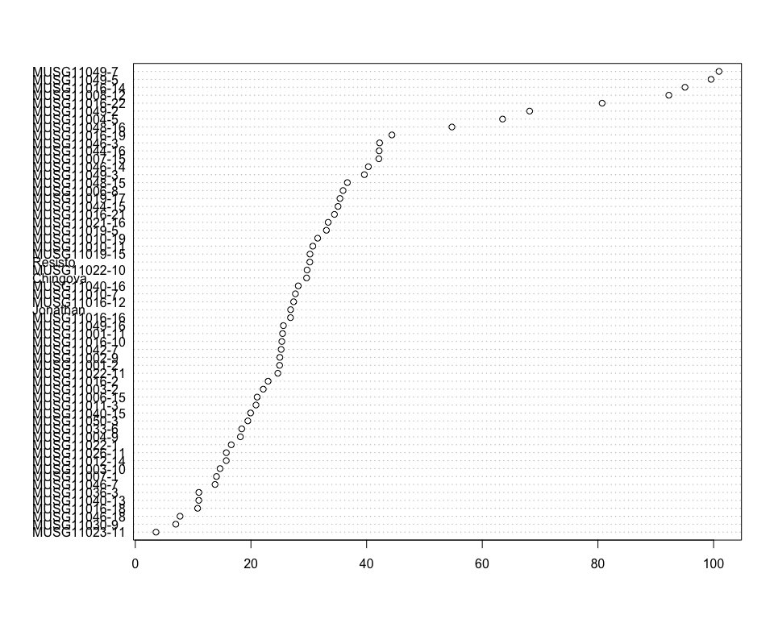

Do not forget the assumptions of the model. It is supposed that the error has a normal distribution with the same variance for all the treatments. The following plots must help you evaluate this:

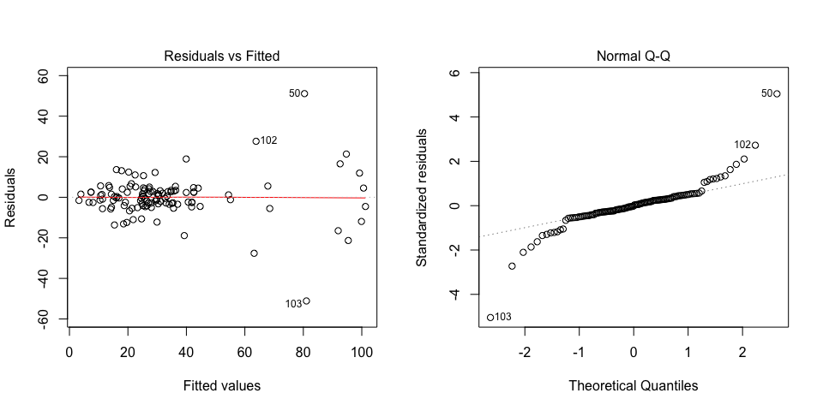

Funnel shapes for the first plot may suggest heterogeneity of variances while departures from the theoretical normal line are symptoms of lack of normality.

### Analysis of **Content of iron on dry weight basis measuring mg per 100g**

You have fitted a linear model for a RCBD. The ANOVA table for your model is:

|  |  |  |  |  |  |
| --- | --- | --- | --- | --- | --- |
|  | Df | Sum Sq | Mean Sq | F value | Pr(>F) |
| **germplasmName** | 58 | 4.3829 | 0.0755672 | 3.27774 | 5.96044e-06 |
| **REP** | 1 | 0.0783629 | 0.0783629 | 3.399 | 0.0703465 |
| **Residuals** | 58 | 1.33717 | 0.0230547 | NA | NA |

The p-value for treatments is 0.00000596044 which is significant at the 5% level.

The means of your treatments are:

|  |  |
| --- | --- |
| germplasmName | Content of iron on dry weight basis measuring mg per 100g |
| Chingova | 1.4 |
| Jonathan | 1.35 |
| MUSG11001-11 | 1.48 |
| MUSG11001-2 | 1.61 |
| MUSG11002-9 | 1.48 |
| MUSG11003-10 | 1.5 |
| MUSG11003-2 | 1.46 |
| MUSG11004-5 | 1.72 |
| MUSG11004-9 | 1.46 |
| MUSG11006-15 | 1.36 |
| MUSG11006-8 | 1.8 |
| MUSG11007-1 | 1.31 |
| MUSG11007-15 | 1.82 |
| MUSG11008-12 | 1.44 |
| MUSG11010-11 | 1.74 |
| MUSG11010-19 | 1.73 |
| MUSG11010-7 | 1.52 |
| MUSG11011-3 | 1.2 |
| MUSG11012-14 | 1.41 |
| MUSG11016-10 | 1.46 |
| MUSG11016-12 | 1.54 |
| MUSG11016-14 | 1.43 |
| MUSG11016-16 | 1.89 |
| MUSG11016-18 | 1.17 |
| MUSG11016-19 | 1.71 |
| MUSG11016-2 | 1.64 |
| MUSG11016-21 | 1.75 |
| MUSG11016-22 | 1.52 |
| MUSG11019-15 | 1.61 |
| MUSG11019-17 | 1.33 |
| MUSG11019-5 | 1.52 |
| MUSG11021-16 | 1.46 |
| MUSG11022-1 | 1.53 |
| MUSG11022-10 | 1.61 |
| MUSG11022-11 | 1.55 |
| MUSG11023-11 | 1.43 |
| MUSG11026-11 | 1.34 |
| MUSG11030-9 | 1.24 |
| MUSG11033-6 | 1.45 |
| MUSG11036-3 | 1.51 |
| MUSG11040-13 | 1.35 |
| MUSG11040-15 | 1.28 |
| MUSG11040-16 | 1.47 |
| MUSG11042-7 | 1.54 |
| MUSG11044-15 | 1.73 |
| MUSG11044-16 | 1.79 |
| MUSG11046-14 | 1.7 |
| MUSG11046-18 | 1.48 |
| MUSG11046-3 | 1.82 |
| MUSG11046-7 | 1.49 |
| MUSG11048-15 | 1.89 |
| MUSG11048-16 | 1.54 |
| MUSG11049-16 | 1.79 |
| MUSG11049-2 | 0.975 |
| MUSG11049-3 | 1.41 |
| MUSG11049-5 | 1.48 |
| MUSG11049-7 | 1.03 |
| MUSG11050-3 | 1.54 |
| Resisto | 1.55 |

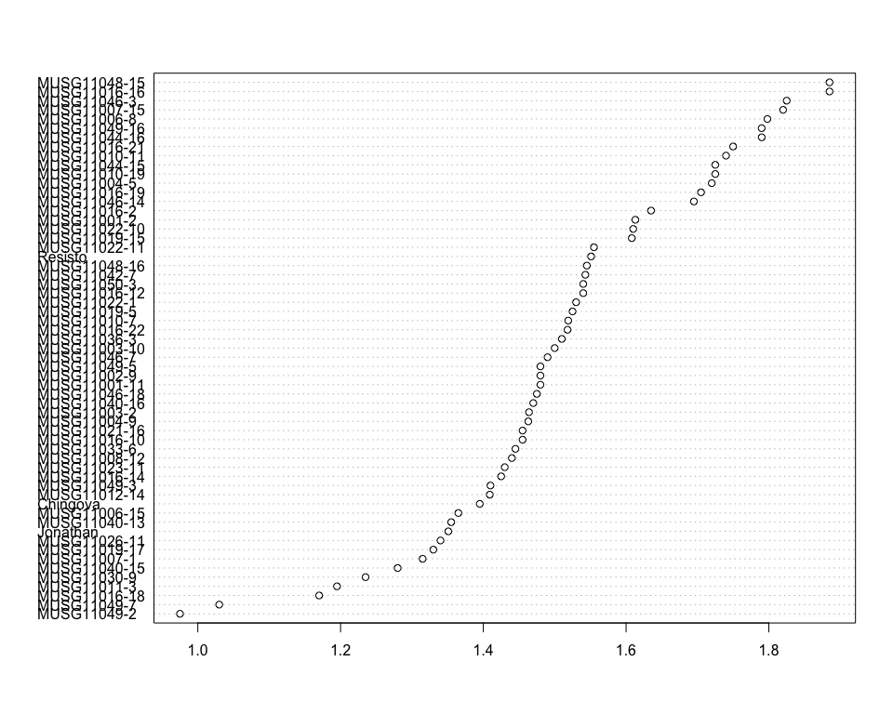

Do not forget the assumptions of the model. It is supposed that the error has a normal distribution with the same variance for all the treatments. The following plots must help you evaluate this:

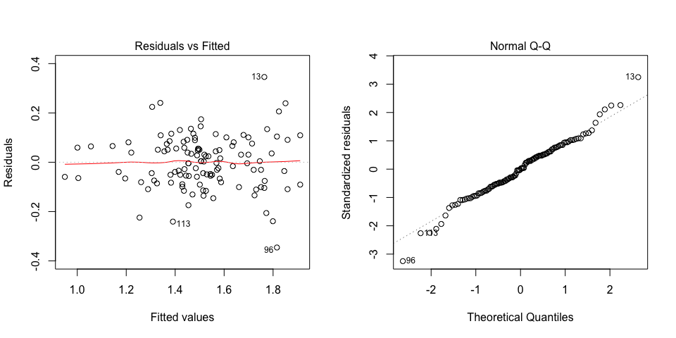

Funnel shapes for the first plot may suggest heterogeneity of variances while departures from the theoretical normal line are symptoms of lack of normality.

### Analysis of **Content of zinc on dry weight basis measuring mg per 100g**

You have fitted a linear model for a RCBD. The ANOVA table for your model is:

|  |  |  |  |  |  |
| --- | --- | --- | --- | --- | --- |
|  | Df | Sum Sq | Mean Sq | F value | Pr(>F) |
| **germplasmName** | 58 | 2.1953 | 0.03785 | 2.57385 | 0.000214798 |
| **REP** | 1 | 0.0734645 | 0.0734645 | 4.99569 | 0.0292761 |
| **Residuals** | 58 | 0.852924 | 0.0147056 | NA | NA |

The p-value for treatments is 0.000214798 which is significant at the 5% level.

The means of your treatments are:

|  |  |
| --- | --- |
| germplasmName | Content of zinc on dry weight basis measuring mg per 100g |
| Chingova | 0.825 |
| Jonathan | 0.758 |
| MUSG11001-11 | 0.795 |
| MUSG11001-2 | 0.867 |
| MUSG11002-9 | 0.905 |
| MUSG11003-10 | 0.965 |
| MUSG11003-2 | 0.827 |
| MUSG11004-5 | 1.03 |
| MUSG11004-9 | 0.885 |
| MUSG11006-15 | 0.5 |
| MUSG11006-8 | 1.09 |
| MUSG11007-1 | 0.775 |
| MUSG11007-15 | 1.03 |
| MUSG11008-12 | 0.57 |
| MUSG11010-11 | 0.93 |
| MUSG11010-19 | 0.925 |
| MUSG11010-7 | 0.932 |
| MUSG11011-3 | 0.78 |
| MUSG11012-14 | 0.821 |
| MUSG11016-10 | 0.925 |
| MUSG11016-12 | 1 |
| MUSG11016-14 | 0.9 |
| MUSG11016-16 | 1.23 |
| MUSG11016-18 | 0.82 |
| MUSG11016-19 | 0.98 |
| MUSG11016-2 | 0.92 |
| MUSG11016-21 | 1.03 |
| MUSG11016-22 | 0.906 |
| MUSG11019-15 | 0.977 |
| MUSG11019-17 | 0.73 |
| MUSG11019-5 | 0.925 |
| MUSG11021-16 | 0.88 |
| MUSG11022-1 | 0.93 |
| MUSG11022-10 | 0.71 |
| MUSG11022-11 | 0.84 |
| MUSG11023-11 | 0.925 |
| MUSG11026-11 | 0.865 |
| MUSG11030-9 | 0.74 |
| MUSG11033-6 | 0.845 |
| MUSG11036-3 | 0.84 |
| MUSG11040-13 | 0.67 |
| MUSG11040-15 | 0.832 |
| MUSG11040-16 | 0.775 |
| MUSG11042-7 | 0.918 |
| MUSG11044-15 | 1.09 |
| MUSG11044-16 | 0.975 |
| MUSG11046-14 | 0.975 |
| MUSG11046-18 | 0.9 |
| MUSG11046-3 | 1.01 |
| MUSG11046-7 | 0.905 |
| MUSG11048-15 | 0.875 |
| MUSG11048-16 | 0.77 |
| MUSG11049-16 | 1.17 |
| MUSG11049-2 | 0.665 |
| MUSG11049-3 | 0.72 |
| MUSG11049-5 | 0.7 |
| MUSG11049-7 | 0.595 |
| MUSG11050-3 | 0.745 |
| Resisto | 0.872 |

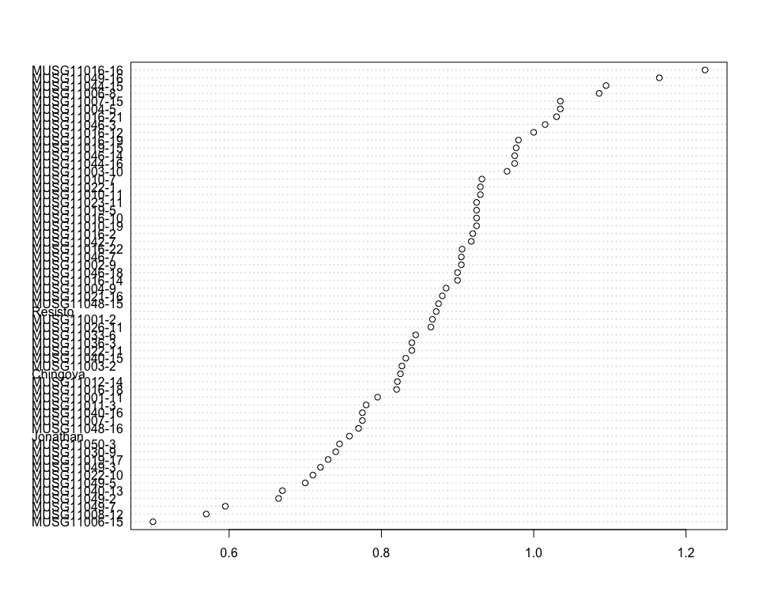

Do not forget the assumptions of the model. It is supposed that the error has a normal distribution with the same variance for all the treatments. The following plots must help you evaluate this:

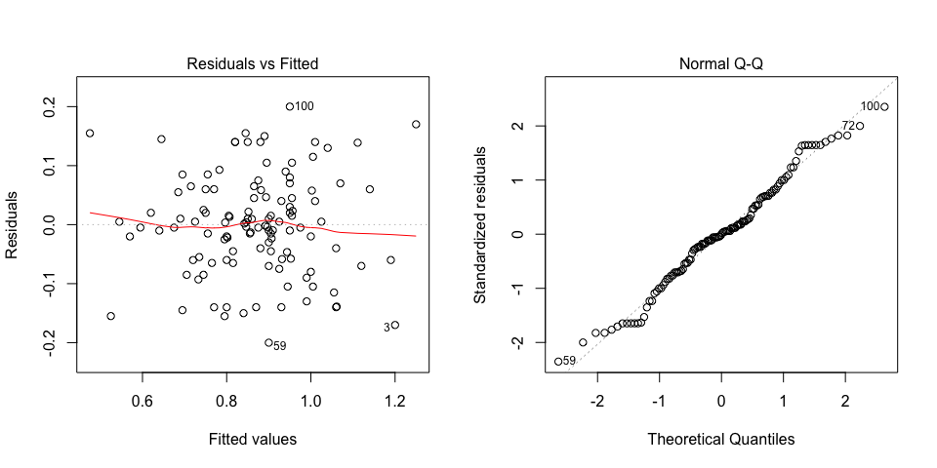

Funnel shapes for the first plot may suggest heterogeneity of variances while departures from the theoretical normal line are symptoms of lack of normality.

### Analysis of **Dry weight of storage root samples measuring g of sample**

You have fitted a linear model for a RCBD. The ANOVA table for your model is:

|  |  |  |  |  |  |
| --- | --- | --- | --- | --- | --- |
|  | Df | Sum Sq | Mean Sq | F value | Pr(>F) |
| **germplasmName** | 58 | 432.738 | 7.46099 | 5.76265 | 1.71204e-10 |
| **REP** | 1 | 0.26421 | 0.26421 | 0.204068 | 0.653142 |
| **Residuals** | 58 | 75.0934 | 1.29471 | NA | NA |

The p-value for treatments is 0.000000000171204 which is significant at the 5% level.

The means of your treatments are:

|  |  |
| --- | --- |
| germplasmName | Dry weight of storage root samples measuring g of sample |
| Chingova | 16.7 |
| Jonathan | 11.9 |
| MUSG11001-11 | 11.5 |
| MUSG11001-2 | 11.9 |
| MUSG11002-9 | 13.4 |
| MUSG11003-10 | 13.1 |
| MUSG11003-2 | 12.1 |
| MUSG11004-5 | 10.8 |
| MUSG11004-9 | 15.1 |
| MUSG11006-15 | 11.7 |
| MUSG11006-8 | 12.3 |
| MUSG11007-1 | 11.9 |
| MUSG11007-15 | 10.2 |
| MUSG11008-12 | 13.2 |
| MUSG11010-11 | 8.88 |
| MUSG11010-19 | 11.9 |
| MUSG11010-7 | 12 |
| MUSG11011-3 | 15.5 |
| MUSG11012-14 | 13.8 |
| MUSG11016-10 | 15.8 |
| MUSG11016-12 | 16.3 |
| MUSG11016-14 | 15.1 |
| MUSG11016-16 | 12.1 |
| MUSG11016-18 | 14.4 |
| MUSG11016-19 | 11.4 |
| MUSG11016-2 | 15.5 |
| MUSG11016-21 | 15 |
| MUSG11016-22 | 14.3 |
| MUSG11019-15 | 11.9 |
| MUSG11019-17 | 14.1 |
| MUSG11019-5 | 15.4 |
| MUSG11021-16 | 11.2 |
| MUSG11022-1 | 13.3 |
| MUSG11022-10 | 11.6 |
| MUSG11022-11 | 11.3 |
| MUSG11023-11 | 14.2 |
| MUSG11026-11 | 16.3 |
| MUSG11030-9 | 16.1 |
| MUSG11033-6 | 12.7 |
| MUSG11036-3 | 8.83 |
| MUSG11040-13 | 13.1 |
| MUSG11040-15 | 13.1 |
| MUSG11040-16 | 13.1 |
| MUSG11042-7 | 12.7 |
| MUSG11044-15 | 12.2 |
| MUSG11044-16 | 12.7 |
| MUSG11046-14 | 11.9 |
| MUSG11046-18 | 12.5 |
| MUSG11046-3 | 9.76 |
| MUSG11046-7 | 12.6 |
| MUSG11048-15 | 8.58 |
| MUSG11048-16 | 12.1 |
| MUSG11049-16 | 15.4 |
| MUSG11049-2 | 14.7 |
| MUSG11049-3 | 10.3 |
| MUSG11049-5 | 12.5 |
| MUSG11049-7 | 10.7 |
| MUSG11050-3 | 13.8 |
| Resisto | 12.4 |

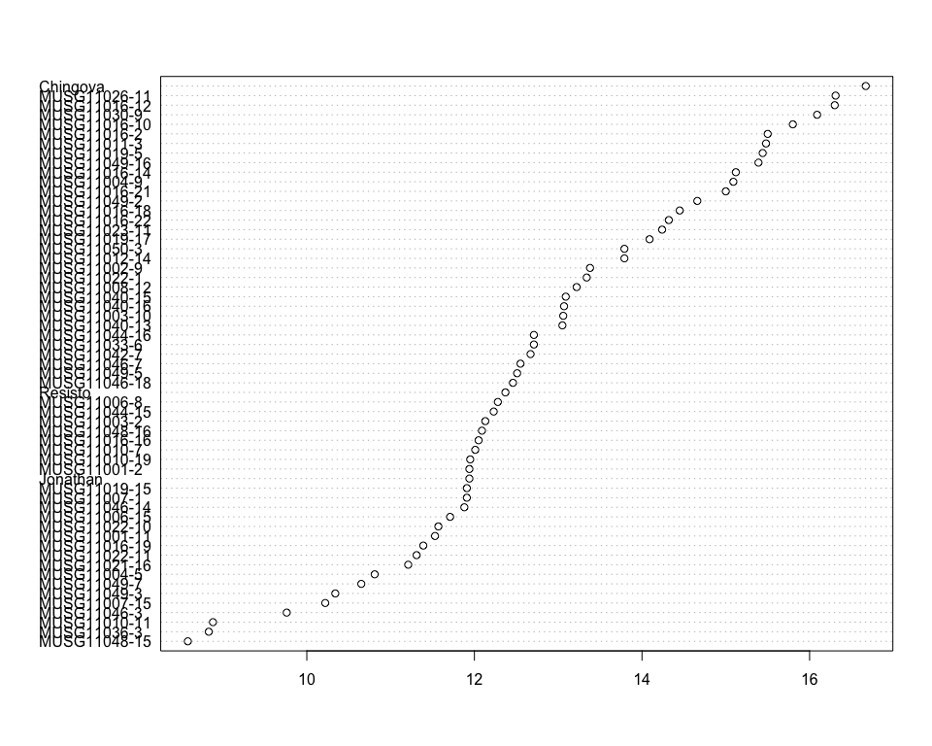

Do not forget the assumptions of the model. It is supposed that the error has a normal distribution with the same variance for all the treatments. The following plots must help you evaluate this:

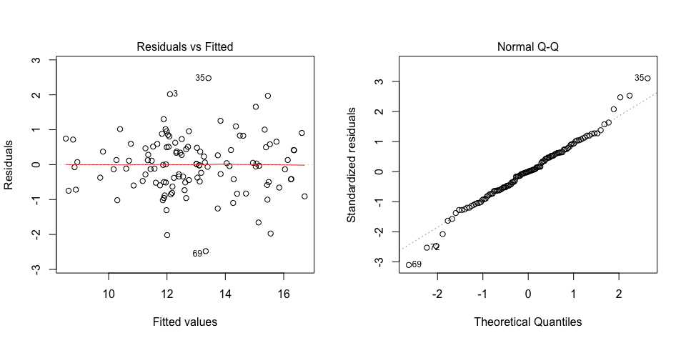

Funnel shapes for the first plot may suggest heterogeneity of variances while departures from the theoretical normal line are symptoms of lack of normality.

### Analysis of **Fibers in cooked samples 1 estimating 1-9**

You have fitted a linear model for a RCBD. The ANOVA table for your model is:

|  |  |  |  |  |  |
| --- | --- | --- | --- | --- | --- |
|  | Df | Sum Sq | Mean Sq | F value | Pr(>F) |
| **germplasmName** | 58 | 45.0508 | 0.776739 | 1.33702 | 0.135817 |
| **REP** | 1 | 0.305085 | 0.305085 | 0.525151 | 0.471566 |
| **Residuals** | 58 | 33.6949 | 0.580947 | NA | NA |

The means of your treatments are:

|  |  |
| --- | --- |
| germplasmName | Fibers in cooked samples 1 estimating 1-9 |
| Chingova | 2 |
| Jonathan | 1.5 |
| MUSG11001-11 | 2 |
| MUSG11001-2 | 2 |
| MUSG11002-9 | 2 |
| MUSG11003-10 | 2 |
| MUSG11003-2 | 2 |
| MUSG11004-5 | 2 |
| MUSG11004-9 | 2 |
| MUSG11006-15 | 2 |
| MUSG11006-8 | 2 |
| MUSG11007-1 | 4 |
| MUSG11007-15 | 2 |
| MUSG11008-12 | 3.5 |
| MUSG11010-11 | 2 |
| MUSG11010-19 | 2 |
| MUSG11010-7 | 2 |
| MUSG11011-3 | 3 |
| MUSG11012-14 | 2 |
| MUSG11016-10 | 3 |
| MUSG11016-12 | 3 |
| MUSG11016-14 | 3 |
| MUSG11016-16 | 4 |
| MUSG11016-18 | 4 |
| MUSG11016-19 | 2 |
| MUSG11016-2 | 3 |
| MUSG11016-21 | 2.5 |
| MUSG11016-22 | 3 |
| MUSG11019-15 | 2 |
| MUSG11019-17 | 2 |
| MUSG11019-5 | 2 |
| MUSG11021-16 | 2 |
| MUSG11022-1 | 2 |
| MUSG11022-10 | 2 |
| MUSG11022-11 | 3 |
| MUSG11023-11 | 2 |
| MUSG11026-11 | 3 |
| MUSG11030-9 | 3 |
| MUSG11033-6 | 3 |
| MUSG11036-3 | 3 |
| MUSG11040-13 | 2 |
| MUSG11040-15 | 2 |
| MUSG11040-16 | 2 |
| MUSG11042-7 | 2 |
| MUSG11044-15 | 2 |
| MUSG11044-16 | 2 |
| MUSG11046-14 | 2 |
| MUSG11046-18 | 2.5 |
| MUSG11046-3 | 2 |
| MUSG11046-7 | 3 |
| MUSG11048-15 | 2 |
| MUSG11048-16 | 2 |
| MUSG11049-16 | 3 |
| MUSG11049-2 | 2 |
| MUSG11049-3 | 2 |
| MUSG11049-5 | 2 |
| MUSG11049-7 | 3 |
| MUSG11050-3 | 2 |
| Resisto | 1 |

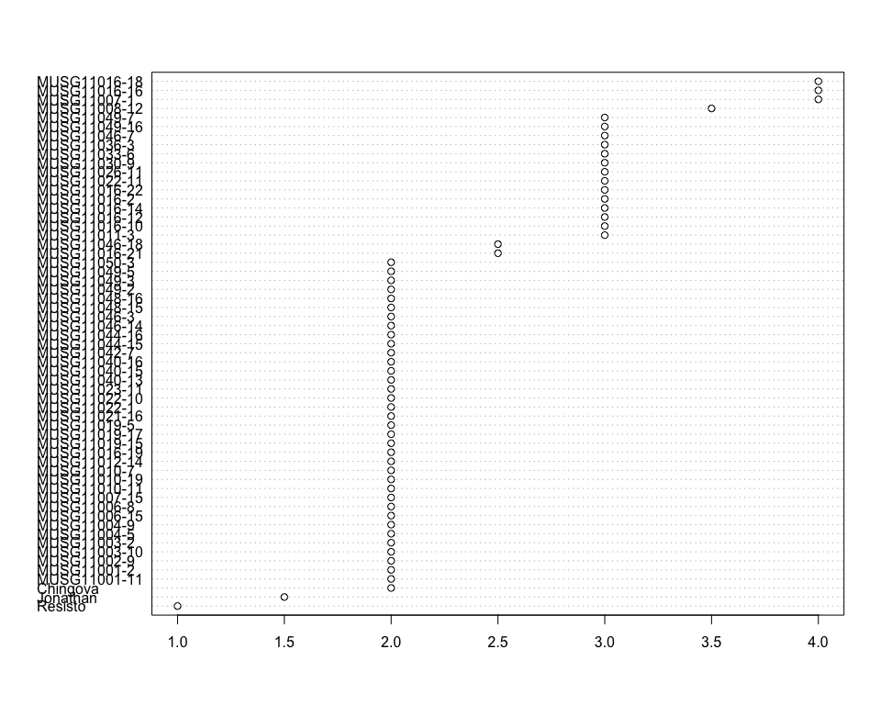

Do not forget the assumptions of the model. It is supposed that the error has a normal distribution with the same variance for all the treatments. The following plots must help you evaluate this:

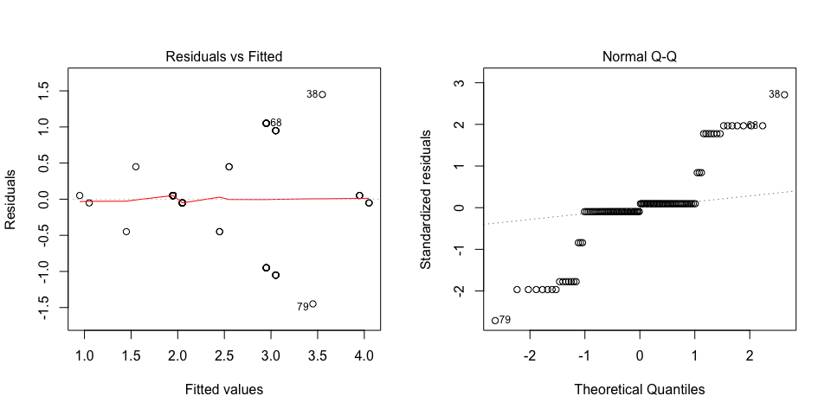

Funnel shapes for the first plot may suggest heterogeneity of variances while departures from the theoretical normal line are symptoms of lack of normality.

### Analysis of **Fresh weight of storage root samples measuring g of sample**

You have fitted a linear model for a RCBD. The ANOVA table for your model is:

|  |  |  |  |  |  |
| --- | --- | --- | --- | --- | --- |
|  | Df | Sum Sq | Mean Sq | F value | Pr(>F) |
| **germplasmName** | 58 | 368.96 | 6.36138 | 1.45841 | 0.0768594 |
| **REP** | 1 | 3.86399 | 3.86399 | 0.885857 | 0.350506 |
| **Residuals** | 58 | 252.988 | 4.36186 | NA | NA |

The means of your treatments are:

|  |  |
| --- | --- |
| germplasmName | Fresh weight of storage root samples measuring g of sample |
| Chingova | 50.8 |
| Jonathan | 50 |
| MUSG11001-11 | 50.8 |
| MUSG11001-2 | 50.4 |
| MUSG11002-9 | 50.1 |
| MUSG11003-10 | 50.8 |
| MUSG11003-2 | 50.2 |
| MUSG11004-5 | 48.5 |
| MUSG11004-9 | 50.2 |
| MUSG11006-15 | 50.6 |
| MUSG11006-8 | 50 |
| MUSG11007-1 | 50.4 |
| MUSG11007-15 | 50.5 |
| MUSG11008-12 | 50.4 |
| MUSG11010-11 | 50.4 |
| MUSG11010-19 | 50.3 |
| MUSG11010-7 | 50.2 |
| MUSG11011-3 | 50.4 |
| MUSG11012-14 | 50.3 |
| MUSG11016-10 | 50.4 |
| MUSG11016-12 | 50.6 |
| MUSG11016-14 | 50.7 |
| MUSG11016-16 | 42 |
| MUSG11016-18 | 48.8 |
| MUSG11016-19 | 50.3 |
| MUSG11016-2 | 50.7 |
| MUSG11016-21 | 50.3 |
| MUSG11016-22 | 50.6 |
| MUSG11019-15 | 50.3 |
| MUSG11019-17 | 50.5 |
| MUSG11019-5 | 50.4 |
| MUSG11021-16 | 50.5 |
| MUSG11022-1 | 50.5 |
| MUSG11022-10 | 50.2 |
| MUSG11022-11 | 46 |
| MUSG11023-11 | 50.4 |
| MUSG11026-11 | 50.5 |
| MUSG11030-9 | 50.5 |
| MUSG11033-6 | 50.7 |
| MUSG11036-3 | 41.6 |
| MUSG11040-13 | 50.4 |
| MUSG11040-15 | 50.1 |
| MUSG11040-16 | 50.3 |
| MUSG11042-7 | 49.9 |
| MUSG11044-15 | 50.8 |
| MUSG11044-16 | 50.6 |
| MUSG11046-14 | 50.4 |
| MUSG11046-18 | 50.6 |
| MUSG11046-3 | 50.8 |
| MUSG11046-7 | 50.1 |
| MUSG11048-15 | 46.3 |
| MUSG11048-16 | 47.6 |
| MUSG11049-16 | 50.3 |
| MUSG11049-2 | 50.3 |
| MUSG11049-3 | 50.9 |
| MUSG11049-5 | 50.9 |
| MUSG11049-7 | 50.4 |
| MUSG11050-3 | 50.3 |
| Resisto | 49.7 |

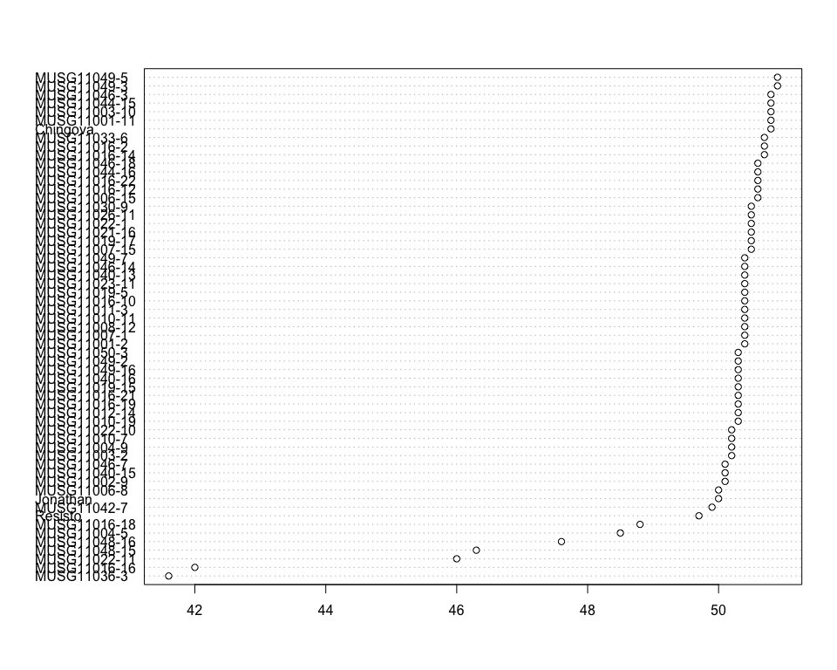

Do not forget the assumptions of the model. It is supposed that the error has a normal distribution with the same variance for all the treatments. The following plots must help you evaluate this:

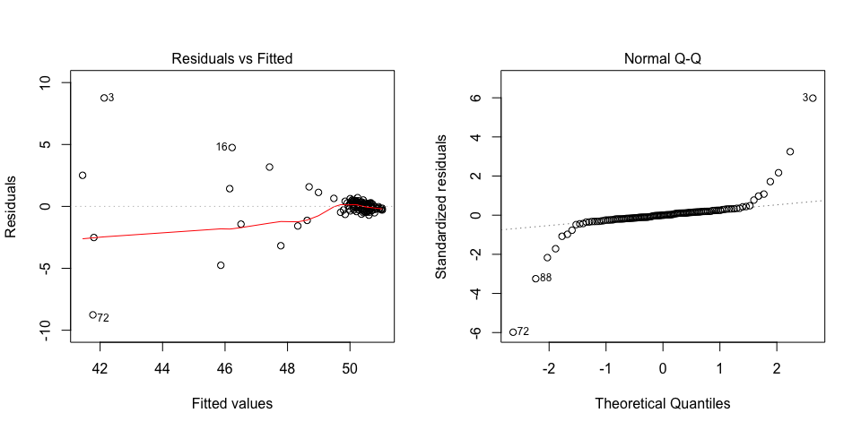

Funnel shapes for the first plot may suggest heterogeneity of variances while departures from the theoretical normal line are symptoms of lack of normality.

### Analysis of **Fructose content measuring percent**

You have fitted a linear model for a RCBD. The ANOVA table for your model is:

|  |  |  |  |  |  |
| --- | --- | --- | --- | --- | --- |
|  | Df | Sum Sq | Mean Sq | F value | Pr(>F) |
| **germplasmName** | 58 | 908.583 | 15.6652 | 4.24222 | 6.9669e-08 |
| **REP** | 1 | 14.5157 | 14.5157 | 3.93091 | 0.0521495 |
| **Residuals** | 58 | 214.176 | 3.69269 | NA | NA |

The p-value for treatments is 0.000000069669 which is significant at the 5% level.

The means of your treatments are:

|  |  |
| --- | --- |
| germplasmName | Fructose content measuring percent |
| Chingova | 5.6 |
| Jonathan | 9.98 |
| MUSG11001-11 | 10.5 |
| MUSG11001-2 | 10.1 |
| MUSG11002-9 | 6.75 |
| MUSG11003-10 | 5.85 |
| MUSG11003-2 | 8.32 |
| MUSG11004-5 | 7.8 |
| MUSG11004-9 | 5.39 |
| MUSG11006-15 | 13.4 |
| MUSG11006-8 | 8.54 |
| MUSG11007-1 | 7.85 |
| MUSG11007-15 | 9.4 |
| MUSG11008-12 | 13.2 |
| MUSG11010-11 | 17.1 |
| MUSG11010-19 | 12.1 |
| MUSG11010-7 | 6.27 |
| MUSG11011-3 | 6.75 |
| MUSG11012-14 | 8.62 |
| MUSG11016-10 | 4.35 |
| MUSG11016-12 | 4.8 |
| MUSG11016-14 | 5.5 |
| MUSG11016-16 | 5.3 |
| MUSG11016-18 | 7.45 |
| MUSG11016-19 | 6.8 |
| MUSG11016-2 | 8.65 |
| MUSG11016-21 | 5.15 |
| MUSG11016-22 | 6.71 |
| MUSG11019-15 | 8.73 |
| MUSG11019-17 | 6.75 |
| MUSG11019-5 | 8.75 |
| MUSG11021-16 | 10.7 |
| MUSG11022-1 | 9.5 |
| MUSG11022-10 | 14.7 |
| MUSG11022-11 | 9.65 |
| MUSG11023-11 | 6.5 |
| MUSG11026-11 | 5 |
| MUSG11030-9 | 7.4 |
| MUSG11033-6 | 11 |
| MUSG11036-3 | 10.4 |
| MUSG11040-13 | 9.5 |
| MUSG11040-15 | 7.47 |
| MUSG11040-16 | 7.7 |
| MUSG11042-7 | 8.44 |
| MUSG11044-15 | 7.65 |
| MUSG11044-16 | 7.45 |
| MUSG11046-14 | 8.3 |
| MUSG11046-18 | 6.8 |
| MUSG11046-3 | 11.1 |
| MUSG11046-7 | 5.85 |
| MUSG11048-15 | 14.9 |
| MUSG11048-16 | 10.7 |
| MUSG11049-16 | 3.95 |
| MUSG11049-2 | 7.4 |
| MUSG11049-3 | 10.6 |
| MUSG11049-5 | 13.2 |
| MUSG11049-7 | 12.3 |
| MUSG11050-3 | 9.55 |
| Resisto | 8.92 |

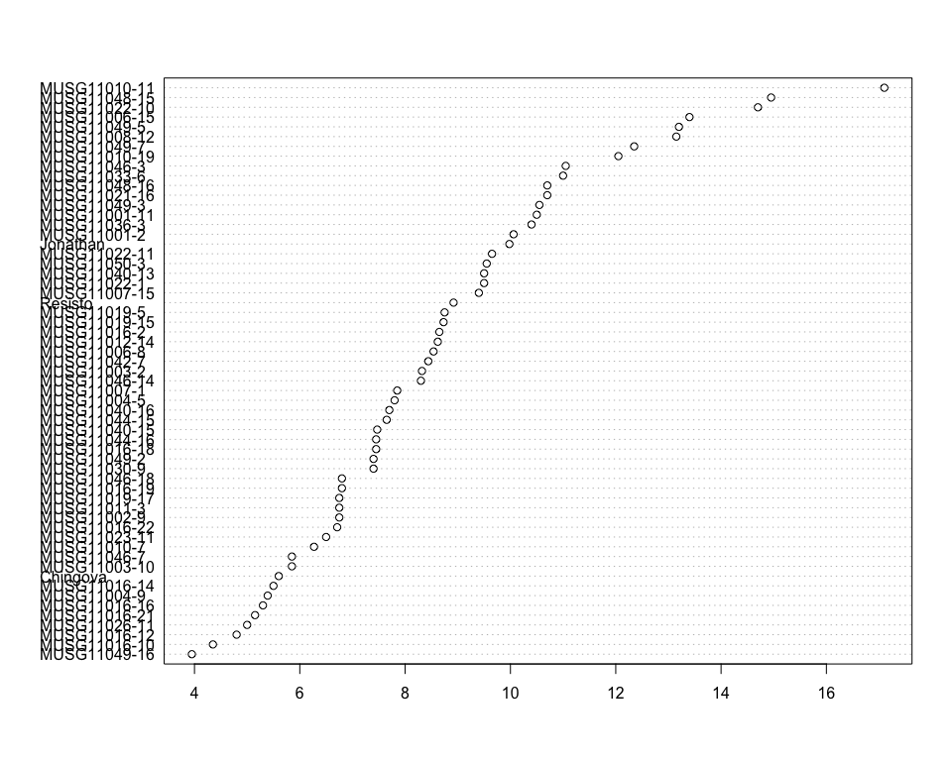

Do not forget the assumptions of the model. It is supposed that the error has a normal distribution with the same variance for all the treatments. The following plots must help you evaluate this:

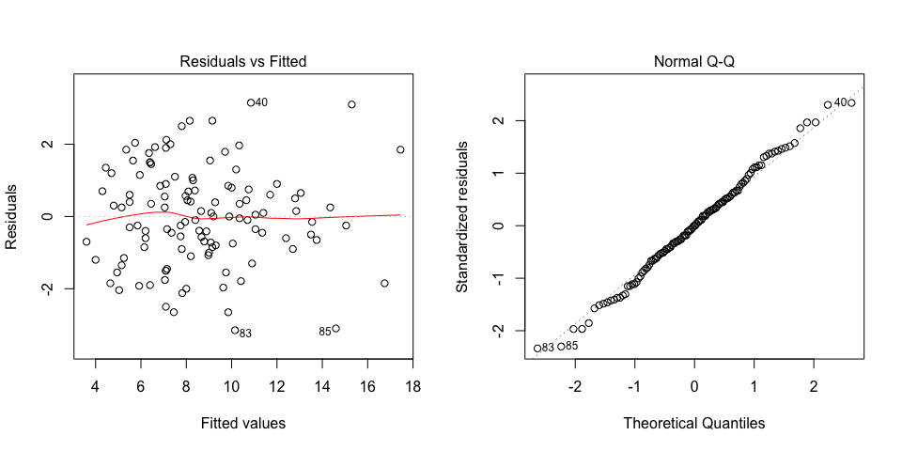

Funnel shapes for the first plot may suggest heterogeneity of variances while departures from the theoretical normal line are symptoms of lack of normality.

### Analysis of **Glucose content measuring percent**

You have fitted a linear model for a RCBD. The ANOVA table for your model is:

|  |  |  |  |  |  |
| --- | --- | --- | --- | --- | --- |
|  | Df | Sum Sq | Mean Sq | F value | Pr(>F) |
| **germplasmName** | 58 | 1622.27 | 27.9702 | 4.15239 | 1.03084e-07 |
| **REP** | 1 | 26.7967 | 26.7967 | 3.97817 | 0.0508006 |
| **Residuals** | 58 | 390.683 | 6.73592 | NA | NA |

The p-value for treatments is 0.000000103084 which is significant at the 5% level.

The means of your treatments are:

|  |  |
| --- | --- |
| germplasmName | Glucose content measuring percent |
| Chingova | 8.15 |
| Jonathan | 13.7 |
| MUSG11001-11 | 14.8 |
| MUSG11001-2 | 13.6 |
| MUSG11002-9 | 9.35 |
| MUSG11003-10 | 8 |
| MUSG11003-2 | 11.2 |
| MUSG11004-5 | 11 |
| MUSG11004-9 | 7.63 |
| MUSG11006-15 | 17.9 |
| MUSG11006-8 | 12.2 |
| MUSG11007-1 | 10.4 |
| MUSG11007-15 | 12.8 |
| MUSG11008-12 | 17.9 |
| MUSG11010-11 | 23.4 |
| MUSG11010-19 | 16.6 |
| MUSG11010-7 | 8.73 |
| MUSG11011-3 | 9.35 |
| MUSG11012-14 | 12 |
| MUSG11016-10 | 6.1 |
| MUSG11016-12 | 6.95 |
| MUSG11016-14 | 7.5 |
| MUSG11016-16 | 8.25 |
| MUSG11016-18 | 10.4 |
| MUSG11016-19 | 9.3 |
| MUSG11016-2 | 12.4 |
| MUSG11016-21 | 7.3 |
| MUSG11016-22 | 9.45 |
| MUSG11019-15 | 11.9 |
| MUSG11019-17 | 9.3 |
| MUSG11019-5 | 11.9 |
| MUSG11021-16 | 15.1 |
| MUSG11022-1 | 13.3 |
| MUSG11022-10 | 20.2 |
| MUSG11022-11 | 13.2 |
| MUSG11023-11 | 9.4 |
| MUSG11026-11 | 7.15 |
| MUSG11030-9 | 10.4 |
| MUSG11033-6 | 15.2 |
| MUSG11036-3 | 13.7 |
| MUSG11040-13 | 12.9 |
| MUSG11040-15 | 10.3 |
| MUSG11040-16 | 10.7 |
| MUSG11042-7 | 11.4 |
| MUSG11044-15 | 10.8 |
| MUSG11044-16 | 10.2 |
| MUSG11046-14 | 11.7 |
| MUSG11046-18 | 9.2 |
| MUSG11046-3 | 15.3 |
| MUSG11046-7 | 8.3 |
| MUSG11048-15 | 20.4 |
| MUSG11048-16 | 14.2 |
| MUSG11049-16 | 5.75 |
| MUSG11049-2 | 10.1 |
| MUSG11049-3 | 14.2 |
| MUSG11049-5 | 18.4 |
| MUSG11049-7 | 16.8 |
| MUSG11050-3 | 13.1 |
| Resisto | 12.2 |

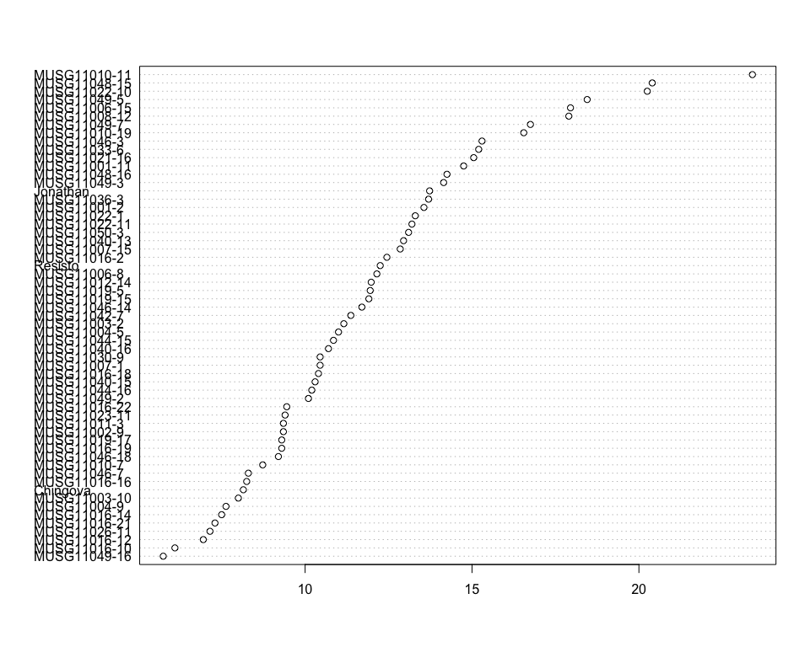

Do not forget the assumptions of the model. It is supposed that the error has a normal distribution with the same variance for all the treatments. The following plots must help you evaluate this:

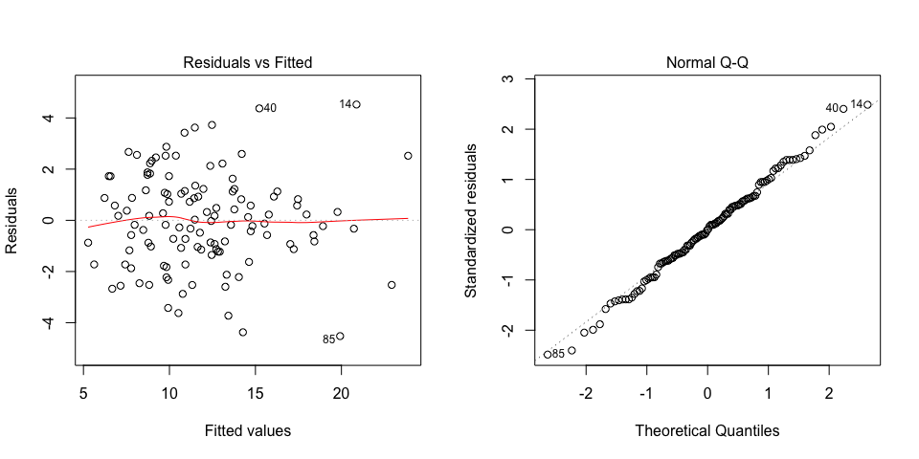

Funnel shapes for the first plot may suggest heterogeneity of variances while departures from the theoretical normal line are symptoms of lack of normality.

### Analysis of **Harvest index computing percent**

You have fitted a linear model for a RCBD. The ANOVA table for your model is:

|  |  |  |  |  |  |
| --- | --- | --- | --- | --- | --- |
|  | Df | Sum Sq | Mean Sq | F value | Pr(>F) |
| **germplasmName** | 58 | 25905 | 446.638 | 2.9918 | 2.47498e-05 |
| **REP** | 1 | 181.582 | 181.582 | 1.21633 | 0.274638 |
| **Residuals** | 58 | 8658.66 | 149.287 | NA | NA |

The p-value for treatments is 0.0000247498 which is significant at the 5% level.

The means of your treatments are:

|  |  |
| --- | --- |
| germplasmName | Harvest index computing percent |
| Chingova | 40 |
| Jonathan | 29 |
| MUSG11001-11 | 44.8 |
| MUSG11001-2 | 90.8 |
| MUSG11002-9 | 68.8 |
| MUSG11003-10 | 52.1 |
| MUSG11003-2 | 73.3 |
| MUSG11004-5 | 60.3 |
| MUSG11004-9 | 66.5 |
| MUSG11006-15 | 62.4 |
| MUSG11006-8 | 19.2 |
| MUSG11007-1 | 63 |
| MUSG11007-15 | 55 |
| MUSG11008-12 | 61 |
| MUSG11010-11 | 42.8 |
| MUSG11010-19 | 44.5 |
| MUSG11010-7 | 46.1 |
| MUSG11011-3 | 40.7 |
| MUSG11012-14 | 48.8 |
| MUSG11016-10 | 47 |
| MUSG11016-12 | 49.5 |
| MUSG11016-14 | 42.9 |
| MUSG11016-16 | 66.6 |
| MUSG11016-18 | 50 |
| MUSG11016-19 | 34.5 |
| MUSG11016-2 | 68.8 |
| MUSG11016-21 | 82.3 |
| MUSG11016-22 | 84.8 |
| MUSG11019-15 | 38.5 |
| MUSG11019-17 | 33.8 |
| MUSG11019-5 | 37.9 |
| MUSG11021-16 | 57.3 |
| MUSG11022-1 | 71.2 |
| MUSG11022-10 | 79.7 |
| MUSG11022-11 | 38.3 |
| MUSG11023-11 | 52.7 |
| MUSG11026-11 | 67.1 |
| MUSG11030-9 | 56 |
| MUSG11033-6 | 64.2 |
| MUSG11036-3 | 55.5 |
| MUSG11040-13 | 40.8 |
| MUSG11040-15 | 24.4 |
| MUSG11040-16 | 51 |
| MUSG11042-7 | 42.5 |
| MUSG11044-15 | 31.4 |
| MUSG11044-16 | 44 |
| MUSG11046-14 | 30.4 |
| MUSG11046-18 | 64.5 |
| MUSG11046-3 | 59 |
| MUSG11046-7 | 52.9 |
| MUSG11048-15 | 40.5 |
| MUSG11048-16 | 45.5 |
| MUSG11049-16 | 38.5 |
| MUSG11049-2 | 54.3 |
| MUSG11049-3 | 57.8 |
| MUSG11049-5 | 53.8 |
| MUSG11049-7 | 51.3 |
| MUSG11050-3 | 61.3 |
| Resisto | 52.6 |

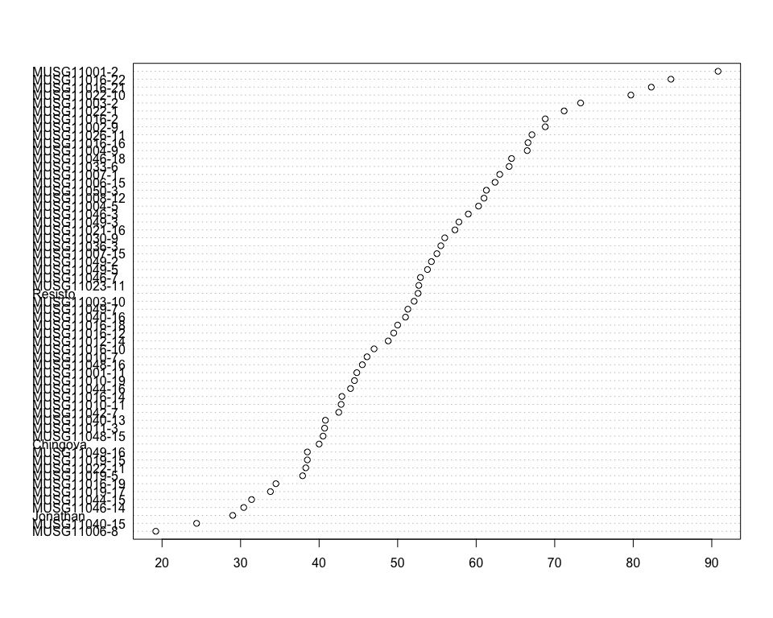

Do not forget the assumptions of the model. It is supposed that the error has a normal distribution with the same variance for all the treatments. The following plots must help you evaluate this:

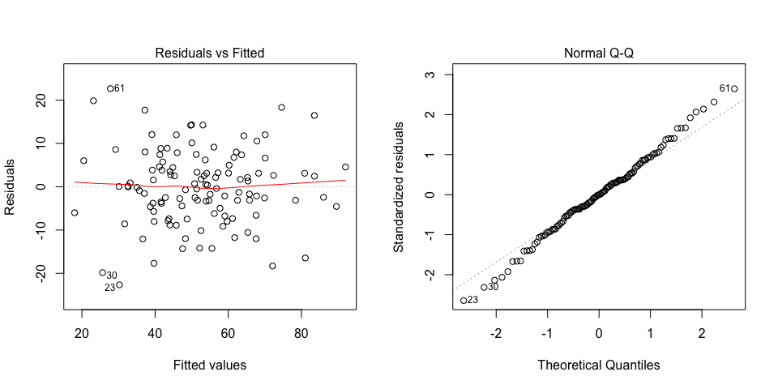

Funnel shapes for the first plot may suggest heterogeneity of variances while departures from the theoretical normal line are symptoms of lack of normality.

### Analysis of **Number of commercial storage roots counting number per plot**

You have fitted a linear model for a RCBD. The ANOVA table for your model is:

|  |  |  |  |  |  |
| --- | --- | --- | --- | --- | --- |
|  | Df | Sum Sq | Mean Sq | F value | Pr(>F) |
| **germplasmName** | 58 | 38466.5 | 663.216 | 3.35416 | 4.10706e-06 |
| **REP** | 1 | 7515.33 | 7515.33 | 38.0082 | 7.27123e-08 |
| **Residuals** | 58 | 11468.3 | 197.729 | NA | NA |

The p-value for treatments is 0.00000410706 which is significant at the 5% level.

The means of your treatments are:

|  |  |
| --- | --- |
| germplasmName | Number of commercial storage roots counting number per plot |
| Chingova | 6.5 |
| Jonathan | 28.3 |
| MUSG11001-11 | 26 |
| MUSG11001-2 | 23.5 |
| MUSG11002-9 | 39.5 |
| MUSG11003-10 | 56 |
| MUSG11003-2 | 20 |
| MUSG11004-5 | 102 |
| MUSG11004-9 | 5.5 |
| MUSG11006-15 | 26 |
| MUSG11006-8 | 4 |
| MUSG11007-1 | 8 |
| MUSG11007-15 | 38 |
| MUSG11008-12 | 16.5 |
| MUSG11010-11 | 34 |
| MUSG11010-19 | 51.5 |
| MUSG11010-7 | 15.5 |
| MUSG11011-3 | 21 |
| MUSG11012-14 | 15.5 |
| MUSG11016-10 | 32.5 |
| MUSG11016-12 | 60.5 |
| MUSG11016-14 | 43 |
| MUSG11016-16 | 40 |
| MUSG11016-18 | 48.5 |
| MUSG11016-19 | 49.5 |
| MUSG11016-2 | 53.5 |
| MUSG11016-21 | 35.5 |
| MUSG11016-22 | 37 |
| MUSG11019-15 | 24 |
| MUSG11019-17 | 25 |
| MUSG11019-5 | 14 |
| MUSG11021-16 | 37 |
| MUSG11022-1 | 35.5 |
| MUSG11022-10 | 41.5 |
| MUSG11022-11 | 37.5 |
| MUSG11023-11 | 63.5 |
| MUSG11026-11 | 24 |
| MUSG11030-9 | 26 |
| MUSG11033-6 | 41 |
| MUSG11036-3 | 35.5 |
| MUSG11040-13 | 35 |
| MUSG11040-15 | 25.5 |
| MUSG11040-16 | 47.5 |
| MUSG11042-7 | 12.5 |
| MUSG11044-15 | 39 |
| MUSG11044-16 | 10.5 |
| MUSG11046-14 | 28 |
| MUSG11046-18 | 39.5 |
| MUSG11046-3 | 49 |
| MUSG11046-7 | 70.5 |
| MUSG11048-15 | 24.5 |
| MUSG11048-16 | 18 |
| MUSG11049-16 | 22.5 |
| MUSG11049-2 | 39.5 |
| MUSG11049-3 | 61 |
| MUSG11049-5 | 46 |
| MUSG11049-7 | 64 |
| MUSG11050-3 | 53 |
| Resisto | 25.8 |

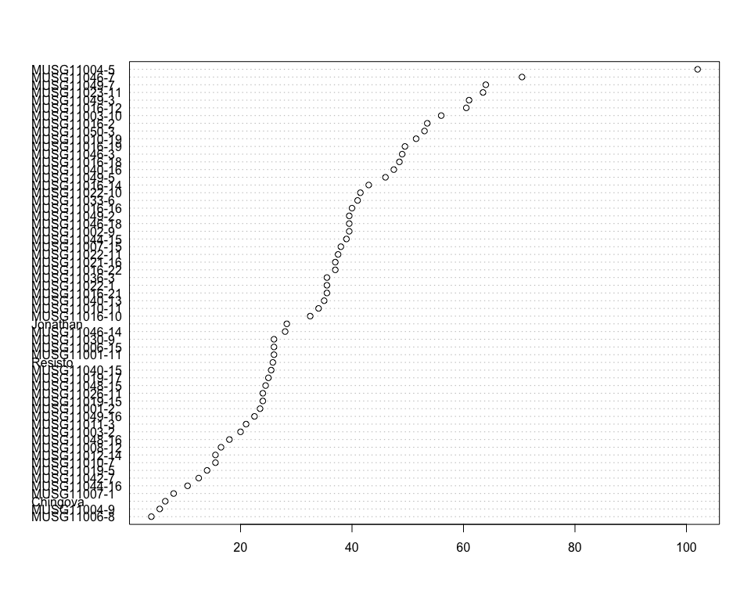

Do not forget the assumptions of the model. It is supposed that the error has a normal distribution with the same variance for all the treatments. The following plots must help you evaluate this:

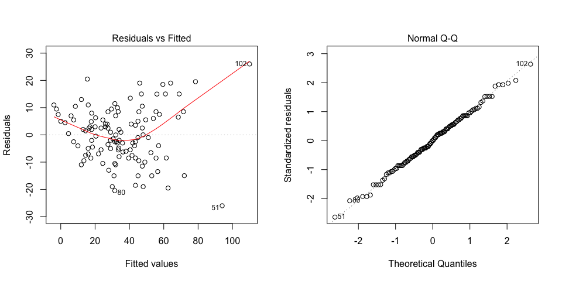

Funnel shapes for the first plot may suggest heterogeneity of variances while departures from the theoretical normal line are symptoms of lack of normality.

### Analysis of **Number of non-commercial storage roots counting number per plot**

You have fitted a linear model for a RCBD. The ANOVA table for your model is:

|  |  |  |  |  |  |
| --- | --- | --- | --- | --- | --- |
|  | Df | Sum Sq | Mean Sq | F value | Pr(>F) |
| **germplasmName** | 58 | 36485 | 629.052 | 2.74525 | 8.76174e-05 |
| **REP** | 1 | 1996 | 1996 | 8.71078 | 0.00455861 |
| **Residuals** | 58 | 13290.2 | 229.142 | NA | NA |

The p-value for treatments is 0.0000876174 which is significant at the 5% level.

The means of your treatments are:

|  |  |
| --- | --- |
| germplasmName | Number of non-commercial storage roots counting number per plot |
| Chingova | 6 |
| Jonathan | 13.1 |
| MUSG11001-11 | 61.5 |
| MUSG11001-2 | 24.5 |
| MUSG11002-9 | 24 |
| MUSG11003-10 | 22 |
| MUSG11003-2 | 14 |
| MUSG11004-5 | 67.5 |
| MUSG11004-9 | 12 |
| MUSG11006-15 | 41.5 |
| MUSG11006-8 | 23.5 |
| MUSG11007-1 | 17 |
| MUSG11007-15 | 23.5 |
| MUSG11008-12 | 15 |
| MUSG11010-11 | 28 |
| MUSG11010-19 | 57.5 |
| MUSG11010-7 | 31.5 |
| MUSG11011-3 | 23.5 |
| MUSG11012-14 | 25 |
| MUSG11016-10 | 13.5 |
| MUSG11016-12 | 54 |
| MUSG11016-14 | 19 |
| MUSG11016-16 | 51 |
| MUSG11016-18 | 28 |
| MUSG11016-19 | 30 |
| MUSG11016-2 | 45.5 |
| MUSG11016-21 | 32.5 |
| MUSG11016-22 | 33.5 |
| MUSG11019-15 | 15.5 |
| MUSG11019-17 | 46 |
| MUSG11019-5 | 10 |
| MUSG11021-16 | 46 |
| MUSG11022-1 | 15 |
| MUSG11022-10 | 57.5 |
| MUSG11022-11 | 28.5 |
| MUSG11023-11 | 76 |
| MUSG11026-11 | 17.5 |
| MUSG11030-9 | 28.5 |
| MUSG11033-6 | 49 |
| MUSG11036-3 | 24.5 |
| MUSG11040-13 | 29 |
| MUSG11040-15 | 20 |
| MUSG11040-16 | 32 |
| MUSG11042-7 | 9 |
| MUSG11044-15 | 28.5 |
| MUSG11044-16 | 15.5 |
| MUSG11046-14 | 17 |
| MUSG11046-18 | 28.5 |
| MUSG11046-3 | 66.5 |
| MUSG11046-7 | 69 |
| MUSG11048-15 | 60 |
| MUSG11048-16 | 23 |
| MUSG11049-16 | 27.5 |
| MUSG11049-2 | 15.4 |
| MUSG11049-3 | 35.5 |
| MUSG11049-5 | 61.5 |
| MUSG11049-7 | 44 |
| MUSG11050-3 | 51 |
| Resisto | 20.8 |

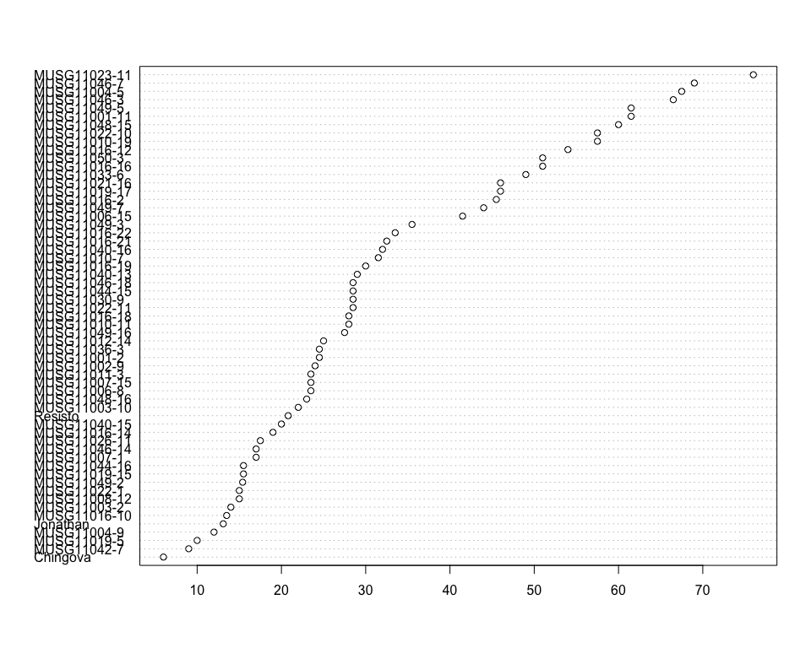

Do not forget the assumptions of the model. It is supposed that the error has a normal distribution with the same variance for all the treatments. The following plots must help you evaluate this:

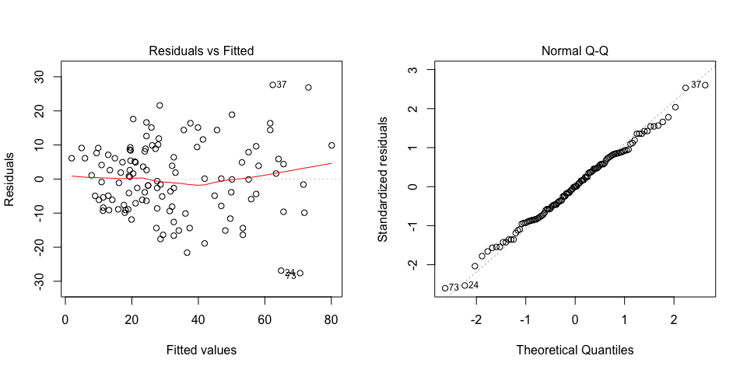

Funnel shapes for the first plot may suggest heterogeneity of variances while departures from the theoretical normal line are symptoms of lack of normality.

### Analysis of **Overall taste of cooked sample 1 estimating 1-9**

You have fitted a linear model for a RCBD. The ANOVA table for your model is:

|  |  |  |  |  |  |
| --- | --- | --- | --- | --- | --- |
|  | Df | Sum Sq | Mean Sq | F value | Pr(>F) |
| **germplasmName** | 58 | 164.441 | 2.83518 | 2.37445 | 0.000619079 |
| **REP** | 1 | 2.74576 | 2.74576 | 2.29956 | 0.134842 |
| **Residuals** | 58 | 69.2542 | 1.19404 | NA | NA |

The p-value for treatments is 0.000619079 which is significant at the 5% level.

The means of your treatments are:

|  |  |
| --- | --- |
| germplasmName | Overall taste of cooked sample 1 estimating 1-9 |
| Chingova | 2 |
| Jonathan | 1.5 |
| MUSG11001-11 | 2 |
| MUSG11001-2 | 5 |
| MUSG11002-9 | 4 |
| MUSG11003-10 | 5 |
| MUSG11003-2 | 2.5 |
| MUSG11004-5 | 2.5 |
| MUSG11004-9 | 3.5 |
| MUSG11006-15 | 2.5 |
| MUSG11006-8 | 2 |
| MUSG11007-1 | 5.5 |
| MUSG11007-15 | 3.5 |
| MUSG11008-12 | 4 |
| MUSG11010-11 | 2 |
| MUSG11010-19 | 3.5 |
| MUSG11010-7 | 2.5 |
| MUSG11011-3 | 2 |
| MUSG11012-14 | 2 |
| MUSG11016-10 | 4 |
| MUSG11016-12 | 5 |
| MUSG11016-14 | 5 |
| MUSG11016-16 | 5 |
| MUSG11016-18 | 4 |
| MUSG11016-19 | 5.5 |
| MUSG11016-2 | 4.5 |
| MUSG11016-21 | 5 |
| MUSG11016-22 | 3.5 |
| MUSG11019-15 | 2 |
| MUSG11019-17 | 3.5 |
| MUSG11019-5 | 4.5 |
| MUSG11021-16 | 2.5 |
| MUSG11022-1 | 3.5 |
| MUSG11022-10 | 2 |
| MUSG11022-11 | 3 |
| MUSG11023-11 | 5 |
| MUSG11026-11 | 4.5 |
| MUSG11030-9 | 3 |
| MUSG11033-6 | 2.5 |
| MUSG11036-3 | 3.5 |
| MUSG11040-13 | 2 |
| MUSG11040-15 | 4 |
| MUSG11040-16 | 3.5 |
| MUSG11042-7 | 2.5 |
| MUSG11044-15 | 2 |
| MUSG11044-16 | 2 |
| MUSG11046-14 | 4 |
| MUSG11046-18 | 5 |
| MUSG11046-3 | 2 |
| MUSG11046-7 | 4 |
| MUSG11048-15 | 2 |
| MUSG11048-16 | 2 |
| MUSG11049-16 | 3.5 |
| MUSG11049-2 | 3.5 |
| MUSG11049-3 | 4 |
| MUSG11049-5 | 2.5 |
| MUSG11049-7 | 5 |
| MUSG11050-3 | 4 |
| Resisto | 1 |

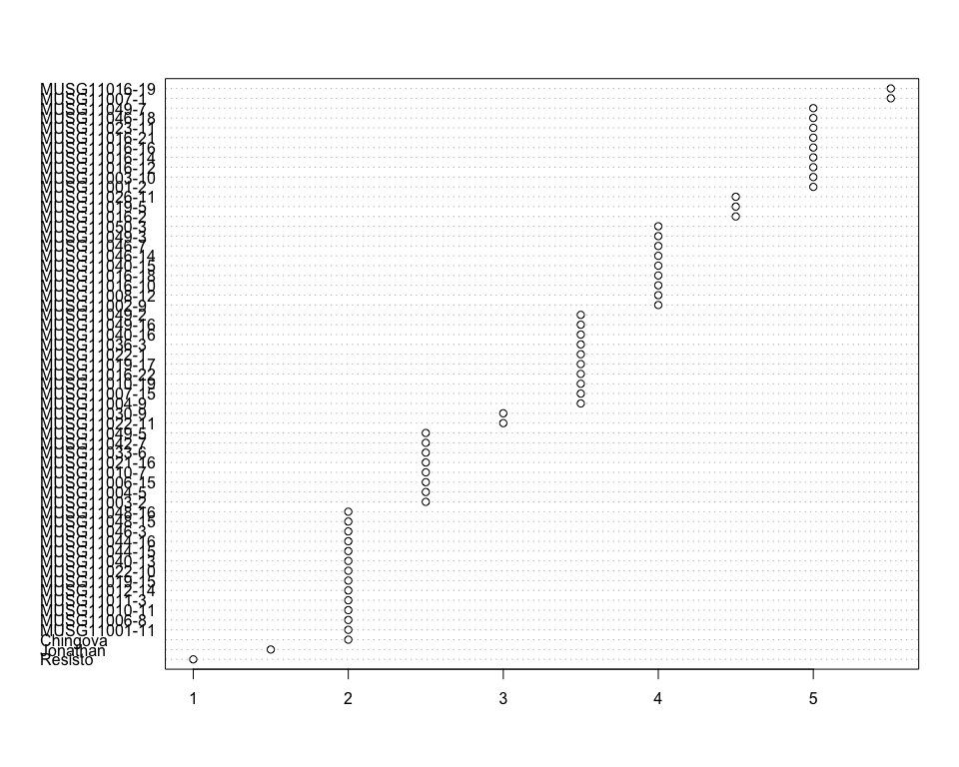

Do not forget the assumptions of the model. It is supposed that the error has a normal distribution with the same variance for all the treatments. The following plots must help you evaluate this:

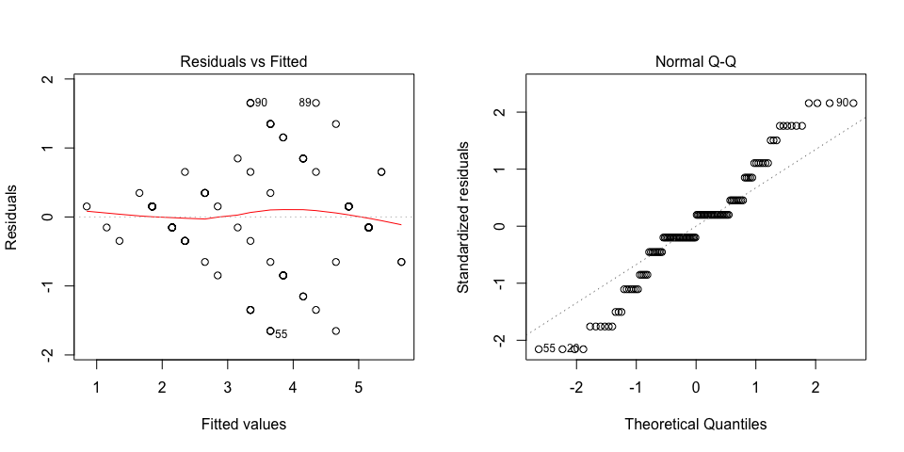

Funnel shapes for the first plot may suggest heterogeneity of variances while departures from the theoretical normal line are symptoms of lack of normality.

### Analysis of **Plants established counting number per plot**

You have fitted a linear model for a RCBD. The ANOVA table for your model is:

|  |  |  |  |  |  |
| --- | --- | --- | --- | --- | --- |
|  | Df | Sum Sq | Mean Sq | F value | Pr(>F) |
| **germplasmName** | 58 | 1404.08 | 24.2084 | 2.02501 | 0.00404478 |
| **REP** | 1 | 7.12712 | 7.12712 | 0.596177 | 0.443175 |
| **Residuals** | 58 | 693.373 | 11.9547 | NA | NA |

The p-value for treatments is 0.00404478 which is significant at the 5% level.

The means of your treatments are:

|  |  |
| --- | --- |
| germplasmName | Plants established counting number per plot |
| Chingova | 20 |
| Jonathan | 14 |
| MUSG11001-11 | 16 |
| MUSG11001-2 | 16 |
| MUSG11002-9 | 15.5 |
| MUSG11003-10 | 21 |
| MUSG11003-2 | 13 |
| MUSG11004-5 | 22.5 |
| MUSG11004-9 | 20 |
| MUSG11006-15 | 22.5 |
| MUSG11006-8 | 17 |
| MUSG11007-1 | 14 |
| MUSG11007-15 | 17.5 |
| MUSG11008-12 | 20.5 |
| MUSG11010-11 | 21 |
| MUSG11010-19 | 18.5 |
| MUSG11010-7 | 18.5 |
| MUSG11011-3 | 20 |
| MUSG11012-14 | 19.5 |
| MUSG11016-10 | 19.5 |
| MUSG11016-12 | 20.5 |
| MUSG11016-14 | 21 |
| MUSG11016-16 | 22.5 |
| MUSG11016-18 | 20 |
| MUSG11016-19 | 18.5 |
| MUSG11016-2 | 23 |
| MUSG11016-21 | 16.5 |
| MUSG11016-22 | 14.5 |
| MUSG11019-15 | 17.5 |
| MUSG11019-17 | 21.5 |
| MUSG11019-5 | 15.5 |
| MUSG11021-16 | 18 |
| MUSG11022-1 | 14.5 |
| MUSG11022-10 | 21 |
| MUSG11022-11 | 22 |
| MUSG11023-11 | 18 |
| MUSG11026-11 | 21.5 |
| MUSG11030-9 | 15.5 |
| MUSG11033-6 | 20 |
| MUSG11036-3 | 16 |
| MUSG11040-13 | 21.5 |
| MUSG11040-15 | 14.5 |
| MUSG11040-16 | 22.5 |
| MUSG11042-7 | 10.5 |
| MUSG11044-15 | 20 |
| MUSG11044-16 | 12 |
| MUSG11046-14 | 17.5 |
| MUSG11046-18 | 16 |
| MUSG11046-3 | 17 |
| MUSG11046-7 | 21 |
| MUSG11048-15 | 18 |
| MUSG11048-16 | 13 |
| MUSG11049-16 | 19.5 |
| MUSG11049-2 | 16.5 |
| MUSG11049-3 | 18 |
| MUSG11049-5 | 19.5 |
| MUSG11049-7 | 16.5 |
| MUSG11050-3 | 17 |
| Resisto | 4 |

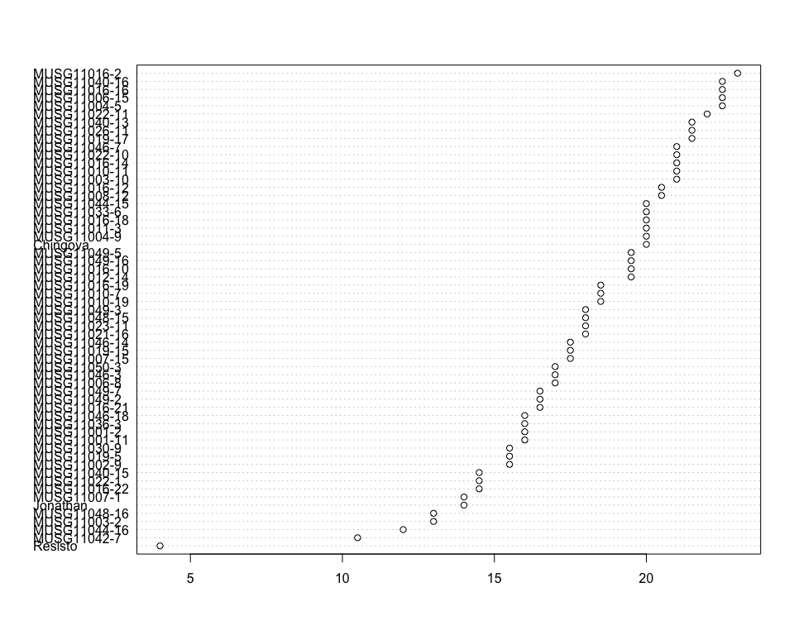

Do not forget the assumptions of the model. It is supposed that the error has a normal distribution with the same variance for all the treatments. The following plots must help you evaluate this:

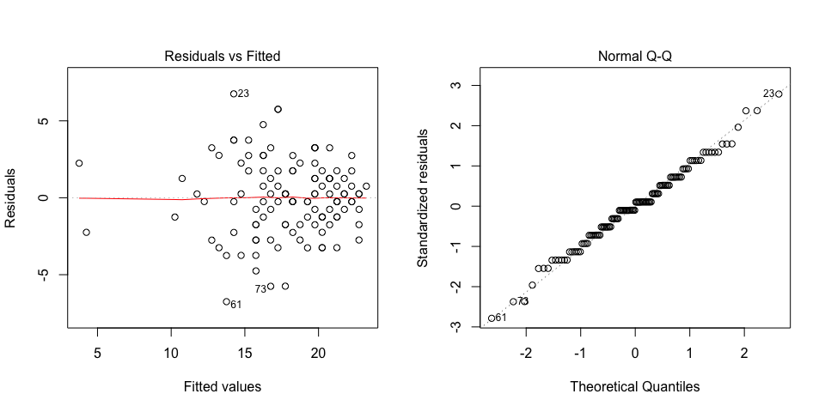

Funnel shapes for the first plot may suggest heterogeneity of variances while departures from the theoretical normal line are symptoms of lack of normality.

### Analysis of **Plants harvested counting number per plot**

You have fitted a linear model for a RCBD. The ANOVA table for your model is:

|  |  |  |  |  |  |
| --- | --- | --- | --- | --- | --- |
|  | Df | Sum Sq | Mean Sq | F value | Pr(>F) |
| **germplasmName** | 58 | 1488.3 | 25.6604 | 2.33343 | 0.000770928 |
| **REP** | 1 | 128.58 | 128.58 | 11.6924 | 0.0011546 |
| **Residuals** | 58 | 637.818 | 10.9969 | NA | NA |

The p-value for treatments is 0.000770928 which is significant at the 5% level.

The means of your treatments are:

|  |  |
| --- | --- |
| germplasmName | Plants harvested counting number per plot |
| Chingova | 4.5 |
| Jonathan | 5.8 |
| MUSG11001-11 | 11 |
| MUSG11001-2 | 10.5 |
| MUSG11002-9 | 9.5 |
| MUSG11003-10 | 15.5 |
| MUSG11003-2 | 6.5 |
| MUSG11004-5 | 21.5 |
| MUSG11004-9 | 7.5 |
| MUSG11006-15 | 11 |
| MUSG11006-8 | 9.5 |
| MUSG11007-1 | 8 |
| MUSG11007-15 | 11.5 |
| MUSG11008-12 | 9 |
| MUSG11010-11 | 10.5 |
| MUSG11010-19 | 17 |
| MUSG11010-7 | 8 |
| MUSG11011-3 | 12 |
| MUSG11012-14 | 10.5 |
| MUSG11016-10 | 10.5 |
| MUSG11016-12 | 15 |
| MUSG11016-14 | 10 |
| MUSG11016-16 | 15.5 |
| MUSG11016-18 | 13.5 |
| MUSG11016-19 | 11.5 |
| MUSG11016-2 | 13.5 |
| MUSG11016-21 | 12.5 |
| MUSG11016-22 | 9 |
| MUSG11019-15 | 11.5 |
| MUSG11019-17 | 13 |
| MUSG11019-5 | 10.5 |
| MUSG11021-16 | 13 |
| MUSG11022-1 | 10 |
| MUSG11022-10 | 14.5 |
| MUSG11022-11 | 13.5 |
| MUSG11023-11 | 20 |
| MUSG11026-11 | 10 |
| MUSG11030-9 | 10 |
| MUSG11033-6 | 14.5 |
| MUSG11036-3 | 9 |
| MUSG11040-13 | 15 |
| MUSG11040-15 | 9.5 |
| MUSG11040-16 | 14.5 |
| MUSG11042-7 | 6.5 |
| MUSG11044-15 | 11.5 |
| MUSG11044-16 | 4.5 |
| MUSG11046-14 | 11 |
| MUSG11046-18 | 13 |
| MUSG11046-3 | 17.5 |
| MUSG11046-7 | 14.5 |
| MUSG11048-15 | 11 |
| MUSG11048-16 | 7 |
| MUSG11049-16 | 13.5 |
| MUSG11049-2 | 12 |
| MUSG11049-3 | 14.5 |
| MUSG11049-5 | 17.5 |
| MUSG11049-7 | 12 |
| MUSG11050-3 | 15 |
| Resisto | 4.79 |

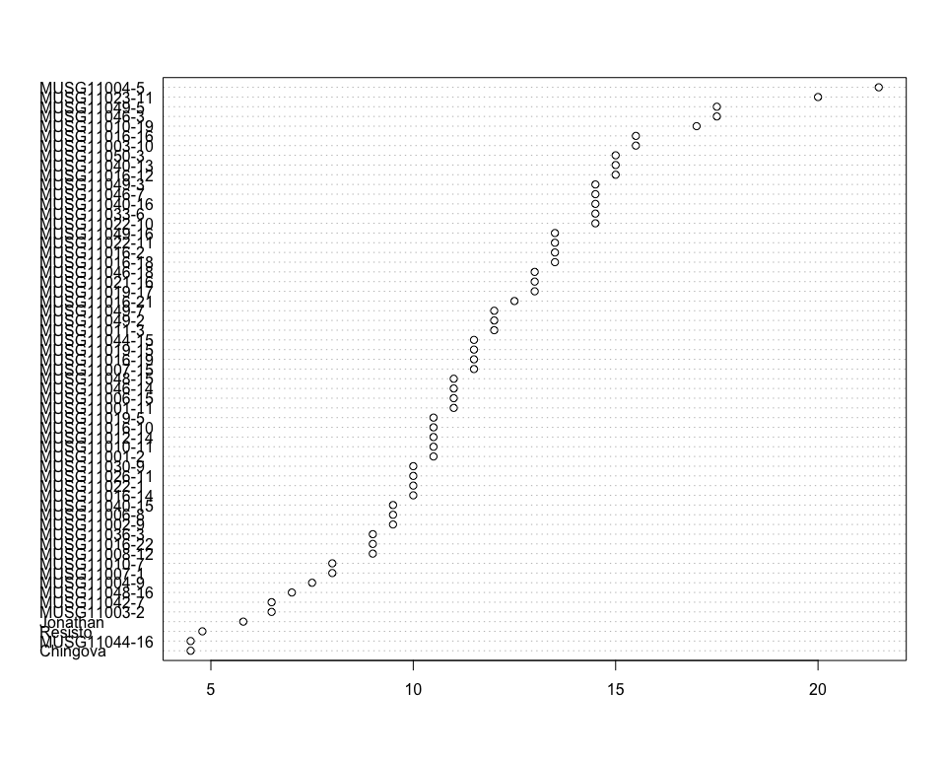

Do not forget the assumptions of the model. It is supposed that the error has a normal distribution with the same variance for all the treatments. The following plots must help you evaluate this:

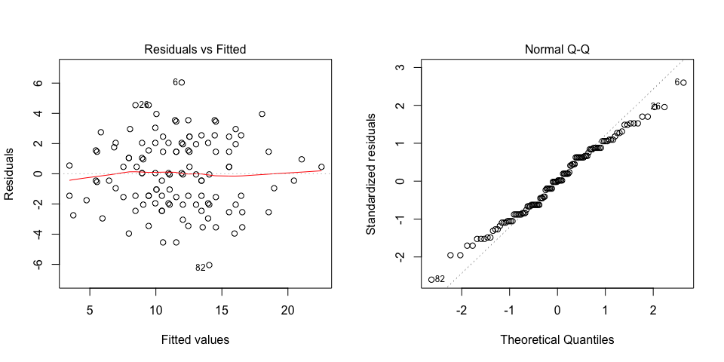

Funnel shapes for the first plot may suggest heterogeneity of variances while departures from the theoretical normal line are symptoms of lack of normality.

### Analysis of **Plants planted counting number per plot**

You have fitted a linear model for a RCBD. The ANOVA table for your model is:

|  |  |  |  |  |  |
| --- | --- | --- | --- | --- | --- |
|  | Df | Sum Sq | Mean Sq | F value | Pr(>F) |
| **germplasmName** | 58 | 1.83016e-26 | 3.15544e-28 | 1 | 0.5 |
| **REP** | 1 | 3.15544e-28 | 3.15544e-28 | 1 | 0.321464 |
| **Residuals** | 58 | 1.83016e-26 | 3.15544e-28 | NA | NA |

The means of your treatments are:

|  |  |
| --- | --- |
| germplasmName | Plants planted counting number per plot |
| Chingova | 26 |
| Jonathan | 26 |
| MUSG11001-11 | 26 |
| MUSG11001-2 | 26 |
| MUSG11002-9 | 26 |
| MUSG11003-10 | 26 |
| MUSG11003-2 | 26 |
| MUSG11004-5 | 26 |
| MUSG11004-9 | 26 |
| MUSG11006-15 | 26 |
| MUSG11006-8 | 26 |
| MUSG11007-1 | 26 |
| MUSG11007-15 | 26 |
| MUSG11008-12 | 26 |
| MUSG11010-11 | 26 |
| MUSG11010-19 | 26 |
| MUSG11010-7 | 26 |
| MUSG11011-3 | 26 |
| MUSG11012-14 | 26 |
| MUSG11016-10 | 26 |
| MUSG11016-12 | 26 |
| MUSG11016-14 | 26 |
| MUSG11016-16 | 26 |
| MUSG11016-18 | 26 |
| MUSG11016-19 | 26 |
| MUSG11016-2 | 26 |
| MUSG11016-21 | 26 |
| MUSG11016-22 | 26 |
| MUSG11019-15 | 26 |
| MUSG11019-17 | 26 |
| MUSG11019-5 | 26 |
| MUSG11021-16 | 26 |
| MUSG11022-1 | 26 |
| MUSG11022-10 | 26 |
| MUSG11022-11 | 26 |
| MUSG11023-11 | 26 |
| MUSG11026-11 | 26 |
| MUSG11030-9 | 26 |
| MUSG11033-6 | 26 |
| MUSG11036-3 | 26 |
| MUSG11040-13 | 26 |
| MUSG11040-15 | 26 |
| MUSG11040-16 | 26 |
| MUSG11042-7 | 26 |
| MUSG11044-15 | 26 |
| MUSG11044-16 | 26 |
| MUSG11046-14 | 26 |
| MUSG11046-18 | 26 |
| MUSG11046-3 | 26 |
| MUSG11046-7 | 26 |
| MUSG11048-15 | 26 |
| MUSG11048-16 | 26 |
| MUSG11049-16 | 26 |
| MUSG11049-2 | 26 |
| MUSG11049-3 | 26 |
| MUSG11049-5 | 26 |
| MUSG11049-7 | 26 |
| MUSG11050-3 | 26 |
| Resisto | 26 |

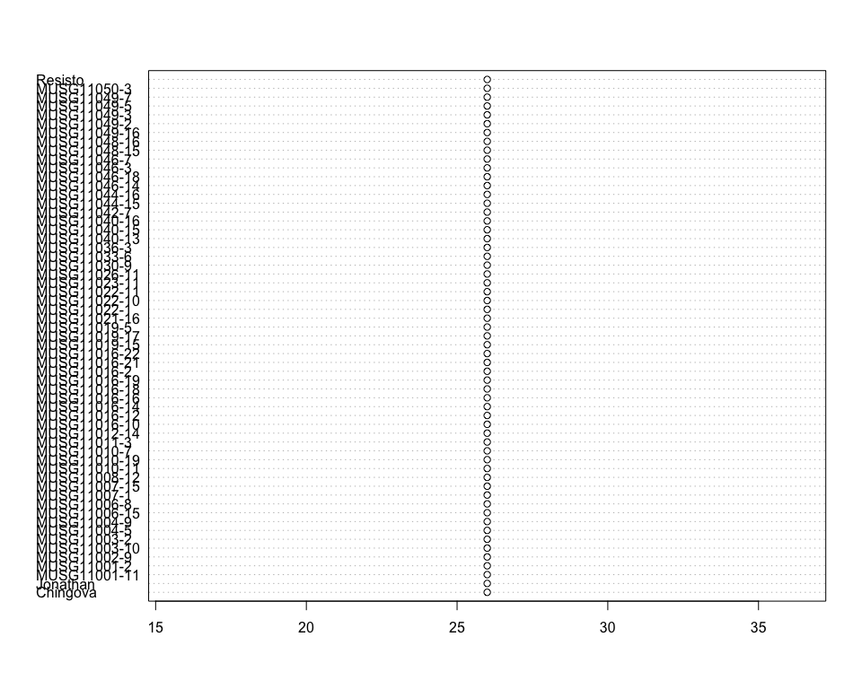

Do not forget the assumptions of the model. It is supposed that the error has a normal distribution with the same variance for all the treatments. The following plots must help you evaluate this:

## Warning in plot.window(...): relative range of values = 17 * EPS, is small  
## (axis 1)

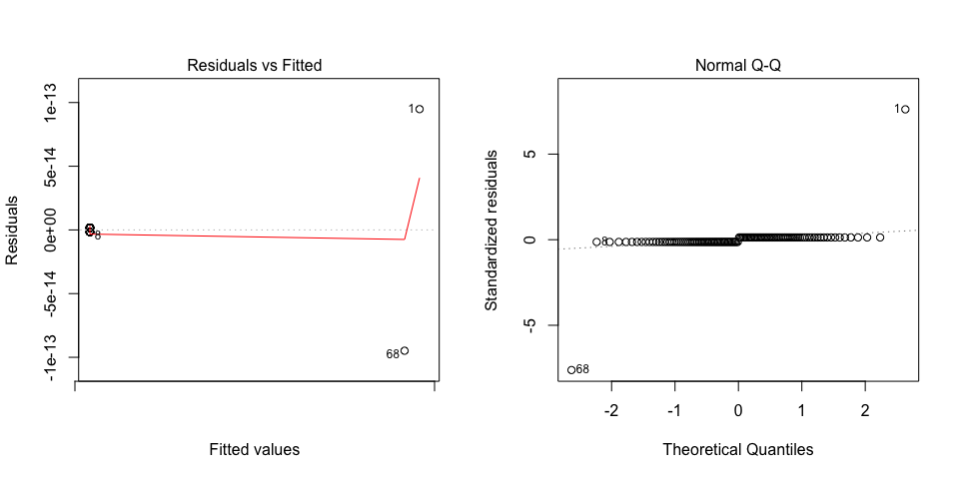

Funnel shapes for the first plot may suggest heterogeneity of variances while departures from the theoretical normal line are symptoms of lack of normality.

### Analysis of **Plants with storage roots counting number per plot**

You have fitted a linear model for a RCBD. The ANOVA table for your model is:

|  |  |  |  |  |  |
| --- | --- | --- | --- | --- | --- |
|  | Df | Sum Sq | Mean Sq | F value | Pr(>F) |
| **germplasmName** | 58 | 1456.08 | 25.1048 | 2.3489 | 0.000709659 |
| **REP** | 1 | 138.594 | 138.594 | 12.9674 | 0.000657968 |
| **Residuals** | 58 | 619.896 | 10.6879 | NA | NA |

The p-value for treatments is 0.000709659 which is significant at the 5% level.

The means of your treatments are:

|  |  |
| --- | --- |
| germplasmName | Plants with storage roots counting number per plot |
| Chingova | 4 |
| Jonathan | 6.57 |
| MUSG11001-11 | 11 |
| MUSG11001-2 | 10 |
| MUSG11002-9 | 9.5 |
| MUSG11003-10 | 14.5 |
| MUSG11003-2 | 6.5 |
| MUSG11004-5 | 21.5 |
| MUSG11004-9 | 7.5 |
| MUSG11006-15 | 11 |
| MUSG11006-8 | 6 |
| MUSG11007-1 | 8 |
| MUSG11007-15 | 11.5 |
| MUSG11008-12 | 9 |
| MUSG11010-11 | 10.5 |
| MUSG11010-19 | 17 |
| MUSG11010-7 | 8 |
| MUSG11011-3 | 12 |
| MUSG11012-14 | 10.5 |
| MUSG11016-10 | 10 |
| MUSG11016-12 | 14.5 |
| MUSG11016-14 | 9.5 |
| MUSG11016-16 | 15.5 |
| MUSG11016-18 | 13.5 |
| MUSG11016-19 | 11 |
| MUSG11016-2 | 13.5 |
| MUSG11016-21 | 12 |
| MUSG11016-22 | 9 |
| MUSG11019-15 | 11.5 |
| MUSG11019-17 | 13 |
| MUSG11019-5 | 9.5 |
| MUSG11021-16 | 13 |
| MUSG11022-1 | 10 |
| MUSG11022-10 | 14.5 |
| MUSG11022-11 | 13 |
| MUSG11023-11 | 20 |
| MUSG11026-11 | 10 |
| MUSG11030-9 | 10 |
| MUSG11033-6 | 14.5 |
| MUSG11036-3 | 9 |
| MUSG11040-13 | 15 |
| MUSG11040-15 | 7 |
| MUSG11040-16 | 14.5 |
| MUSG11042-7 | 6.5 |
| MUSG11044-15 | 11.5 |
| MUSG11044-16 | 4.5 |
| MUSG11046-14 | 11 |
| MUSG11046-18 | 13 |
| MUSG11046-3 | 17.5 |
| MUSG11046-7 | 13 |
| MUSG11048-15 | 11 |
| MUSG11048-16 | 7 |
| MUSG11049-16 | 13 |
| MUSG11049-2 | 12 |
| MUSG11049-3 | 14.5 |
| MUSG11049-5 | 17 |
| MUSG11049-7 | 12 |
| MUSG11050-3 | 15 |
| Resisto | 8.97 |

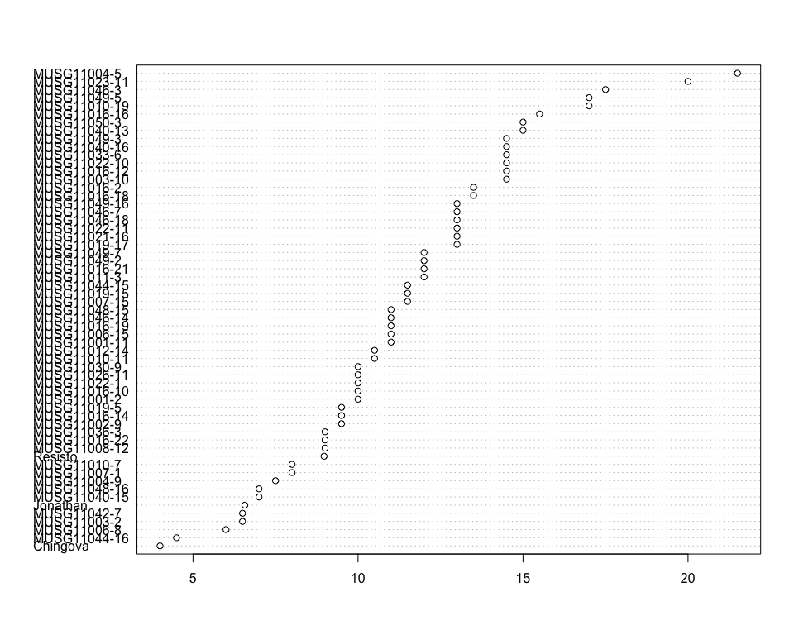

Do not forget the assumptions of the model. It is supposed that the error has a normal distribution with the same variance for all the treatments. The following plots must help you evaluate this:

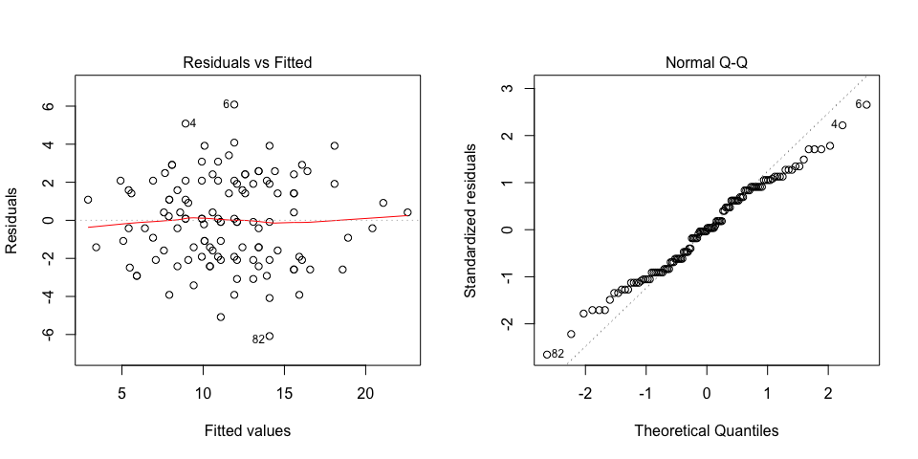

Funnel shapes for the first plot may suggest heterogeneity of variances while departures from the theoretical normal line are symptoms of lack of normality.

### Analysis of **Protein content measuring percent**

You have fitted a linear model for a RCBD. The ANOVA table for your model is:

|  |  |  |  |  |  |
| --- | --- | --- | --- | --- | --- |
|  | Df | Sum Sq | Mean Sq | F value | Pr(>F) |
| **germplasmName** | 58 | 32.6968 | 0.563738 | 1.88089 | 0.00875395 |
| **REP** | 1 | 1.2938 | 1.2938 | 4.31669 | 0.0421771 |
| **Residuals** | 58 | 17.3837 | 0.299719 | NA | NA |

The p-value for treatments is 0.00875395 which is significant at the 5% level.

The means of your treatments are:

|  |  |
| --- | --- |
| germplasmName | Protein content measuring percent |
| Chingova | 3.2 |
| Jonathan | 2.34 |
| MUSG11001-11 | 2.35 |
| MUSG11001-2 | 2.66 |
| MUSG11002-9 | 2.65 |
| MUSG11003-10 | 2.05 |
| MUSG11003-2 | 2.1 |
| MUSG11004-5 | 3.2 |
| MUSG11004-9 | 2.94 |
| MUSG11006-15 | 2.3 |
| MUSG11006-8 | 3.46 |
| MUSG11007-1 | 2.2 |
| MUSG11007-15 | 2.1 |
| MUSG11008-12 | 3.1 |
| MUSG11010-11 | 1.9 |
| MUSG11010-19 | 2.55 |
| MUSG11010-7 | 2.25 |
| MUSG11011-3 | 2.05 |
| MUSG11012-14 | 2.64 |
| MUSG11016-10 | 4.1 |
| MUSG11016-12 | 3 |
| MUSG11016-14 | 2.55 |
| MUSG11016-16 | 3.85 |
| MUSG11016-18 | 2.05 |
| MUSG11016-19 | 2.75 |
| MUSG11016-2 | 3.25 |
| MUSG11016-21 | 3.55 |
| MUSG11016-22 | 3.18 |
| MUSG11019-15 | 2.36 |
| MUSG11019-17 | 2.65 |
| MUSG11019-5 | 2.35 |
| MUSG11021-16 | 2.6 |
| MUSG11022-1 | 2.75 |
| MUSG11022-10 | 1.95 |
| MUSG11022-11 | 2.1 |
| MUSG11023-11 | 3.1 |
| MUSG11026-11 | 3.55 |
| MUSG11030-9 | 2.9 |
| MUSG11033-6 | 2.25 |
| MUSG11036-3 | 2.1 |
| MUSG11040-13 | 2.2 |
| MUSG11040-15 | 2.11 |
| MUSG11040-16 | 2.55 |
| MUSG11042-7 | 2.33 |
| MUSG11044-15 | 2.8 |
| MUSG11044-16 | 3 |
| MUSG11046-14 | 2.8 |
| MUSG11046-18 | 2.3 |
| MUSG11046-3 | 3.5 |
| MUSG11046-7 | 2.65 |
| MUSG11048-15 | 2.25 |
| MUSG11048-16 | 2.1 |
| MUSG11049-16 | 3.1 |
| MUSG11049-2 | 1.9 |
| MUSG11049-3 | 2.1 |
| MUSG11049-5 | 2.35 |
| MUSG11049-7 | 1.7 |
| MUSG11050-3 | 2.2 |
| Resisto | 2.54 |

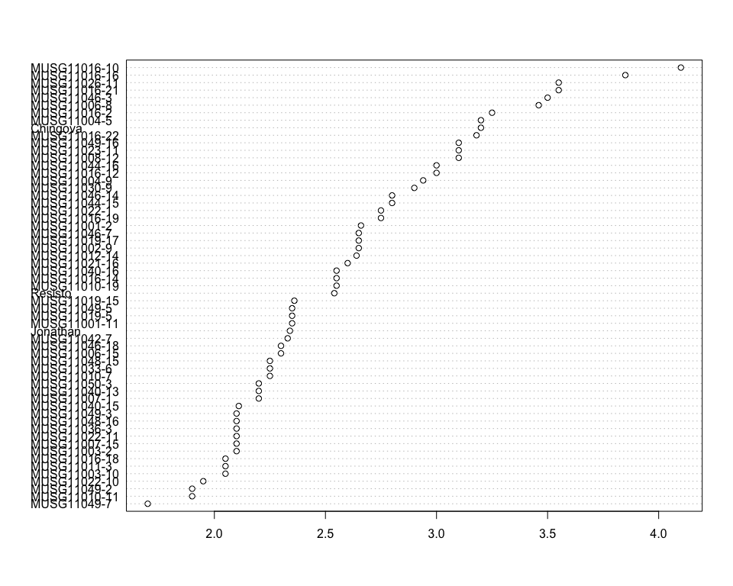

Do not forget the assumptions of the model. It is supposed that the error has a normal distribution with the same variance for all the treatments. The following plots must help you evaluate this:

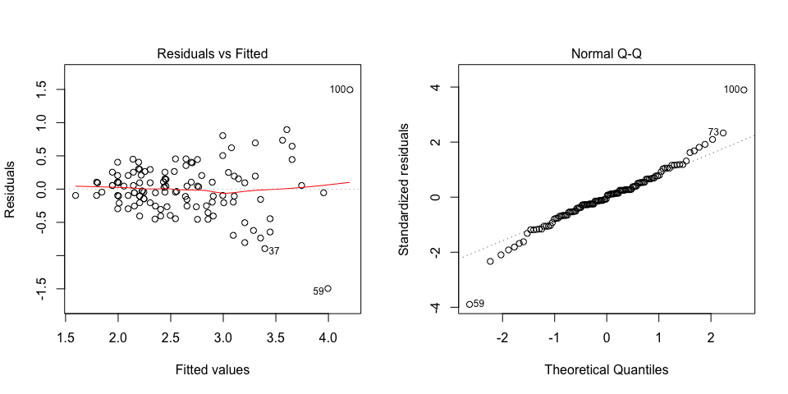

Funnel shapes for the first plot may suggest heterogeneity of variances while departures from the theoretical normal line are symptoms of lack of normality.

### Analysis of **Storage root damages estimatimg 1-9**

You have fitted a linear model for a RCBD. The ANOVA table for your model is:

|  |  |  |  |  |  |
| --- | --- | --- | --- | --- | --- |
|  | Df | Sum Sq | Mean Sq | F value | Pr(>F) |
| **germplasmName** | 58 | 237.441 | 4.0938 | 2.4487 | 0.000416731 |
| **REP** | 1 | 0.0338983 | 0.0338983 | 0.0202762 | 0.887262 |
| **Residuals** | 58 | 96.9661 | 1.67183 | NA | NA |

The p-value for treatments is 0.000416731 which is significant at the 5% level.

The means of your treatments are:

|  |  |
| --- | --- |
| germplasmName | Storage root damages estimatimg 1-9 |
| Chingova | 6.5 |
| Jonathan | 1.5 |
| MUSG11001-11 | 6 |
| MUSG11001-2 | 4.5 |
| MUSG11002-9 | 4 |
| MUSG11003-10 | 4.5 |
| MUSG11003-2 | 3 |
| MUSG11004-5 | 5 |
| MUSG11004-9 | 7.5 |
| MUSG11006-15 | 5 |
| MUSG11006-8 | 5 |
| MUSG11007-1 | 5 |
| MUSG11007-15 | 7 |
| MUSG11008-12 | 7 |
| MUSG11010-11 | 5 |
| MUSG11010-19 | 4 |
| MUSG11010-7 | 4 |
| MUSG11011-3 | 2.5 |
| MUSG11012-14 | 6 |
| MUSG11016-10 | 3 |
| MUSG11016-12 | 4.5 |
| MUSG11016-14 | 4 |
| MUSG11016-16 | 5 |
| MUSG11016-18 | 4.5 |
| MUSG11016-19 | 4.5 |
| MUSG11016-2 | 4 |
| MUSG11016-21 | 3.5 |
| MUSG11016-22 | 4 |
| MUSG11019-15 | 4.5 |
| MUSG11019-17 | 4 |
| MUSG11019-5 | 6.5 |
| MUSG11021-16 | 6.5 |
| MUSG11022-1 | 4 |
| MUSG11022-10 | 4 |
| MUSG11022-11 | 4 |
| MUSG11023-11 | 3 |
| MUSG11026-11 | 4.5 |
| MUSG11030-9 | 4 |
| MUSG11033-6 | 5 |
| MUSG11036-3 | 2.5 |
| MUSG11040-13 | 7 |
| MUSG11040-15 | 5 |
| MUSG11040-16 | 6.5 |
| MUSG11042-7 | 4.5 |
| MUSG11044-15 | 2.5 |
| MUSG11044-16 | 2 |
| MUSG11046-14 | 4.5 |
| MUSG11046-18 | 6.5 |
| MUSG11046-3 | 7.5 |
| MUSG11046-7 | 4.5 |
| MUSG11048-15 | 5 |
| MUSG11048-16 | 6.5 |
| MUSG11049-16 | 5 |
| MUSG11049-2 | 5 |
| MUSG11049-3 | 4.5 |
| MUSG11049-5 | 6 |
| MUSG11049-7 | 4.5 |
| MUSG11050-3 | 4.5 |
| Resisto | 1 |

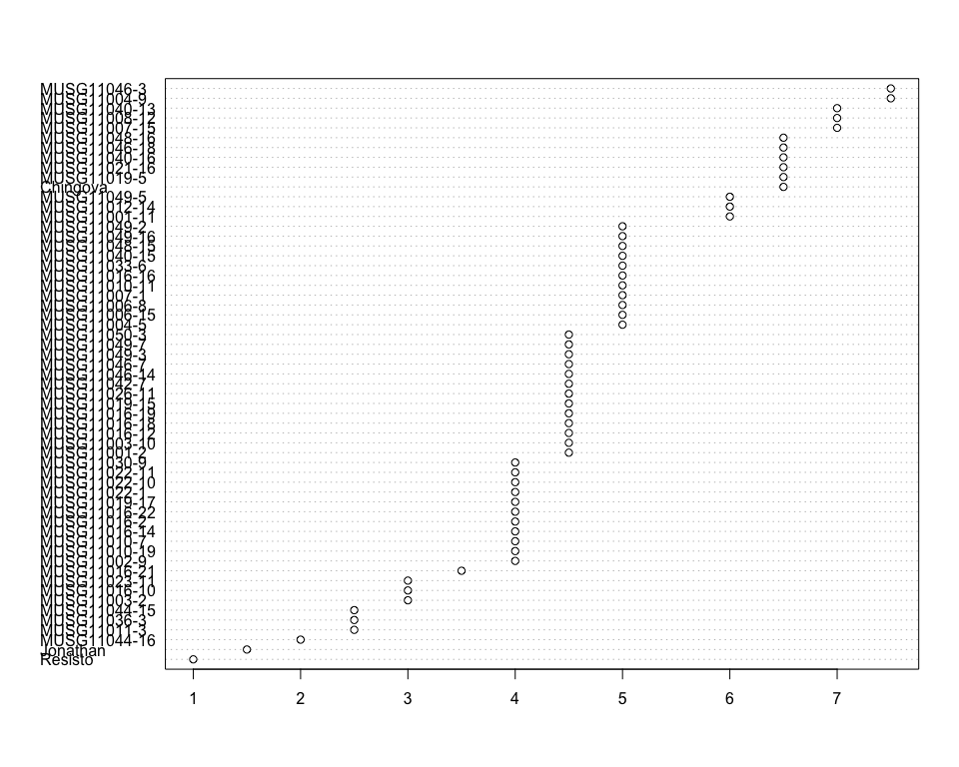

Do not forget the assumptions of the model. It is supposed that the error has a normal distribution with the same variance for all the treatments. The following plots must help you evaluate this:

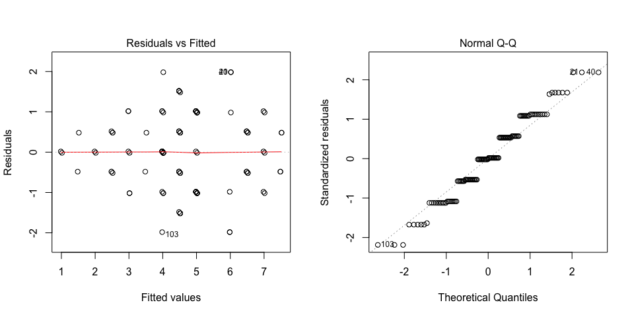

Funnel shapes for the first plot may suggest heterogeneity of variances while departures from the theoretical normal line are symptoms of lack of normality.

### Analysis of **Storage root dry matter content computing percent**

You have fitted a linear model for a RCBD. The ANOVA table for your model is:

|  |  |  |  |  |  |
| --- | --- | --- | --- | --- | --- |
|  | Df | Sum Sq | Mean Sq | F value | Pr(>F) |
| **germplasmName** | 58 | 397508 | 6853.59 | 6.58506 | 1.01085e-11 |
| **REP** | 1 | 22.1484 | 22.1484 | 0.0212806 | 0.884523 |
| **Residuals** | 58 | 60365.2 | 1040.78 | NA | NA |

The p-value for treatments is 0.0000000000101085 which is significant at the 5% level.

The means of your treatments are:

|  |  |
| --- | --- |
| germplasmName | Storage root dry matter content computing percent |
| Chingova | 306 |
| Jonathan | 427 |
| MUSG11001-11 | 440 |
| MUSG11001-2 | 427 |
| MUSG11002-9 | 388 |
| MUSG11003-10 | 389 |
| MUSG11003-2 | 419 |
| MUSG11004-5 | 451 |
| MUSG11004-9 | 339 |
| MUSG11006-15 | 433 |
| MUSG11006-8 | 412 |
| MUSG11007-1 | 423 |
| MUSG11007-15 | 494 |
| MUSG11008-12 | 381 |
| MUSG11010-11 | 568 |
| MUSG11010-19 | 422 |
| MUSG11010-7 | 423 |
| MUSG11011-3 | 326 |
| MUSG11012-14 | 372 |
| MUSG11016-10 | 320 |
| MUSG11016-12 | 311 |
| MUSG11016-14 | 335 |
| MUSG11016-16 | 345 |
| MUSG11016-18 | 338 |
| MUSG11016-19 | 441 |
| MUSG11016-2 | 332 |
| MUSG11016-21 | 336 |
| MUSG11016-22 | 358 |
| MUSG11019-15 | 429 |
| MUSG11019-17 | 358 |
| MUSG11019-5 | 327 |
| MUSG11021-16 | 451 |
| MUSG11022-1 | 378 |
| MUSG11022-10 | 435 |
| MUSG11022-11 | 406 |
| MUSG11023-11 | 354 |
| MUSG11026-11 | 310 |
| MUSG11030-9 | 314 |
| MUSG11033-6 | 399 |
| MUSG11036-3 | 472 |
| MUSG11040-13 | 386 |
| MUSG11040-15 | 386 |
| MUSG11040-16 | 385 |
| MUSG11042-7 | 397 |
| MUSG11044-15 | 416 |
| MUSG11044-16 | 401 |
| MUSG11046-14 | 426 |
| MUSG11046-18 | 407 |
| MUSG11046-3 | 521 |
| MUSG11046-7 | 400 |
| MUSG11048-15 | 542 |
| MUSG11048-16 | 394 |
| MUSG11049-16 | 328 |
| MUSG11049-2 | 344 |
| MUSG11049-3 | 497 |
| MUSG11049-5 | 407 |
| MUSG11049-7 | 473 |
| MUSG11050-3 | 365 |
| Resisto | 409 |

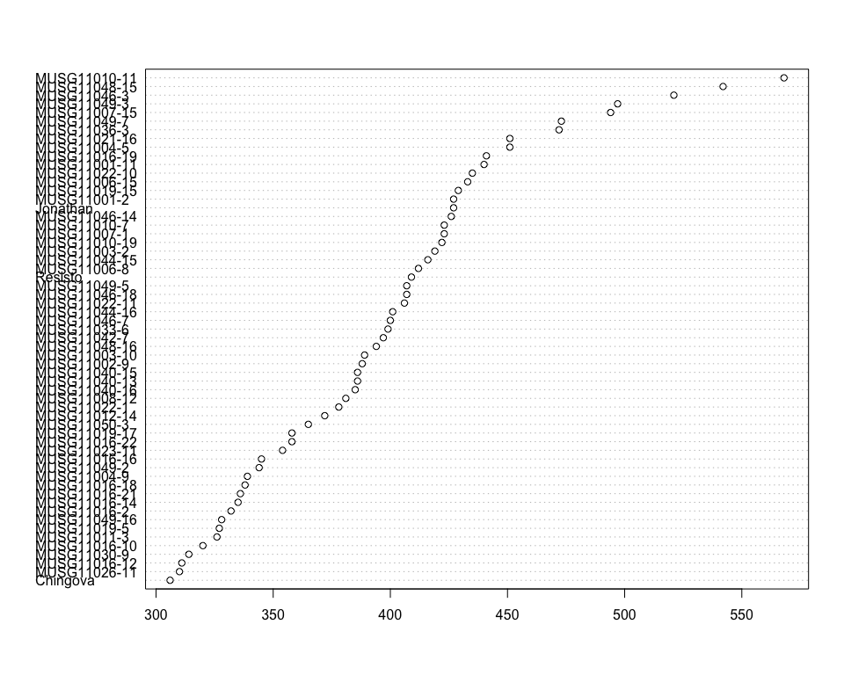

Do not forget the assumptions of the model. It is supposed that the error has a normal distribution with the same variance for all the treatments. The following plots must help you evaluate this:

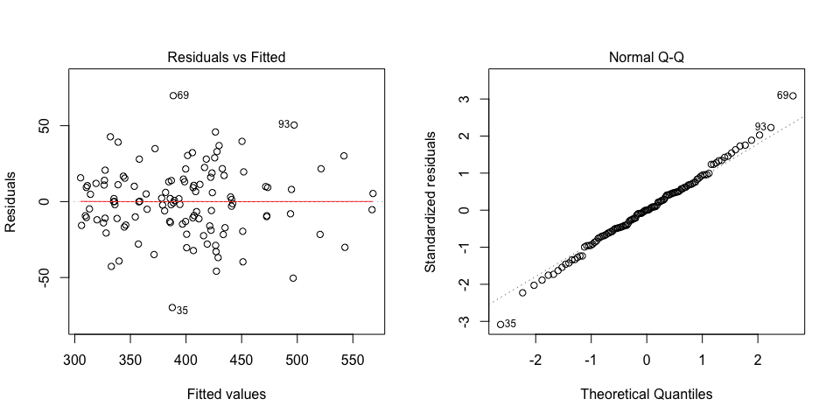

Funnel shapes for the first plot may suggest heterogeneity of variances while departures from the theoretical normal line are symptoms of lack of normality.

### Analysis of **Storage root form estimating 1-9**

You have fitted a linear model for a RCBD. The ANOVA table for your model is:

|  |  |  |  |  |  |
| --- | --- | --- | --- | --- | --- |
|  | Df | Sum Sq | Mean Sq | F value | Pr(>F) |
| **germplasmName** | 58 | 153.864 | 2.65283 | 3.21687 | 8.0386e-06 |
| **REP** | 1 | 2.16949 | 2.16949 | 2.63076 | 0.110236 |
| **Residuals** | 58 | 47.8305 | 0.824664 | NA | NA |

The p-value for treatments is 0.0000080386 which is significant at the 5% level.

The means of your treatments are:

|  |  |
| --- | --- |
| germplasmName | Storage root form estimating 1-9 |
| Chingova | 3 |
| Jonathan | 2 |
| MUSG11001-11 | 5 |
| MUSG11001-2 | 3 |
| MUSG11002-9 | 3.5 |
| MUSG11003-10 | 3 |
| MUSG11003-2 | 4 |
| MUSG11004-5 | 4 |
| MUSG11004-9 | 4.5 |
| MUSG11006-15 | 4 |
| MUSG11006-8 | 5 |
| MUSG11007-1 | 4.5 |
| MUSG11007-15 | 4 |
| MUSG11008-12 | 4 |
| MUSG11010-11 | 3 |
| MUSG11010-19 | 3.5 |
| MUSG11010-7 | 5 |
| MUSG11011-3 | 4.5 |
| MUSG11012-14 | 5.5 |
| MUSG11016-10 | 3 |
| MUSG11016-12 | 3 |
| MUSG11016-14 | 3 |
| MUSG11016-16 | 4 |
| MUSG11016-18 | 3 |
| MUSG11016-19 | 5 |
| MUSG11016-2 | 2 |
| MUSG11016-21 | 4.5 |
| MUSG11016-22 | 3 |
| MUSG11019-15 | 5.5 |
| MUSG11019-17 | 5 |
| MUSG11019-5 | 5 |
| MUSG11021-16 | 6 |
| MUSG11022-1 | 3.5 |
| MUSG11022-10 | 2.5 |
| MUSG11022-11 | 5 |
| MUSG11023-11 | 5 |
| MUSG11026-11 | 3 |
| MUSG11030-9 | 5 |
| MUSG11033-6 | 4 |
| MUSG11036-3 | 2.5 |
| MUSG11040-13 | 5 |
| MUSG11040-15 | 5 |
| MUSG11040-16 | 5.5 |
| MUSG11042-7 | 5 |
| MUSG11044-15 | 3 |
| MUSG11044-16 | 3 |
| MUSG11046-14 | 3 |
| MUSG11046-18 | 3 |
| MUSG11046-3 | 7 |
| MUSG11046-7 | 4 |
| MUSG11048-15 | 5 |
| MUSG11048-16 | 5 |
| MUSG11049-16 | 4 |
| MUSG11049-2 | 3 |
| MUSG11049-3 | 4 |
| MUSG11049-5 | 6 |
| MUSG11049-7 | 4 |
| MUSG11050-3 | 5 |
| Resisto | 1 |

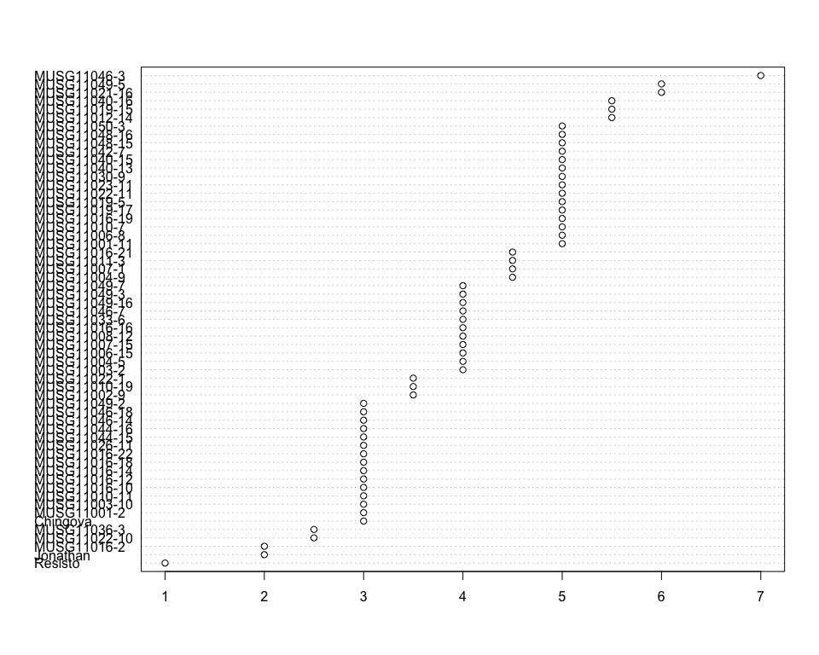

Do not forget the assumptions of the model. It is supposed that the error has a normal distribution with the same variance for all the treatments. The following plots must help you evaluate this:

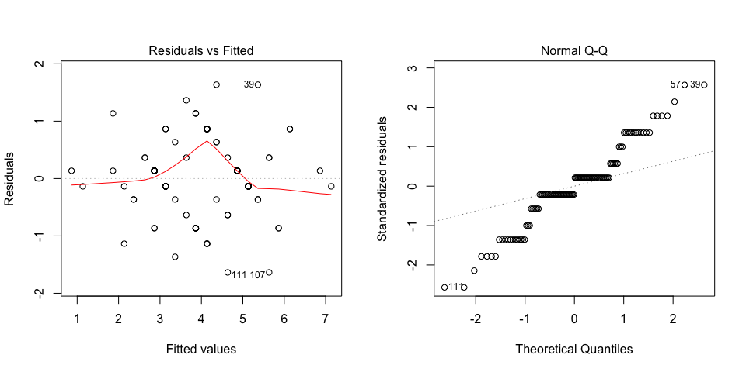

Funnel shapes for the first plot may suggest heterogeneity of variances while departures from the theoretical normal line are symptoms of lack of normality.

### Analysis of **Storage root size estimating 1-9**

You have fitted a linear model for a RCBD. The ANOVA table for your model is:

|  |  |  |  |  |  |
| --- | --- | --- | --- | --- | --- |
|  | Df | Sum Sq | Mean Sq | F value | Pr(>F) |
| **germplasmName** | 58 | 156.78 | 2.7031 | 2.06105 | 0.00333208 |
| **REP** | 1 | 1.4322 | 1.4322 | 1.09202 | 0.300359 |
| **Residuals** | 58 | 76.0678 | 1.31151 | NA | NA |

The p-value for treatments is 0.00333208 which is significant at the 5% level.

The means of your treatments are:

|  |  |
| --- | --- |
| germplasmName | Storage root size estimating 1-9 |
| Chingova | 2.5 |
| Jonathan | 1.5 |
| MUSG11001-11 | 5 |
| MUSG11001-2 | 3 |
| MUSG11002-9 | 2.5 |
| MUSG11003-10 | 4 |
| MUSG11003-2 | 4 |
| MUSG11004-5 | 2.5 |
| MUSG11004-9 | 4 |
| MUSG11006-15 | 3.5 |
| MUSG11006-8 | 5.5 |
| MUSG11007-1 | 4 |
| MUSG11007-15 | 4 |
| MUSG11008-12 | 4.5 |
| MUSG11010-11 | 4 |
| MUSG11010-19 | 2.5 |
| MUSG11010-7 | 6 |
| MUSG11011-3 | 2.5 |
| MUSG11012-14 | 5 |
| MUSG11016-10 | 3 |
| MUSG11016-12 | 2 |
| MUSG11016-14 | 2.5 |
| MUSG11016-16 | 4 |
| MUSG11016-18 | 2.5 |
| MUSG11016-19 | 2.5 |
| MUSG11016-2 | 2 |
| MUSG11016-21 | 2.5 |
| MUSG11016-22 | 2.5 |
| MUSG11019-15 | 5 |
| MUSG11019-17 | 5 |
| MUSG11019-5 | 5 |
| MUSG11021-16 | 5 |
| MUSG11022-1 | 2 |
| MUSG11022-10 | 3 |
| MUSG11022-11 | 4 |
| MUSG11023-11 | 4 |
| MUSG11026-11 | 2.5 |
| MUSG11030-9 | 3 |
| MUSG11033-6 | 5 |
| MUSG11036-3 | 3 |
| MUSG11040-13 | 3 |
| MUSG11040-15 | 5 |
| MUSG11040-16 | 4 |
| MUSG11042-7 | 5 |
| MUSG11044-15 | 3 |
| MUSG11044-16 | 2.5 |
| MUSG11046-14 | 3.5 |
| MUSG11046-18 | 4 |
| MUSG11046-3 | 4 |
| MUSG11046-7 | 4 |
| MUSG11048-15 | 6 |
| MUSG11048-16 | 5 |
| MUSG11049-16 | 5 |
| MUSG11049-2 | 2.5 |
| MUSG11049-3 | 4 |
| MUSG11049-5 | 4 |
| MUSG11049-7 | 2.5 |
| MUSG11050-3 | 4 |
| Resisto | 1 |

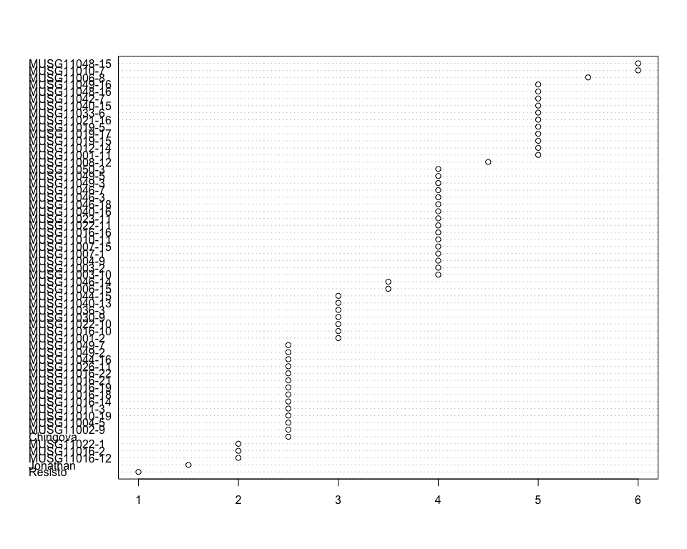

Do not forget the assumptions of the model. It is supposed that the error has a normal distribution with the same variance for all the treatments. The following plots must help you evaluate this:

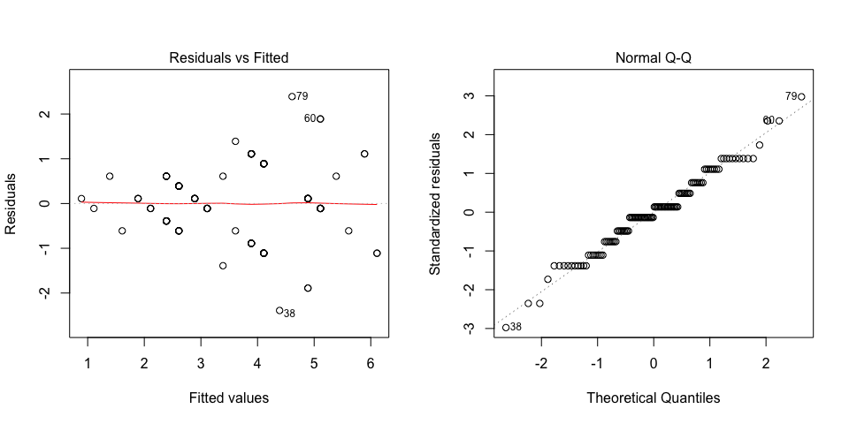

Funnel shapes for the first plot may suggest heterogeneity of variances while departures from the theoretical normal line are symptoms of lack of normality.

### Analysis of **Storage root starch content measuring percent**

You have fitted a linear model for a RCBD. The ANOVA table for your model is:

|  |  |  |  |  |  |
| --- | --- | --- | --- | --- | --- |
|  | Df | Sum Sq | Mean Sq | F value | Pr(>F) |
| **germplasmName** | 58 | 4591.44 | 79.1628 | 4.3217 | 4.94431e-08 |
| **REP** | 1 | 4.88682 | 4.88682 | 0.266784 | 0.607461 |
| **Residuals** | 58 | 1062.41 | 18.3175 | NA | NA |

The p-value for treatments is 0.0000000494431 which is significant at the 5% level.

The means of your treatments are:

|  |  |
| --- | --- |
| germplasmName | Storage root starch content measuring percent |
| Chingova | 61.7 |
| Jonathan | 51.4 |
| MUSG11001-11 | 53.1 |
| MUSG11001-2 | 52.9 |
| MUSG11002-9 | 59.3 |
| MUSG11003-10 | 60.2 |
| MUSG11003-2 | 54.9 |
| MUSG11004-5 | 52.9 |
| MUSG11004-9 | 61.8 |
| MUSG11006-15 | 52.7 |
| MUSG11006-8 | 50.7 |
| MUSG11007-1 | 55.6 |
| MUSG11007-15 | 42.7 |
| MUSG11008-12 | 49.2 |
| MUSG11010-11 | 36.8 |
| MUSG11010-19 | 50.3 |
| MUSG11010-7 | 57.4 |
| MUSG11011-3 | 60 |
| MUSG11012-14 | 57.9 |
| MUSG11016-10 | 63.4 |
| MUSG11016-12 | 61.9 |
| MUSG11016-14 | 59.5 |
| MUSG11016-16 | 60.5 |
| MUSG11016-18 | 60.3 |
| MUSG11016-19 | 51 |
| MUSG11016-2 | 59.3 |
| MUSG11016-21 | 60.4 |
| MUSG11016-22 | 56.4 |
| MUSG11019-15 | 53.5 |
| MUSG11019-17 | 52.5 |
| MUSG11019-5 | 54.4 |
| MUSG11021-16 | 51.1 |
| MUSG11022-1 | 57.6 |
| MUSG11022-10 | 44.5 |
| MUSG11022-11 | 53.8 |
| MUSG11023-11 | 56.3 |
| MUSG11026-11 | 66.7 |
| MUSG11030-9 | 62 |
| MUSG11033-6 | 47 |
| MUSG11036-3 | 53.1 |
| MUSG11040-13 | 48.9 |
| MUSG11040-15 | 58.7 |
| MUSG11040-16 | 51.5 |
| MUSG11042-7 | 57.4 |
| MUSG11044-15 | 50.2 |
| MUSG11044-16 | 50.4 |
| MUSG11046-14 | 53 |
| MUSG11046-18 | 48.6 |
| MUSG11046-3 | 46.4 |
| MUSG11046-7 | 56 |
| MUSG11048-15 | 35.7 |
| MUSG11048-16 | 48.7 |
| MUSG11049-16 | 65.7 |
| MUSG11049-2 | 63.6 |
| MUSG11049-3 | 51.4 |
| MUSG11049-5 | 47.6 |
| MUSG11049-7 | 53.2 |
| MUSG11050-3 | 55 |
| Resisto | 53.9 |

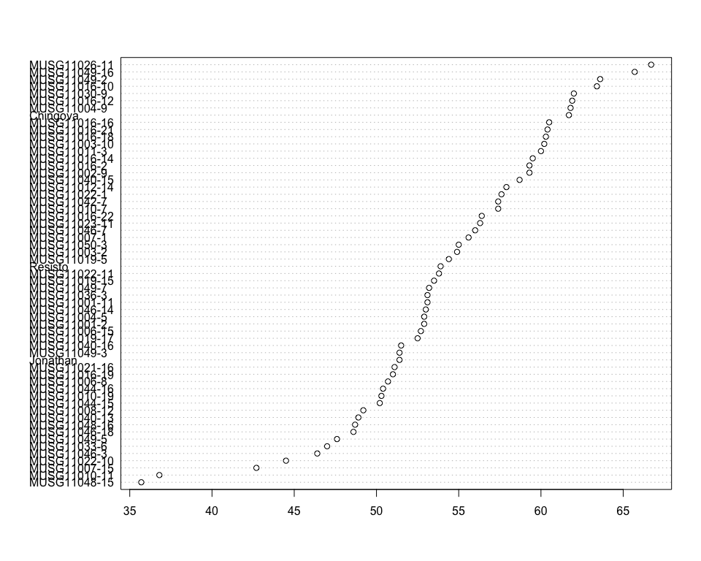

Do not forget the assumptions of the model. It is supposed that the error has a normal distribution with the same variance for all the treatments. The following plots must help you evaluate this:

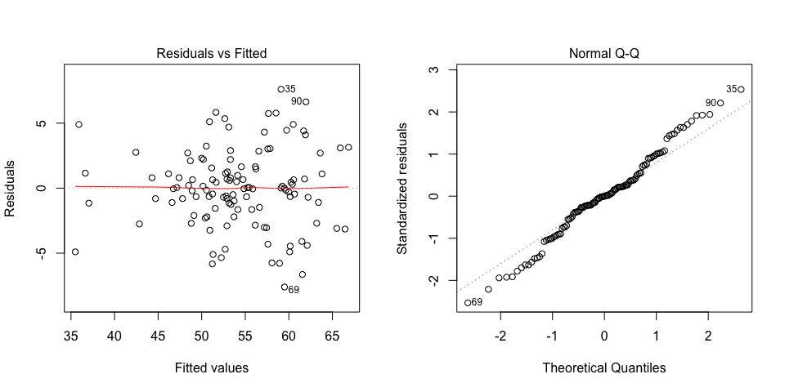

Funnel shapes for the first plot may suggest heterogeneity of variances while departures from the theoretical normal line are symptoms of lack of normality.

### Analysis of **Storage root sweetness 1 estimating 1-9**

You have fitted a linear model for a RCBD. The ANOVA table for your model is:

|  |  |  |  |  |  |
| --- | --- | --- | --- | --- | --- |
|  | Df | Sum Sq | Mean Sq | F value | Pr(>F) |
| **germplasmName** | 58 | 282.458 | 4.86996 | 1.80065 | 0.0134052 |
| **REP** | 1 | 0.135593 | 0.135593 | 0.0501351 | 0.823615 |
| **Residuals** | 58 | 156.864 | 2.70456 | NA | NA |

The p-value for treatments is 0.0134052 which is significant at the 5% level.

The means of your treatments are:

|  |  |
| --- | --- |
| germplasmName | Storage root sweetness 1 estimating 1-9 |
| Chingova | 7 |
| Jonathan | 4 |
| MUSG11001-11 | 7 |
| MUSG11001-2 | 4 |
| MUSG11002-9 | 5.5 |
| MUSG11003-10 | 4.5 |
| MUSG11003-2 | 8 |
| MUSG11004-5 | 6.5 |
| MUSG11004-9 | 7 |
| MUSG11006-15 | 8 |
| MUSG11006-8 | 8 |
| MUSG11007-1 | 4 |
| MUSG11007-15 | 7 |
| MUSG11008-12 | 5 |
| MUSG11010-11 | 8 |
| MUSG11010-19 | 6 |
| MUSG11010-7 | 7.5 |
| MUSG11011-3 | 7 |
| MUSG11012-14 | 8 |
| MUSG11016-10 | 5 |
| MUSG11016-12 | 4 |
| MUSG11016-14 | 5 |
| MUSG11016-16 | 5 |
| MUSG11016-18 | 5 |
| MUSG11016-19 | 3.5 |
| MUSG11016-2 | 5.5 |
| MUSG11016-21 | 4 |
| MUSG11016-22 | 6 |
| MUSG11019-15 | 6.5 |
| MUSG11019-17 | 6 |
| MUSG11019-5 | 4 |
| MUSG11021-16 | 6.5 |
| MUSG11022-1 | 7 |
| MUSG11022-10 | 8 |
| MUSG11022-11 | 6.5 |
| MUSG11023-11 | 4 |
| MUSG11026-11 | 4.5 |
| MUSG11030-9 | 7 |
| MUSG11033-6 | 8 |
| MUSG11036-3 | 7 |
| MUSG11040-13 | 7 |
| MUSG11040-15 | 5 |
| MUSG11040-16 | 7 |
| MUSG11042-7 | 6 |
| MUSG11044-15 | 6.5 |
| MUSG11044-16 | 8 |
| MUSG11046-14 | 5 |
| MUSG11046-18 | 4 |
| MUSG11046-3 | 7.5 |
| MUSG11046-7 | 5 |
| MUSG11048-15 | 9 |
| MUSG11048-16 | 7 |
| MUSG11049-16 | 4.5 |
| MUSG11049-2 | 6 |
| MUSG11049-3 | 5 |
| MUSG11049-5 | 7 |
| MUSG11049-7 | 5 |
| MUSG11050-3 | 4.5 |
| Resisto | 1 |

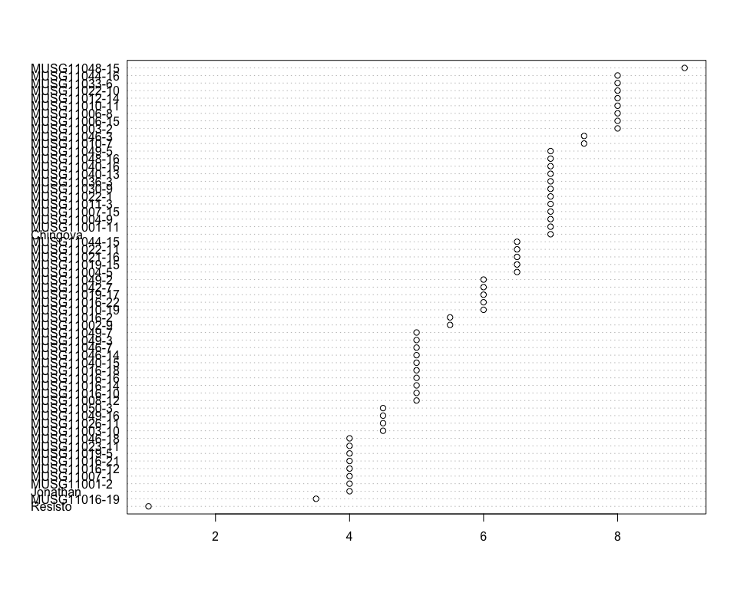

Do not forget the assumptions of the model. It is supposed that the error has a normal distribution with the same variance for all the treatments. The following plots must help you evaluate this:

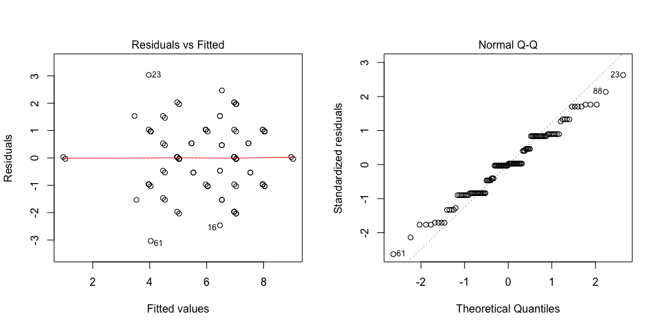

Funnel shapes for the first plot may suggest heterogeneity of variances while departures from the theoretical normal line are symptoms of lack of normality.

### Analysis of **Storage root texture 1 estimating 1-9**

You have fitted a linear model for a RCBD. The ANOVA table for your model is:

|  |  |  |  |  |  |
| --- | --- | --- | --- | --- | --- |
|  | Df | Sum Sq | Mean Sq | F value | Pr(>F) |
| **germplasmName** | 58 | 172.119 | 2.96756 | 1.89001 | 0.00833833 |
| **REP** | 1 | 1.4322 | 1.4322 | 0.912153 | 0.343508 |
| **Residuals** | 58 | 91.0678 | 1.57013 | NA | NA |

The p-value for treatments is 0.00833833 which is significant at the 5% level.

The means of your treatments are:

|  |  |
| --- | --- |
| germplasmName | Storage root texture 1 estimating 1-9 |
| Chingova | 6 |
| Jonathan | 2 |
| MUSG11001-11 | 3.5 |
| MUSG11001-2 | 4 |
| MUSG11002-9 | 3 |
| MUSG11003-10 | 3 |
| MUSG11003-2 | 4.5 |
| MUSG11004-5 | 4.5 |
| MUSG11004-9 | 3.5 |
| MUSG11006-15 | 2.5 |
| MUSG11006-8 | 3 |
| MUSG11007-1 | 4.5 |
| MUSG11007-15 | 2.5 |
| MUSG11008-12 | 6 |
| MUSG11010-11 | 4 |
| MUSG11010-19 | 4 |
| MUSG11010-7 | 3.5 |
| MUSG11011-3 | 6 |
| MUSG11012-14 | 4.5 |
| MUSG11016-10 | 7 |
| MUSG11016-12 | 5.5 |
| MUSG11016-14 | 5 |
| MUSG11016-16 | 7 |
| MUSG11016-18 | 5 |
| MUSG11016-19 | 4 |
| MUSG11016-2 | 4 |
| MUSG11016-21 | 4.5 |
| MUSG11016-22 | 4.5 |
| MUSG11019-15 | 3.5 |
| MUSG11019-17 | 3.5 |
| MUSG11019-5 | 6 |
| MUSG11021-16 | 4 |
| MUSG11022-1 | 5 |
| MUSG11022-10 | 3.5 |
| MUSG11022-11 | 4 |
| MUSG11023-11 | 6 |
| MUSG11026-11 | 6.5 |
| MUSG11030-9 | 4 |
| MUSG11033-6 | 4 |
| MUSG11036-3 | 3 |
| MUSG11040-13 | 4 |
| MUSG11040-15 | 3.5 |
| MUSG11040-16 | 6 |
| MUSG11042-7 | 5 |
| MUSG11044-15 | 4.5 |
| MUSG11044-16 | 5 |
| MUSG11046-14 | 3 |
| MUSG11046-18 | 4.5 |
| MUSG11046-3 | 4.5 |
| MUSG11046-7 | 3 |
| MUSG11048-15 | 4 |
| MUSG11048-16 | 5 |
| MUSG11049-16 | 5.5 |
| MUSG11049-2 | 6 |
| MUSG11049-3 | 4 |
| MUSG11049-5 | 3 |
| MUSG11049-7 | 4 |
| MUSG11050-3 | 4 |
| Resisto | 1 |

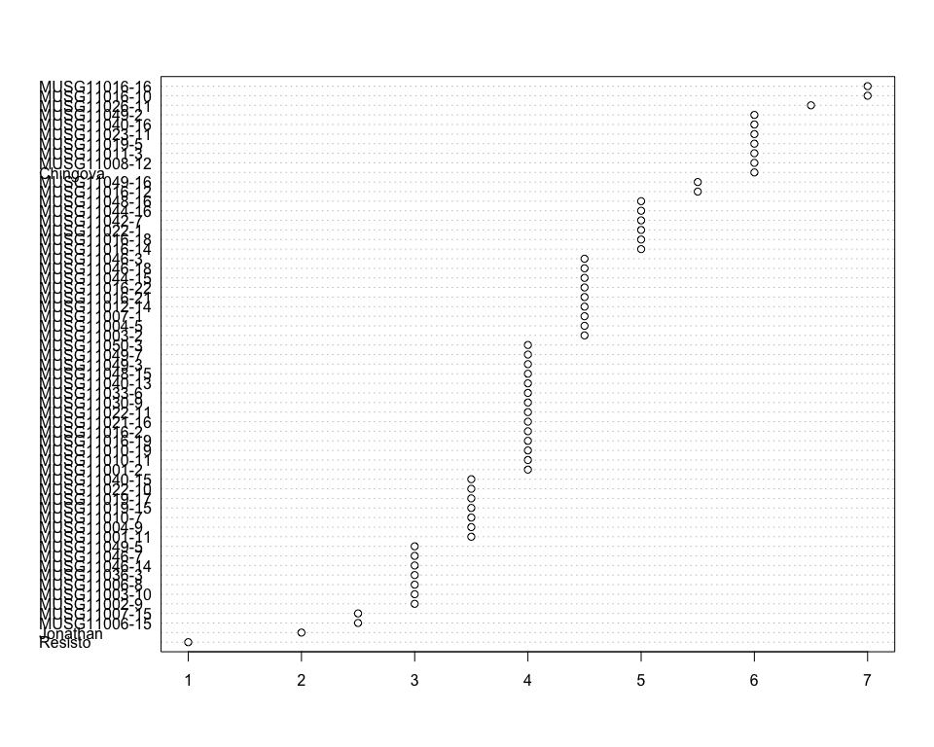

Do not forget the assumptions of the model. It is supposed that the error has a normal distribution with the same variance for all the treatments. The following plots must help you evaluate this:

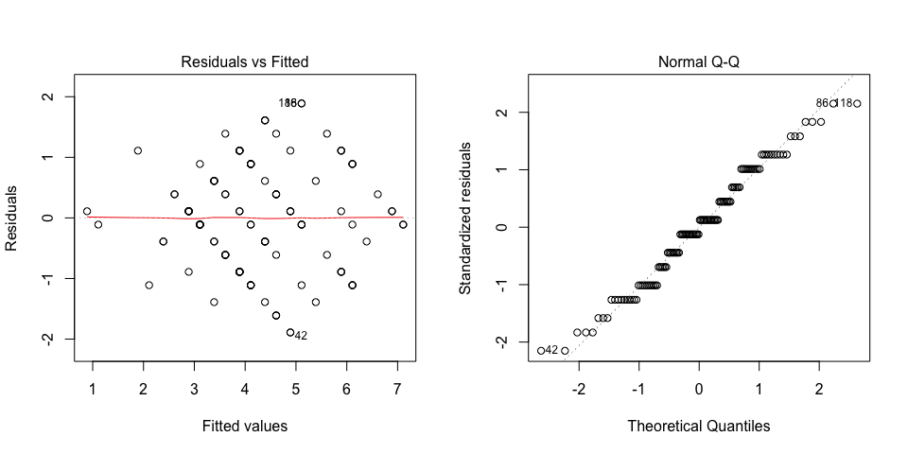

Funnel shapes for the first plot may suggest heterogeneity of variances while departures from the theoretical normal line are symptoms of lack of normality.

### Analysis of **Survival index computing percent**

You have fitted a linear model for a RCBD. The ANOVA table for your model is:

|  |  |  |  |  |  |
| --- | --- | --- | --- | --- | --- |
|  | Df | Sum Sq | Mean Sq | F value | Pr(>F) |
| **germplasmName** | 58 | 2.14782 | 0.0370314 | 2.17475 | 0.00180714 |
| **REP** | 1 | 0.176661 | 0.176661 | 10.3748 | 0.0020957 |
| **Residuals** | 58 | 0.987616 | 0.0170279 | NA | NA |

The p-value for treatments is 0.00180714 which is significant at the 5% level.

The means of your treatments are:

|  |  |
| --- | --- |
| germplasmName | Survival index computing percent |
| Chingova | 0.2 |
| Jonathan | 0.243 |
| MUSG11001-11 | 0.4 |
| MUSG11001-2 | 0.4 |
| MUSG11002-9 | 0.35 |
| MUSG11003-10 | 0.6 |
| MUSG11003-2 | 0.25 |
| MUSG11004-5 | 0.85 |
| MUSG11004-9 | 0.25 |
| MUSG11006-15 | 0.45 |
| MUSG11006-8 | 0.35 |
| MUSG11007-1 | 0.3 |
| MUSG11007-15 | 0.4 |
| MUSG11008-12 | 0.3 |
| MUSG11010-11 | 0.4 |
| MUSG11010-19 | 0.65 |
| MUSG11010-7 | 0.3 |
| MUSG11011-3 | 0.45 |
| MUSG11012-14 | 0.4 |
| MUSG11016-10 | 0.4 |
| MUSG11016-12 | 0.6 |
| MUSG11016-14 | 0.4 |
| MUSG11016-16 | 0.6 |
| MUSG11016-18 | 0.5 |
| MUSG11016-19 | 0.45 |
| MUSG11016-2 | 0.5 |
| MUSG11016-21 | 0.5 |
| MUSG11016-22 | 0.35 |
| MUSG11019-15 | 0.45 |
| MUSG11019-17 | 0.5 |
| MUSG11019-5 | 0.4 |
| MUSG11021-16 | 0.5 |
| MUSG11022-1 | 0.35 |
| MUSG11022-10 | 0.6 |
| MUSG11022-11 | 0.5 |
| MUSG11023-11 | 0.75 |
| MUSG11026-11 | 0.35 |
| MUSG11030-9 | 0.35 |
| MUSG11033-6 | 0.55 |
| MUSG11036-3 | 0.3 |
| MUSG11040-13 | 0.55 |
| MUSG11040-15 | 0.4 |
| MUSG11040-16 | 0.55 |
| MUSG11042-7 | 0.25 |
| MUSG11044-15 | 0.45 |
| MUSG11044-16 | 0.2 |
| MUSG11046-14 | 0.4 |
| MUSG11046-18 | 0.5 |
| MUSG11046-3 | 0.65 |
| MUSG11046-7 | 0.55 |
| MUSG11048-15 | 0.45 |
| MUSG11048-16 | 0.25 |
| MUSG11049-16 | 0.5 |
| MUSG11049-2 | 0.45 |
| MUSG11049-3 | 0.55 |
| MUSG11049-5 | 0.7 |
| MUSG11049-7 | 0.45 |
| MUSG11050-3 | 0.55 |
| Resisto | 0.345 |

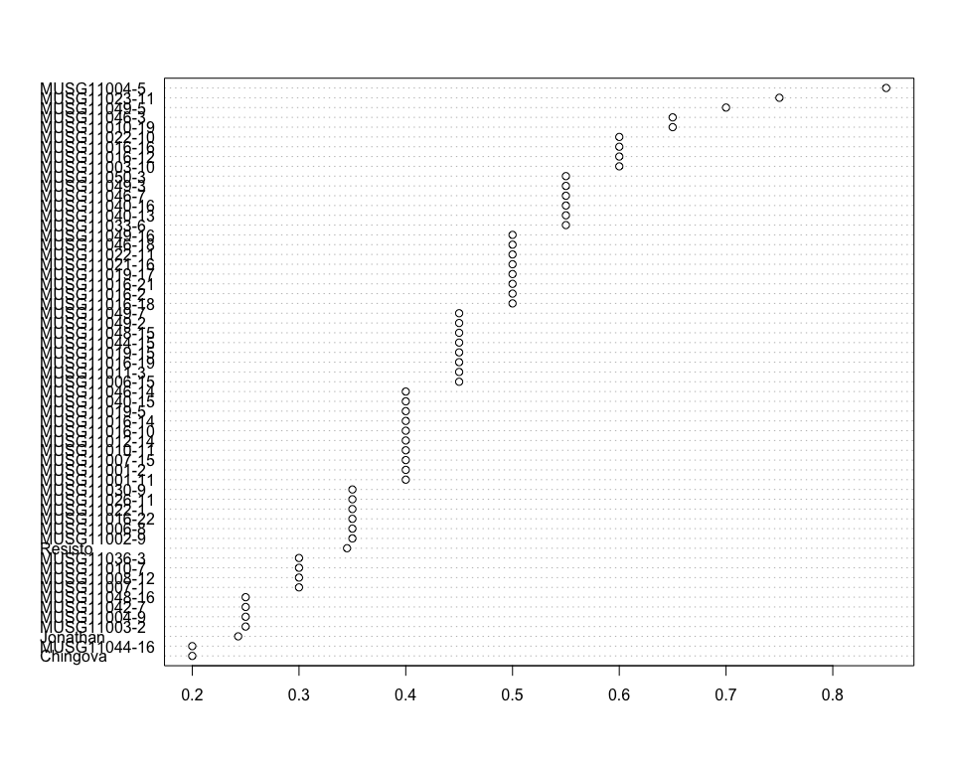

Do not forget the assumptions of the model. It is supposed that the error has a normal distribution with the same variance for all the treatments. The following plots must help you evaluate this:

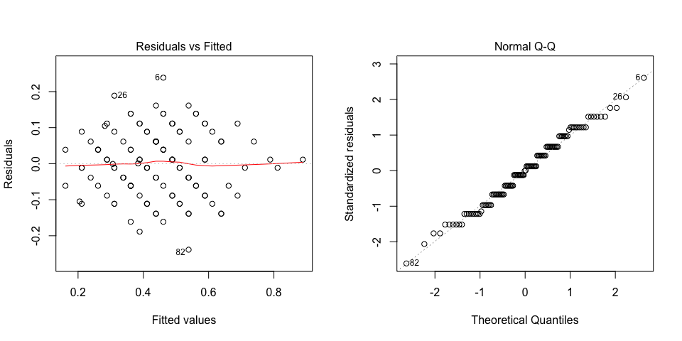

Funnel shapes for the first plot may suggest heterogeneity of variances while departures from the theoretical normal line are symptoms of lack of normality.

### Analysis of **Sweet potato weevil symptoms 1 estimating 1-9**

You have fitted a linear model for a RCBD. The ANOVA table for your model is:

|  |  |  |  |  |  |
| --- | --- | --- | --- | --- | --- |
|  | Df | Sum Sq | Mean Sq | F value | Pr(>F) |
| **germplasmName** | 58 | 182.966 | 3.15459 | 1.37991 | 0.111553 |
| **REP** | 1 | 46.4068 | 46.4068 | 20.2996 | 3.25953e-05 |
| **Residuals** | 58 | 132.593 | 2.28609 | NA | NA |

The means of your treatments are:

|  |  |
| --- | --- |
| germplasmName | Sweet potato weevil symptoms 1 estimating 1-9 |
| Chingova | 3 |
| Jonathan | 4 |
| MUSG11001-11 | 6 |
| MUSG11001-2 | 3.5 |
| MUSG11002-9 | 4 |
| MUSG11003-10 | 3.5 |
| MUSG11003-2 | 2 |
| MUSG11004-5 | 4.5 |
| MUSG11004-9 | 5.5 |
| MUSG11006-15 | 4 |
| MUSG11006-8 | 5.5 |
| MUSG11007-1 | 6 |
| MUSG11007-15 | 4.5 |
| MUSG11008-12 | 6 |
| MUSG11010-11 | 3 |
| MUSG11010-19 | 3 |
| MUSG11010-7 | 3.5 |
| MUSG11011-3 | 4.5 |
| MUSG11012-14 | 4 |
| MUSG11016-10 | 3 |
| MUSG11016-12 | 5 |
| MUSG11016-14 | 2.5 |
| MUSG11016-16 | 3.5 |
| MUSG11016-18 | 4.5 |
| MUSG11016-19 | 4 |
| MUSG11016-2 | 3 |
| MUSG11016-21 | 2.5 |
| MUSG11016-22 | 7 |
| MUSG11019-15 | 2.5 |
| MUSG11019-17 | 6.5 |
| MUSG11019-5 | 3.5 |
| MUSG11021-16 | 6 |
| MUSG11022-1 | 4 |
| MUSG11022-10 | 2.5 |
| MUSG11022-11 | 3 |
| MUSG11023-11 | 5.5 |
| MUSG11026-11 | 4 |
| MUSG11030-9 | 4 |
| MUSG11033-6 | 2.5 |
| MUSG11036-3 | 3 |
| MUSG11040-13 | 4 |
| MUSG11040-15 | 2.5 |
| MUSG11040-16 | 5.5 |
| MUSG11042-7 | 3 |
| MUSG11044-15 | 4.5 |
| MUSG11044-16 | 5 |
| MUSG11046-14 | 3.5 |
| MUSG11046-18 | 2.5 |
| MUSG11046-3 | 4 |
| MUSG11046-7 | 4 |
| MUSG11048-15 | 5.5 |
| MUSG11048-16 | 4 |
| MUSG11049-16 | 5.5 |
| MUSG11049-2 | 2 |
| MUSG11049-3 | 4 |
| MUSG11049-5 | 4 |
| MUSG11049-7 | 3.5 |
| MUSG11050-3 | 5 |
| Resisto | 1 |

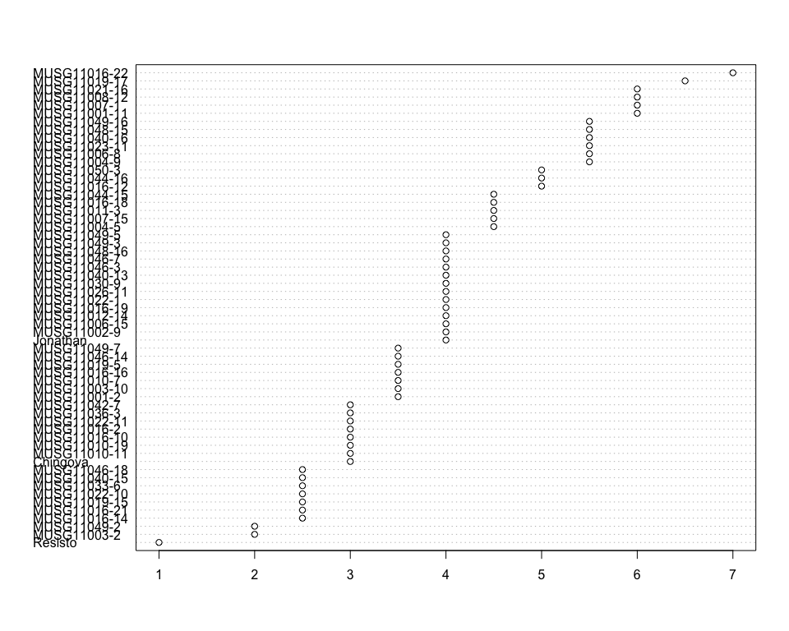

Do not forget the assumptions of the model. It is supposed that the error has a normal distribution with the same variance for all the treatments. The following plots must help you evaluate this:

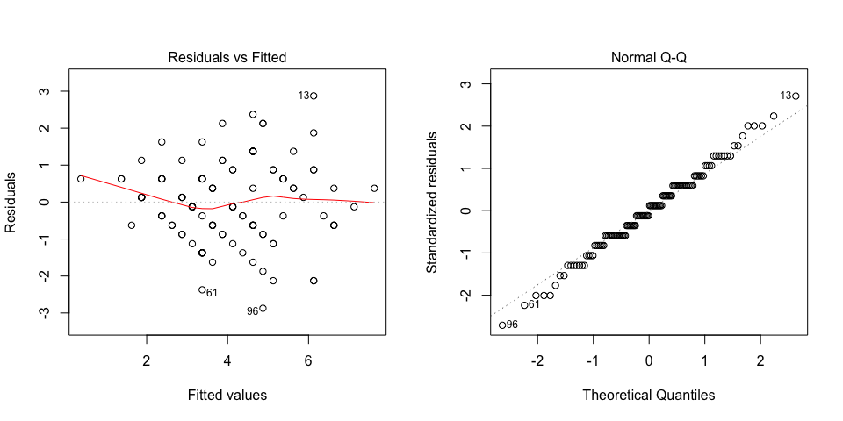

Funnel shapes for the first plot may suggest heterogeneity of variances while departures from the theoretical normal line are symptoms of lack of normality.

### Analysis of **Total carotenoids measuring mg per 100g**

You have fitted a linear model for a RCBD. The ANOVA table for your model is:

|  |  |  |  |  |  |
| --- | --- | --- | --- | --- | --- |
|  | Df | Sum Sq | Mean Sq | F value | Pr(>F) |
| **germplasmName** | 58 | 2271.74 | 39.1679 | 7.42126 | 7.27331e-13 |
| **REP** | 1 | 7.93806 | 7.93806 | 1.50405 | 0.225005 |
| **Residuals** | 58 | 306.112 | 5.2778 | NA | NA |

The p-value for treatments is 0.000000000000727331 which is significant at the 5% level.

The means of your treatments are:

|  |  |
| --- | --- |
| germplasmName | Total carotenoids measuring mg per 100g |
| Chingova | 0.02 |
| Jonathan | 9.44 |
| MUSG11001-11 | 12.4 |
| MUSG11001-2 | 13.4 |
| MUSG11002-9 | 14.4 |
| MUSG11003-10 | 7.23 |
| MUSG11003-2 | 11 |
| MUSG11004-5 | 14.4 |
| MUSG11004-9 | 7.23 |
| MUSG11006-15 | 4.47 |
| MUSG11006-8 | 14.4 |
| MUSG11007-1 | 14.4 |
| MUSG11007-15 | 10.8 |
| MUSG11008-12 | 3.03 |
| MUSG11010-11 | 14.4 |
| MUSG11010-19 | 12.9 |
| MUSG11010-7 | 14.4 |
| MUSG11011-3 | 1.38 |
| MUSG11012-14 | 6.12 |
| MUSG11016-10 | 4.8 |
| MUSG11016-12 | 0.02 |
| MUSG11016-14 | 11 |
| MUSG11016-16 | 1.74 |
| MUSG11016-18 | 8.05 |
| MUSG11016-19 | 13.4 |
| MUSG11016-2 | 1.74 |
| MUSG11016-21 | 14.4 |
| MUSG11016-22 | 6.12 |
| MUSG11019-15 | 14.4 |
| MUSG11019-17 | 12.4 |
| MUSG11019-5 | 4.46 |
| MUSG11021-16 | 11.7 |
| MUSG11022-1 | 12.4 |
| MUSG11022-10 | 14.4 |
| MUSG11022-11 | 11.4 |
| MUSG11023-11 | 8.06 |
| MUSG11026-11 | 5.49 |
| MUSG11030-9 | 6.12 |
| MUSG11033-6 | 12.4 |
| MUSG11036-3 | 14.4 |
| MUSG11040-13 | 9.26 |
| MUSG11040-15 | 12.4 |
| MUSG11040-16 | 12.4 |
| MUSG11042-7 | 14.4 |
| MUSG11044-15 | 13.4 |
| MUSG11044-16 | 14.4 |
| MUSG11046-14 | 14.4 |
| MUSG11046-18 | 6.12 |
| MUSG11046-3 | 14.4 |
| MUSG11046-7 | 5.46 |
| MUSG11048-15 | 14.4 |
| MUSG11048-16 | 13.4 |
| MUSG11049-16 | 11 |
| MUSG11049-2 | 3.72 |
| MUSG11049-3 | 11 |
| MUSG11049-5 | 13.4 |
| MUSG11049-7 | 7.23 |
| MUSG11050-3 | 14.4 |
| Resisto | 11.3 |

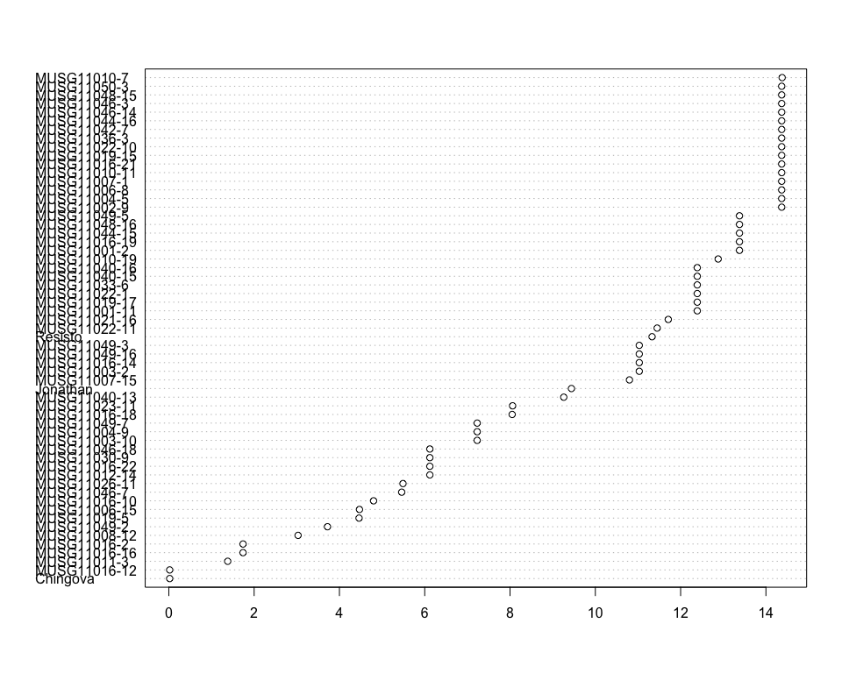

Do not forget the assumptions of the model. It is supposed that the error has a normal distribution with the same variance for all the treatments. The following plots must help you evaluate this:

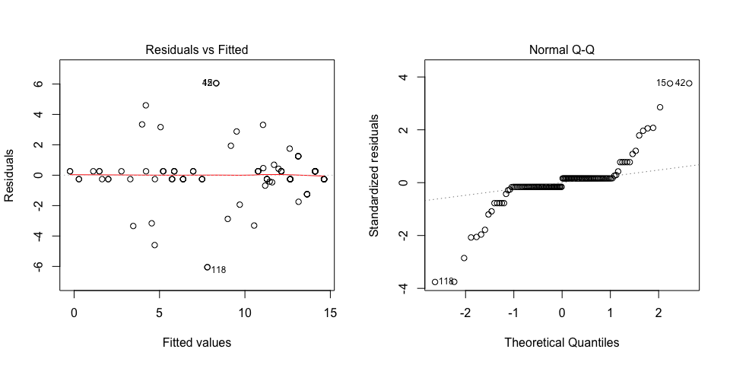

Funnel shapes for the first plot may suggest heterogeneity of variances while departures from the theoretical normal line are symptoms of lack of normality.

### Analysis of **Vine vigor 1 estimating 1-9**

You have fitted a linear model for a RCBD. The ANOVA table for your model is:

|  |  |  |  |  |  |
| --- | --- | --- | --- | --- | --- |
|  | Df | Sum Sq | Mean Sq | F value | Pr(>F) |
| **germplasmName** | 58 | 207.153 | 3.5716 | 3.37998 | 3.62432e-06 |
| **REP** | 1 | 34.7119 | 34.7119 | 32.8496 | 3.76116e-07 |
| **Residuals** | 58 | 61.2881 | 1.05669 | NA | NA |

The p-value for treatments is 0.00000362432 which is significant at the 5% level.

The means of your treatments are:

|  |  |
| --- | --- |
| germplasmName | Vine vigor 1 estimating 1-9 |
| Chingova | 4.5 |
| Jonathan | 3.5 |
| MUSG11001-11 | 6.5 |
| MUSG11001-2 | 4 |
| MUSG11002-9 | 5.5 |
| MUSG11003-10 | 7 |
| MUSG11003-2 | 5.5 |
| MUSG11004-5 | 8.5 |
| MUSG11004-9 | 5 |
| MUSG11006-15 | 7.5 |
| MUSG11006-8 | 5 |
| MUSG11007-1 | 4.5 |
| MUSG11007-15 | 7 |
| MUSG11008-12 | 5.5 |
| MUSG11010-11 | 5.5 |
| MUSG11010-19 | 7 |
| MUSG11010-7 | 4.5 |
| MUSG11011-3 | 6.5 |
| MUSG11012-14 | 5 |
| MUSG11016-10 | 6.5 |
| MUSG11016-12 | 7 |
| MUSG11016-14 | 6.5 |
| MUSG11016-16 | 6 |
| MUSG11016-18 | 3 |
| MUSG11016-19 | 8 |
| MUSG11016-2 | 5.5 |
| MUSG11016-21 | 6 |
| MUSG11016-22 | 5.5 |
| MUSG11019-15 | 7 |
| MUSG11019-17 | 7 |
| MUSG11019-5 | 6 |
| MUSG11021-16 | 6.5 |
| MUSG11022-1 | 5 |
| MUSG11022-10 | 5.5 |
| MUSG11022-11 | 7.5 |
| MUSG11023-11 | 9 |
| MUSG11026-11 | 6 |
| MUSG11030-9 | 4.5 |
| MUSG11033-6 | 5 |
| MUSG11036-3 | 5.5 |
| MUSG11040-13 | 8 |
| MUSG11040-15 | 6.5 |
| MUSG11040-16 | 7 |
| MUSG11042-7 | 5.5 |
| MUSG11044-15 | 6.5 |
| MUSG11044-16 | 5 |
| MUSG11046-14 | 7.5 |
| MUSG11046-18 | 5.5 |
| MUSG11046-3 | 7 |
| MUSG11046-7 | 6.5 |
| MUSG11048-15 | 6 |
| MUSG11048-16 | 5.5 |
| MUSG11049-16 | 6.5 |
| MUSG11049-2 | 6 |
| MUSG11049-3 | 8 |
| MUSG11049-5 | 8.5 |
| MUSG11049-7 | 8 |
| MUSG11050-3 | 6.5 |
| Resisto | 2.5 |

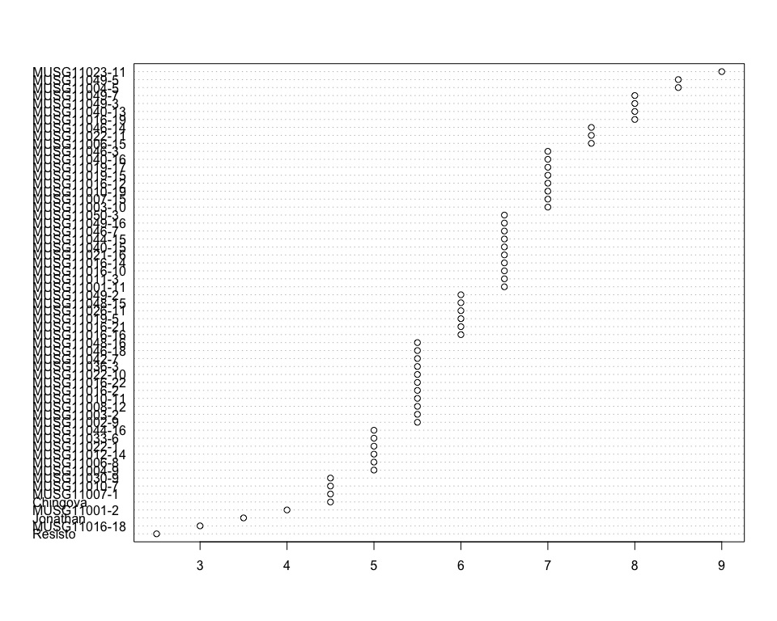

Do not forget the assumptions of the model. It is supposed that the error has a normal distribution with the same variance for all the treatments. The following plots must help you evaluate this:

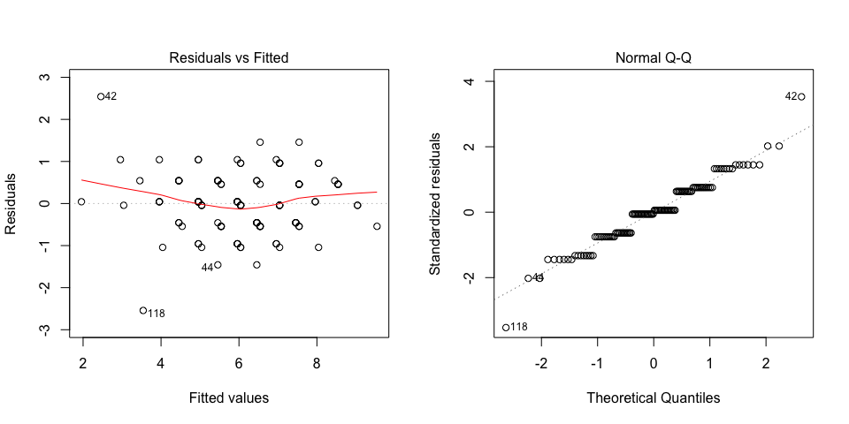

Funnel shapes for the first plot may suggest heterogeneity of variances while departures from the theoretical normal line are symptoms of lack of normality.

### Analysis of **Virus symptoms 1 estimating 1-9**

You have fitted a linear model for a RCBD. The ANOVA table for your model is:

|  |  |  |  |  |  |
| --- | --- | --- | --- | --- | --- |
|  | Df | Sum Sq | Mean Sq | F value | Pr(>F) |
| **germplasmName** | 58 | 32.7627 | 0.564874 | 1.58313 | 0.0414329 |
| **REP** | 1 | 0.305085 | 0.305085 | 0.855037 | 0.358963 |
| **Residuals** | 58 | 20.6949 | 0.356809 | NA | NA |

The p-value for treatments is 0.0414329 which is significant at the 5% level.

The means of your treatments are:

|  |  |
| --- | --- |
| germplasmName | Virus symptoms 1 estimating 1-9 |
| Chingova | 1 |
| Jonathan | 2 |
| MUSG11001-11 | 1 |
| MUSG11001-2 | 1.5 |
| MUSG11002-9 | 1 |
| MUSG11003-10 | 1 |
| MUSG11003-2 | 1 |
| MUSG11004-5 | 1 |
| MUSG11004-9 | 3.5 |
| MUSG11006-15 | 1 |
| MUSG11006-8 | 1.5 |
| MUSG11007-1 | 1.5 |
| MUSG11007-15 | 1 |
| MUSG11008-12 | 1 |
| MUSG11010-11 | 1.5 |
| MUSG11010-19 | 1 |
| MUSG11010-7 | 1.5 |
| MUSG11011-3 | 1 |
| MUSG11012-14 | 1.5 |
| MUSG11016-10 | 2 |
| MUSG11016-12 | 1.5 |
| MUSG11016-14 | 1.5 |
| MUSG11016-16 | 1.5 |
| MUSG11016-18 | 1 |
| MUSG11016-19 | 2 |
| MUSG11016-2 | 2.5 |
| MUSG11016-21 | 1 |
| MUSG11016-22 | 1.5 |
| MUSG11019-15 | 1 |
| MUSG11019-17 | 1 |
| MUSG11019-5 | 1.5 |
| MUSG11021-16 | 1 |
| MUSG11022-1 | 1 |
| MUSG11022-10 | 1 |
| MUSG11022-11 | 1 |
| MUSG11023-11 | 1.5 |
| MUSG11026-11 | 1 |
| MUSG11030-9 | 1 |
| MUSG11033-6 | 1 |
| MUSG11036-3 | 1 |
| MUSG11040-13 | 1.5 |
| MUSG11040-15 | 1 |
| MUSG11040-16 | 1 |
| MUSG11042-7 | 1.5 |
| MUSG11044-15 | 1 |
| MUSG11044-16 | 2.5 |
| MUSG11046-14 | 1 |
| MUSG11046-18 | 3 |
| MUSG11046-3 | 1 |
| MUSG11046-7 | 2 |
| MUSG11048-15 | 1 |
| MUSG11048-16 | 1 |
| MUSG11049-16 | 1 |
| MUSG11049-2 | 1 |
| MUSG11049-3 | 1 |
| MUSG11049-5 | 1 |
| MUSG11049-7 | 1 |
| MUSG11050-3 | 1 |
| Resisto | 1.5 |

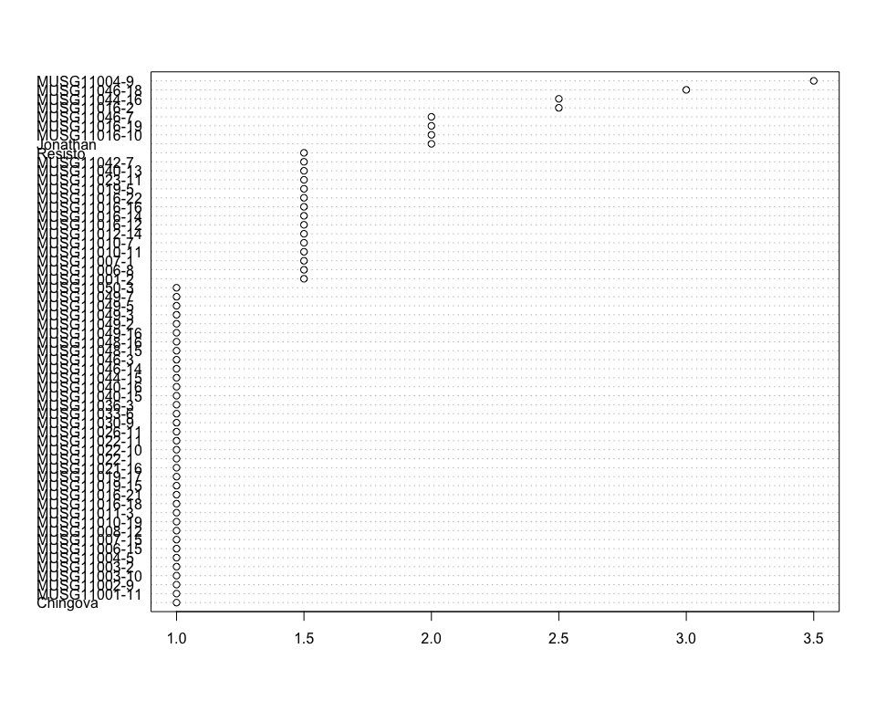

Do not forget the assumptions of the model. It is supposed that the error has a normal distribution with the same variance for all the treatments. The following plots must help you evaluate this:

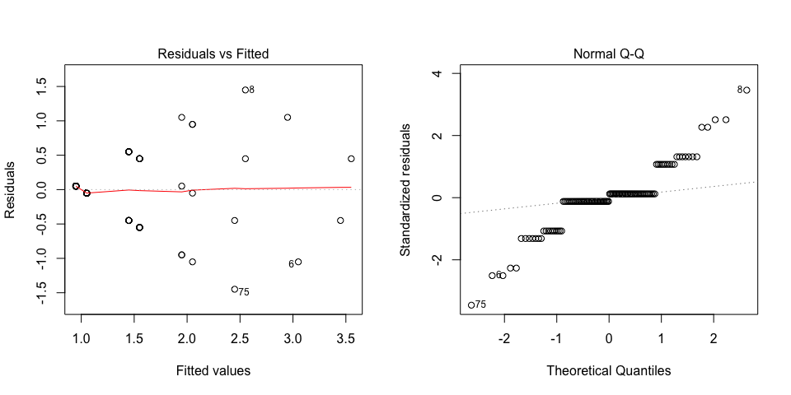

Funnel shapes for the first plot may suggest heterogeneity of variances while departures from the theoretical normal line are symptoms of lack of normality.

### Analysis of **Virus symptoms 2 estimating 1-9**

You have fitted a linear model for a RCBD. The ANOVA table for your model is:

|  |  |  |  |  |  |
| --- | --- | --- | --- | --- | --- |
|  | Df | Sum Sq | Mean Sq | F value | Pr(>F) |
| **germplasmName** | 58 | 44.7797 | 0.772063 | 2.66331 | 0.000134289 |
| **REP** | 1 | 0.686441 | 0.686441 | 2.36794 | 0.129288 |
| **Residuals** | 58 | 16.8136 | 0.289889 | NA | NA |

The p-value for treatments is 0.000134289 which is significant at the 5% level.

The means of your treatments are:

|  |  |
| --- | --- |
| germplasmName | Virus symptoms 2 estimating 1-9 |
| Chingova | 1 |
| Jonathan | 3 |
| MUSG11001-11 | 1 |
| MUSG11001-2 | 1.5 |
| MUSG11002-9 | 1 |
| MUSG11003-10 | 1 |
| MUSG11003-2 | 1 |
| MUSG11004-5 | 1 |
| MUSG11004-9 | 3.5 |
| MUSG11006-15 | 1.5 |
| MUSG11006-8 | 1.5 |
| MUSG11007-1 | 1 |
| MUSG11007-15 | 2 |
| MUSG11008-12 | 1 |
| MUSG11010-11 | 1.5 |
| MUSG11010-19 | 1 |
| MUSG11010-7 | 1.5 |
| MUSG11011-3 | 1 |
| MUSG11012-14 | 1.5 |
| MUSG11016-10 | 2 |
| MUSG11016-12 | 1.5 |
| MUSG11016-14 | 2 |
| MUSG11016-16 | 1 |
| MUSG11016-18 | 1.5 |
| MUSG11016-19 | 1.5 |
| MUSG11016-2 | 3.5 |
| MUSG11016-21 | 1 |
| MUSG11016-22 | 1.5 |
| MUSG11019-15 | 1 |
| MUSG11019-17 | 1 |
| MUSG11019-5 | 1 |
| MUSG11021-16 | 1 |
| MUSG11022-1 | 1 |
| MUSG11022-10 | 1 |
| MUSG11022-11 | 1 |
| MUSG11023-11 | 1.5 |
| MUSG11026-11 | 1 |
| MUSG11030-9 | 1 |
| MUSG11033-6 | 1 |
| MUSG11036-3 | 1 |
| MUSG11040-13 | 1 |
| MUSG11040-15 | 1 |
| MUSG11040-16 | 1 |
| MUSG11042-7 | 2 |
| MUSG11044-15 | 1.5 |
| MUSG11044-16 | 2.5 |
| MUSG11046-14 | 1.5 |
| MUSG11046-18 | 3 |
| MUSG11046-3 | 1.5 |
| MUSG11046-7 | 2 |
| MUSG11048-15 | 1 |
| MUSG11048-16 | 1 |
| MUSG11049-16 | 1 |
| MUSG11049-2 | 1.5 |
| MUSG11049-3 | 1 |
| MUSG11049-5 | 1 |
| MUSG11049-7 | 1 |
| MUSG11050-3 | 1 |
| Resisto | 1.5 |

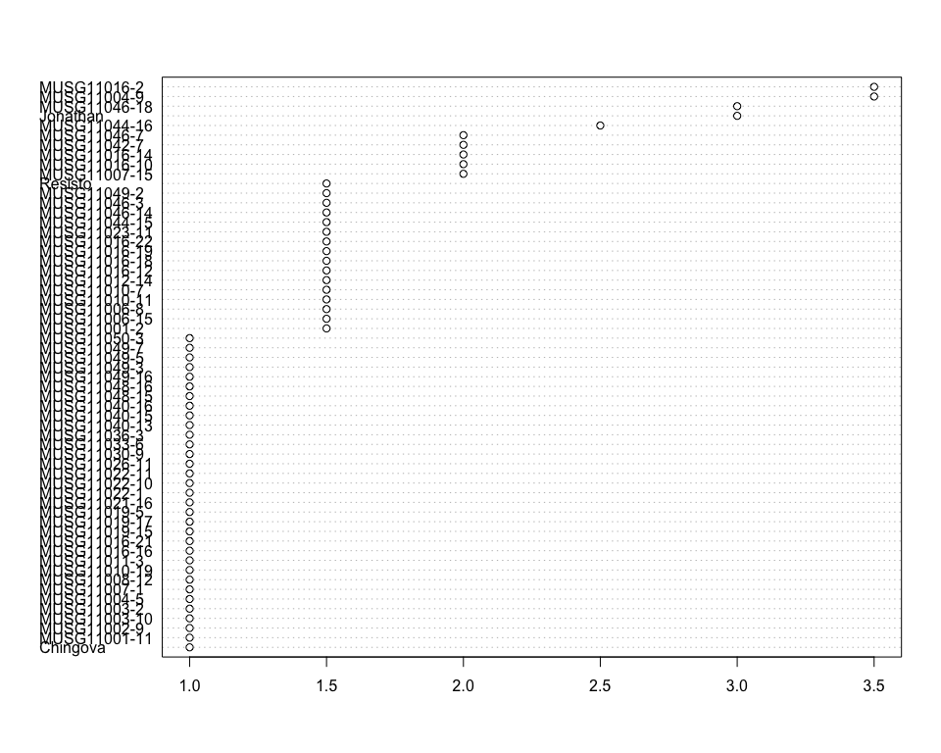

Do not forget the assumptions of the model. It is supposed that the error has a normal distribution with the same variance for all the treatments. The following plots must help you evaluate this:

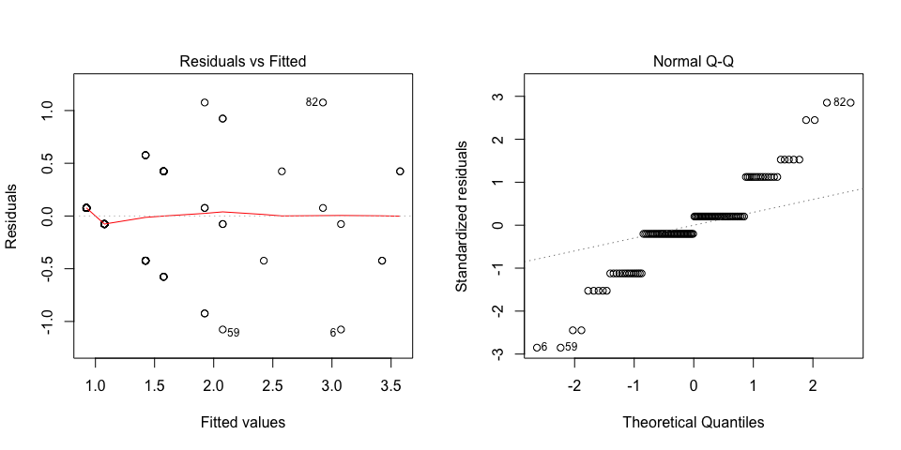

Funnel shapes for the first plot may suggest heterogeneity of variances while departures from the theoretical normal line are symptoms of lack of normality.

### Analysis of **Weight of commercial storage roots measuring kg per plot**

You have fitted a linear model for a RCBD. The ANOVA table for your model is:

|  |  |  |  |  |  |
| --- | --- | --- | --- | --- | --- |
|  | Df | Sum Sq | Mean Sq | F value | Pr(>F) |
| **germplasmName** | 58 | 3020.4 | 52.0759 | 2.91379 | 3.67918e-05 |
| **REP** | 1 | 1116.75 | 1116.75 | 62.4854 | 8.84638e-11 |
| **Residuals** | 58 | 1036.59 | 17.8722 | NA | NA |

The p-value for treatments is 0.0000367918 which is significant at the 5% level.

The means of your treatments are:

|  |  |
| --- | --- |
| germplasmName | Weight of commercial storage roots measuring kg per plot |
| Chingova | 0.75 |
| Jonathan | 7.6 |
| MUSG11001-11 | 8.5 |
| MUSG11001-2 | 5.7 |
| MUSG11002-9 | 15.5 |
| MUSG11003-10 | 16.1 |
| MUSG11003-2 | 6.1 |
| MUSG11004-5 | 29 |
| MUSG11004-9 | 3.05 |
| MUSG11006-15 | 11.7 |
| MUSG11006-8 | 0.55 |
| MUSG11007-1 | 2.95 |
| MUSG11007-15 | 11.6 |
| MUSG11008-12 | 5 |
| MUSG11010-11 | 6.5 |
| MUSG11010-19 | 15.5 |
| MUSG11010-7 | 2.45 |
| MUSG11011-3 | 8.5 |
| MUSG11012-14 | 4.5 |
| MUSG11016-10 | 12.9 |
| MUSG11016-12 | 15 |
| MUSG11016-14 | 11.5 |
| MUSG11016-16 | 12 |
| MUSG11016-18 | 11.1 |
| MUSG11016-19 | 7.95 |
| MUSG11016-2 | 15.5 |
| MUSG11016-21 | 9.5 |
| MUSG11016-22 | 10.5 |
| MUSG11019-15 | 9 |
| MUSG11019-17 | 3.75 |
| MUSG11019-5 | 3.95 |
| MUSG11021-16 | 10.1 |
| MUSG11022-1 | 10 |
| MUSG11022-10 | 8.45 |
| MUSG11022-11 | 8.75 |
| MUSG11023-11 | 17 |
| MUSG11026-11 | 14.5 |
| MUSG11030-9 | 6.5 |
| MUSG11033-6 | 7.65 |
| MUSG11036-3 | 8.1 |
| MUSG11040-13 | 11 |
| MUSG11040-15 | 4.1 |
| MUSG11040-16 | 10.6 |
| MUSG11042-7 | 7.5 |
| MUSG11044-15 | 3.55 |
| MUSG11044-16 | 3.5 |
| MUSG11046-14 | 7.05 |
| MUSG11046-18 | 11.6 |
| MUSG11046-3 | 14.5 |
| MUSG11046-7 | 15.1 |
| MUSG11048-15 | 5.1 |
| MUSG11048-16 | 8.5 |
| MUSG11049-16 | 5.2 |
| MUSG11049-2 | 13.9 |
| MUSG11049-3 | 19.5 |
| MUSG11049-5 | 12.9 |
| MUSG11049-7 | 11.2 |
| MUSG11050-3 | 14 |
| Resisto | 7.4 |

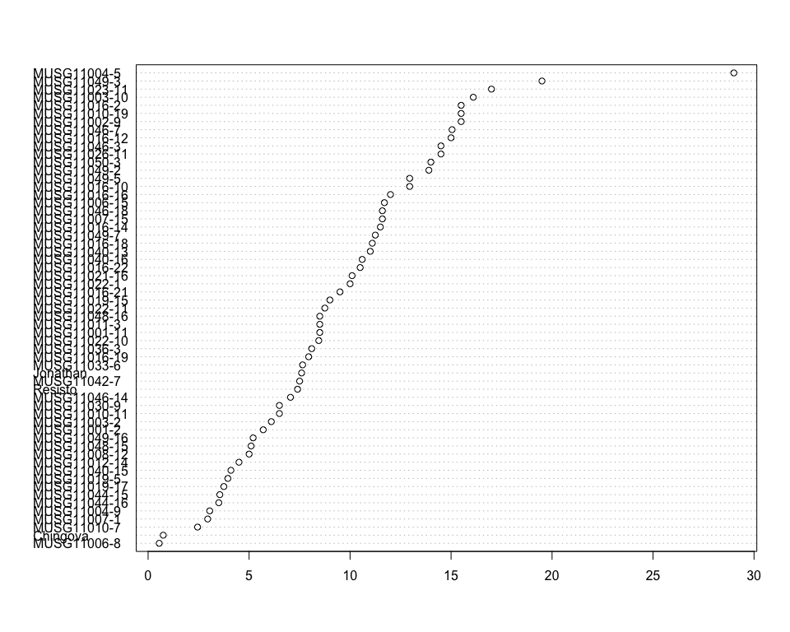

Do not forget the assumptions of the model. It is supposed that the error has a normal distribution with the same variance for all the treatments. The following plots must help you evaluate this:

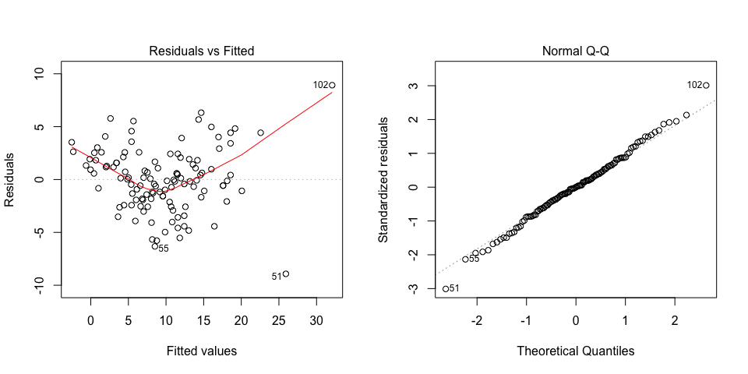

Funnel shapes for the first plot may suggest heterogeneity of variances while departures from the theoretical normal line are symptoms of lack of normality.

### Analysis of **Weight of non-commercial storage roots measuring kg per plot**

You have fitted a linear model for a RCBD. The ANOVA table for your model is:

|  |  |  |  |  |  |
| --- | --- | --- | --- | --- | --- |
|  | Df | Sum Sq | Mean Sq | F value | Pr(>F) |
| **germplasmName** | 58 | 373.894 | 6.44645 | 2.61653 | 0.000171603 |
| **REP** | 1 | 35.5352 | 35.5352 | 14.4233 | 0.000351771 |
| **Residuals** | 58 | 142.897 | 2.46374 | NA | NA |

The p-value for treatments is 0.000171603 which is significant at the 5% level.

The means of your treatments are:

|  |  |
| --- | --- |
| germplasmName | Weight of non-commercial storage roots measuring kg per plot |
| Chingova | 0.5 |
| Jonathan | 1.46 |
| MUSG11001-11 | 4.25 |
| MUSG11001-2 | 1.7 |
| MUSG11002-9 | 2.5 |
| MUSG11003-10 | 3.15 |
| MUSG11003-2 | 0.7 |
| MUSG11004-5 | 5.6 |
| MUSG11004-9 | 1.1 |
| MUSG11006-15 | 5.15 |
| MUSG11006-8 | 1.65 |
| MUSG11007-1 | 2 |
| MUSG11007-15 | 2.5 |
| MUSG11008-12 | 5 |
| MUSG11010-11 | 2.3 |
| MUSG11010-19 | 6 |
| MUSG11010-7 | 1.55 |
| MUSG11011-3 | 1.6 |
| MUSG11012-14 | 3.1 |
| MUSG11016-10 | 1.6 |
| MUSG11016-12 | 4.65 |
| MUSG11016-14 | 1.5 |
| MUSG11016-16 | 4.2 |
| MUSG11016-18 | 2.1 |
| MUSG11016-19 | 3.5 |
| MUSG11016-2 | 3.5 |
| MUSG11016-21 | 2.15 |
| MUSG11016-22 | 2.05 |
| MUSG11019-15 | 3.2 |
| MUSG11019-17 | 3.55 |
| MUSG11019-5 | 0.45 |
| MUSG11021-16 | 4.45 |
| MUSG11022-1 | 1.6 |
| MUSG11022-10 | 3.4 |
| MUSG11022-11 | 3.1 |
| MUSG11023-11 | 10 |
| MUSG11026-11 | 1.6 |
| MUSG11030-9 | 2.7 |
| MUSG11033-6 | 4 |
| MUSG11036-3 | 1.3 |
| MUSG11040-13 | 5.5 |
| MUSG11040-15 | 0.95 |
| MUSG11040-16 | 5.55 |
| MUSG11042-7 | 0.4 |
| MUSG11044-15 | 2.82 |
| MUSG11044-16 | 1.5 |
| MUSG11046-14 | 1.55 |
| MUSG11046-18 | 2.6 |
| MUSG11046-3 | 6.2 |
| MUSG11046-7 | 3.5 |
| MUSG11048-15 | 1.95 |
| MUSG11048-16 | 1.75 |
| MUSG11049-16 | 3.15 |
| MUSG11049-2 | 1.53 |
| MUSG11049-3 | 2.9 |
| MUSG11049-5 | 5.55 |
| MUSG11049-7 | 5 |
| MUSG11050-3 | 4 |
| Resisto | 1.76 |

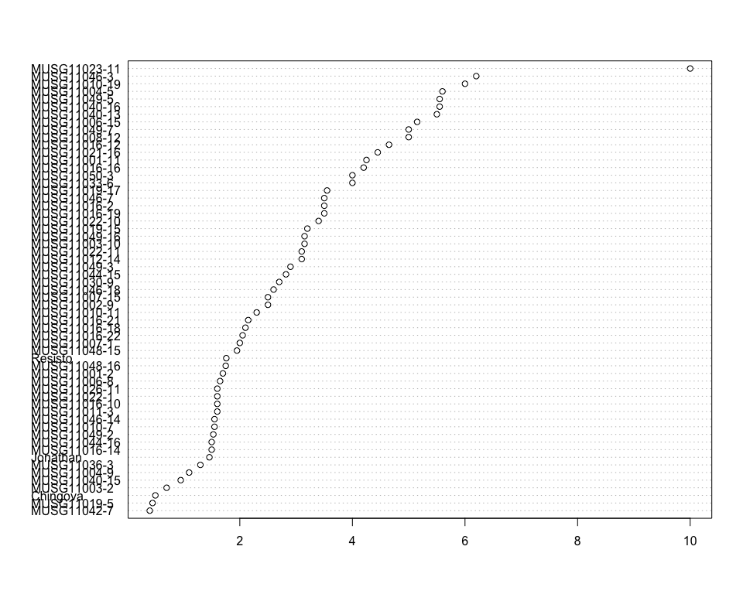

Do not forget the assumptions of the model. It is supposed that the error has a normal distribution with the same variance for all the treatments. The following plots must help you evaluate this:

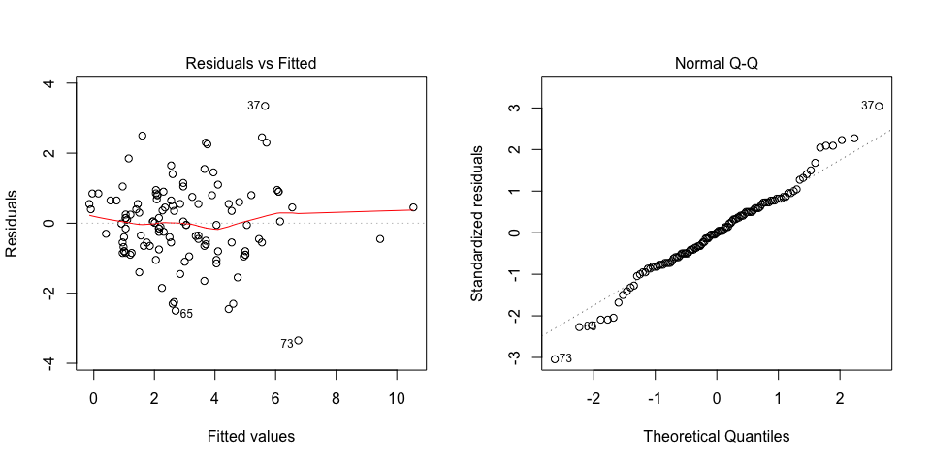

Funnel shapes for the first plot may suggest heterogeneity of variances while departures from the theoretical normal line are symptoms of lack of normality.

### Analysis of **Weight of vines measuring kg per plot**

You have fitted a linear model for a RCBD. The ANOVA table for your model is:

|  |  |  |  |  |  |
| --- | --- | --- | --- | --- | --- |
|  | Df | Sum Sq | Mean Sq | F value | Pr(>F) |
| **germplasmName** | 58 | 4482.98 | 77.2928 | 2.61471 | 0.000173254 |
| **REP** | 1 | 1722.61 | 1722.61 | 58.2735 | 2.52288e-10 |
| **Residuals** | 58 | 1714.53 | 29.5608 | NA | NA |

The p-value for treatments is 0.000173254 which is significant at the 5% level.

The means of your treatments are:

|  |  |
| --- | --- |
| germplasmName | Weight of vines measuring kg per plot |
| Chingova | 2 |
| Jonathan | 9.61 |
| MUSG11001-11 | 16.8 |
| MUSG11001-2 | 0.5 |
| MUSG11002-9 | 11.2 |
| MUSG11003-10 | 19.4 |
| MUSG11003-2 | 3.8 |
| MUSG11004-5 | 26.6 |
| MUSG11004-9 | 2.05 |
| MUSG11006-15 | 12.2 |
| MUSG11006-8 | 11.1 |
| MUSG11007-1 | 3.65 |
| MUSG11007-15 | 10.2 |
| MUSG11008-12 | 7.3 |
| MUSG11010-11 | 11.3 |
| MUSG11010-19 | 24.9 |
| MUSG11010-7 | 4.25 |
| MUSG11011-3 | 15.1 |
| MUSG11012-14 | 10.1 |
| MUSG11016-10 | 13.6 |
| MUSG11016-12 | 20.2 |
| MUSG11016-14 | 18.5 |
| MUSG11016-16 | 9.2 |
| MUSG11016-18 | 16.1 |
| MUSG11016-19 | 21.9 |
| MUSG11016-2 | 9.45 |
| MUSG11016-21 | 8.79 |
| MUSG11016-22 | 2.15 |
| MUSG11019-15 | 13.3 |
| MUSG11019-17 | 14.6 |
| MUSG11019-5 | 9.05 |
| MUSG11021-16 | 10.7 |
| MUSG11022-1 | 5.15 |
| MUSG11022-10 | 3.45 |
| MUSG11022-11 | 18.6 |
| MUSG11023-11 | 24.1 |
| MUSG11026-11 | 8.3 |
| MUSG11030-9 | 7.75 |
| MUSG11033-6 | 6.75 |
| MUSG11036-3 | 7.6 |
| MUSG11040-13 | 27.1 |
| MUSG11040-15 | 8.95 |
| MUSG11040-16 | 15.7 |
| MUSG11042-7 | 9.15 |
| MUSG11044-15 | 11.3 |
| MUSG11044-16 | 7.2 |
| MUSG11046-14 | 17.8 |
| MUSG11046-18 | 7.8 |
| MUSG11046-3 | 14.7 |
| MUSG11046-7 | 17.4 |
| MUSG11048-15 | 10.1 |
| MUSG11048-16 | 11.8 |
| MUSG11049-16 | 13.2 |
| MUSG11049-2 | 10.2 |
| MUSG11049-3 | 16.1 |
| MUSG11049-5 | 15.8 |
| MUSG11049-7 | 13.3 |
| MUSG11050-3 | 11.1 |
| Resisto | 5.06 |

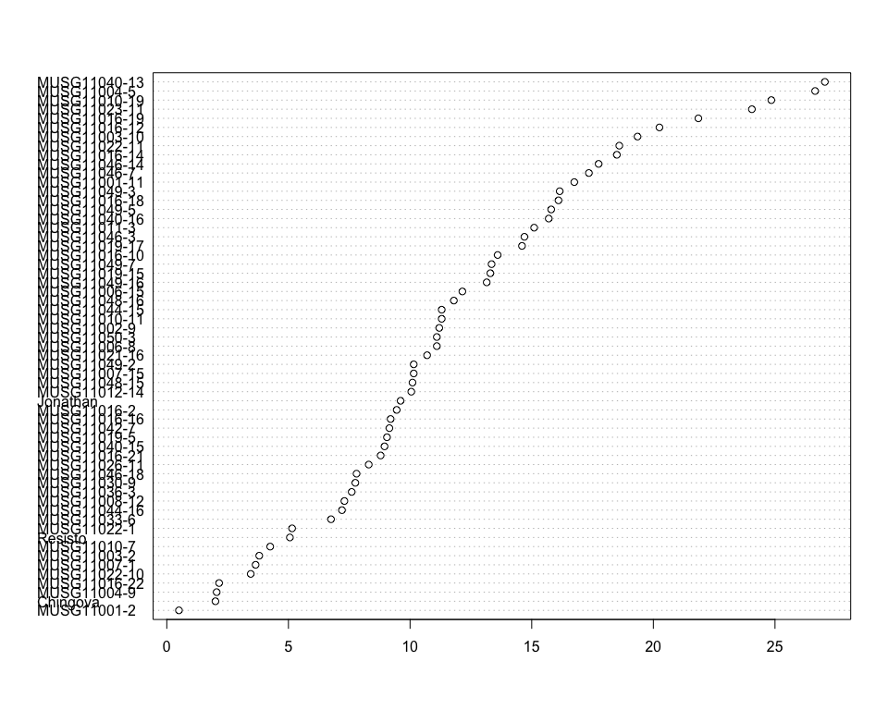

Do not forget the assumptions of the model. It is supposed that the error has a normal distribution with the same variance for all the treatments. The following plots must help you evaluate this:

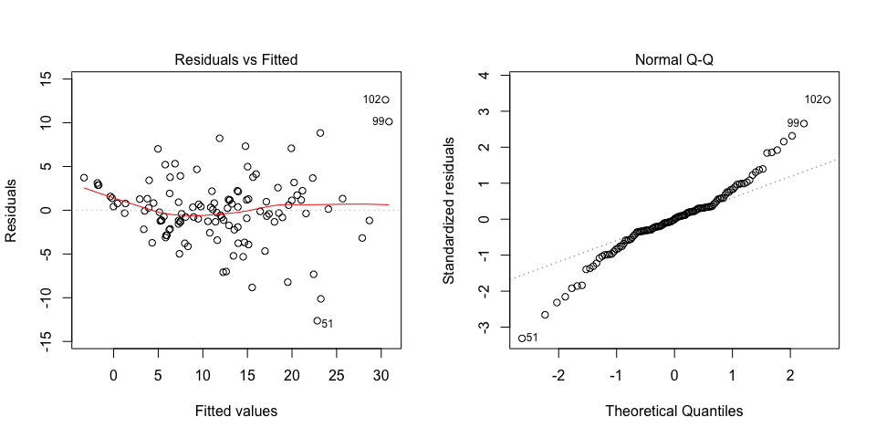

Funnel shapes for the first plot may suggest heterogeneity of variances while departures from the theoretical normal line are symptoms of lack of normality.

## Trait correlations

## Variety candidate selection

# Summary

# References

## Data sources

## Literature